Wall and reflux features as determinant parameters of the venous disease
By Claude Franceschi
ABSTRACT
The venous system consists of various aspects, biological , anatomic and hemodynamic that provide an appropriate venous function i.e drainage of the tissues, thermoregulation and heart pre-load feeding. The draining function and vein volume control depend on the correct balance of the trans-mural pressure at the micro and macro venous bed. Its impairment is the central cause of the venous disease that can be due to various anomalies of the valves, the venous conduit and its wall, the venous pumps, related to congenital malformations or to secondary mechanic and biologic disorders. Despite crucial, the hemodynamic aspect has been for a long time underestimated, partly because of the lack of deep investigation means. To-day, after invasive pressure measurements, venography and plethysmography, DUS has provided an invaluable tool that allowed a dramatic progress in its knowledge and understanding.

A/ Physical and Biological variables generally involved in Venous Diseases

1GENETICS predisposition venous malformation
2 BIOLOGY Infection Phlebitis Inflammation Venous ablation
4 HEMODYNAMIC IMPAIRMENT 5 Trans Mural Pressure TMP Excess
3 VENOUS SYSTEM DAMAGES
Obstruction Valve incompetence Open Vicarious Shunts Closed Shunts CS Open Deviate Shunts ODS
6 DRAINAGE IMPAIRMENT
Oedema Hypodermitis Ulcer
7 VENOUS DILATION
Varices
Effects
Vicious circle
PREVENTION?
GENETIC REPAIR?
TMP CORRECTION Clearing the obstructions
Repairing the valves
Hydrostatic Pressure fractioning
Disconnecting CS and ODS
Drainage preservation
TMP CORRECTION Feet Elevation Legs Compression
treatments
causes

1-Genetics, Biology and hemodynamics are not independent but interactive physiological components of the venous system that provides the venous function where the Trans Mural Pressure TMP control is crucial .To restore the TMP hemodynamic control is a necessary condition to carry on a correct function, whatever the means, physio-anatomical-like or not. So, any treatment which can restore it is sufficient to provide a correct function. Clearing the obstructions, Repairing or building the valves, CHIVA (Hydrostatic Pressure fractioning, CS and ODS Disconnection, Drainage preservation). To treat or prevent the genetic and biological defects are not yet arisen.

2/ Trans Mural Pressure TMP (TMP = Intravenous pressure IVI – Extra-venous pressure EVP) is made of is the difference of lateral pressure LP between the internal and external wall side of veins and venous capillaries.
TMP is the central hemodynamic parameter that controls both venous calibre and tissue drainage.
EVP depends on the atmospheric and tissue pressure.
IVP is made of 2 pressures in healthy individuals: hydrostatic pressure HSP due to gravity, thus depending on the posture and Residual Pressure RP provided by arterial pressure and reduced and modulated by the micro-circulation resistances MCR.
In venous insufficient Individuals, the shunt pressure SP provided by the valvo-muscular pump VMP action has to be added to HSP and RP.

3/HSP is equal in healthy and venous incompetent individuals in any posture except when walking where it decreases dramatically below the knee ( from 90 to 30 mmHg) in normal but not in venous insufficient.¹
This is due to the VMP that fractionates the HSP column thanks to an alternate closure of down and upstream valves during the systolic and diastolic phases of walking. We named this phenomenon: Dynamic Fractioning of the Hydrostatic Pressure DFHSP.
In case of venous insufficiency, the DFHSP is impaired in proportion with the valve incompetence. ^{2,3}

4/ TMP excesses are due to IVP increase or EVP decrease ( low atmospheric pressure, low tissue pressure).
IVP excess are counterbalanced by EVP Increase (compression).
IVP excesses are due either to RP increase (AV fistula, MCR decrease, downstream obstacles) and/or to DFHSP impairment because of valve incompetence frequently associated to an overloading shunt pressure (SP) due to closed shunts CS and deviate open shunts DOS. CS is a N2 and/or N3 vein overloaded during the diastolic phase of the calf muscular pump by a deep vein N1 through a proximal refluxing escape point( SFJ, SPJ or a pelvic or thigh perforator) and re-entering distally to the calf pump deep veins N1 through an inwards perforator. ODS is refluxing saphenous tributary (N3) fed by N2 (GSV or SSV) and re-entering as a CS. CS works as a closed circuit while the ODS that is not fed by N1. This overloading flow adds the SP to the HSP and is responsible for the varicose veins enlargement with muscular activity ( walking, running etc..). The disconnection of these shunts flush to the escape point fractionates the HSP and ablates the overloading SP, so that the varicose vein collapses to normal while it keeps physiologically draining the skin despite still refluxing but at low flow/pressure, so avoiding skin suffering and collateral varicose recurrence. ^{3,5,6,7}
These CS can be seen in the deep veins when an both its distal and proximal ends connect to a competent deep collateral.
5/The flow direction antegrade or retrograde (reflux) is not specific of any pathological status if it is not defined by its source(s) and its destination(s). Classification of shunts permits a comprehensive definition of any venous circulation pattern. ^{4,7}

6/The vicarious compensatory collateral veins (open vicarious shunts OVS) are overloaded by the flow that escapes distally to/from the blocked vein and re-enter proximally to it. They are seen after an important deep venous thrombosis, but also after a superficial vein ablation, so accounting for superficial varicose veins recurrence.

Obstruction
VENOUS SYSTEM DAMAGES and hemodynamics
Valve incompetence Closed Shunts CS Open Deviate Shunts ODS
Residual Pressure increase
Dynamic Hydrostatic Pressure Fraction Impairment
Pump Pressure Overload
Open Shunts
varices
TMP excess
Trophic disorders
Varices

B/ Reflux.
Reflux can be misunderstood and source of confusion if not related to a common definition.
We propose : reflux =venous flow opposite to the valve direction independently of its origin, destination and flow component.
Any flow, whatever its direction results from a pressure gradient.. The gradient pressure inversion is physiological when the proximal pressure increases ( cough, defecation, heavy weight bearing, Valsalva manoeuver) or the distal pressure decreases ( diastolic phase of the muscular pump, particularly the calf pump). The flow reverses when the valves are not capable to stop it (valve absence or incompetence) ^{2,8;10;11} . It is always a reflux at its start point but it can feed an antegrade flow. 2 examples: the pelvis escape (start) points are refluxing while they feed in orthograde (antegrade) direction the upper tributaries of the GSV arch and a femoro-popliteal obstruction can be by-passed ( open vicarious shunt) by a calf refluxing perforator that feed an orthograde GSV flow.
The reflux time in deep veins is normal when it is not longer than 10OO ms in the deep veins (N1) and less than 500 ms in the superficial veins ( N2,N3). ¹²
The value of the deep pathological reflux can be rated according to the valves damages and position. Total when the all the overlying and underlying valves are incompetent, segmental when the upper valves are competent and partial when the valve leak is small. Some indexes can assess these different features of reflux.¹³
The superficial veins refluxes can be defined according to the pressure gradient that triggers them (Valsava manoeuver, muscular pump systole or diastole), their escape points, their pathways ( saphenous trunks N2 and or tributaries N3) and their re-entry points towards N1. They can be classified according theses parameters in various types of shunts. ^{7, 14 15}

C/ Compliance, Visco-elasticity and wall remodeling
Compliance and Visco-elasticity are the parameters that account for the mechanics properties of the venous wall and interfere with the “reservoir effect” and the wall remodeling.
1- Compliance:
Compliance is the physical feature measurement of the vessel wall related to its capability for blood volume Q storing according to the TMP ( Tension = TMP. Vein radius) . The volume variation is generally a sigmoid curve (Hooks modulus) where two different values can be measured at each point P
1-Static compliance SC = Q/TMP i.e the resulting volume variation according to the TMP
2-Dynamic compliance DC = dQ/dPTM i.e the velocity of the volume variations (acceleration) that decreases with the wall viscosity.
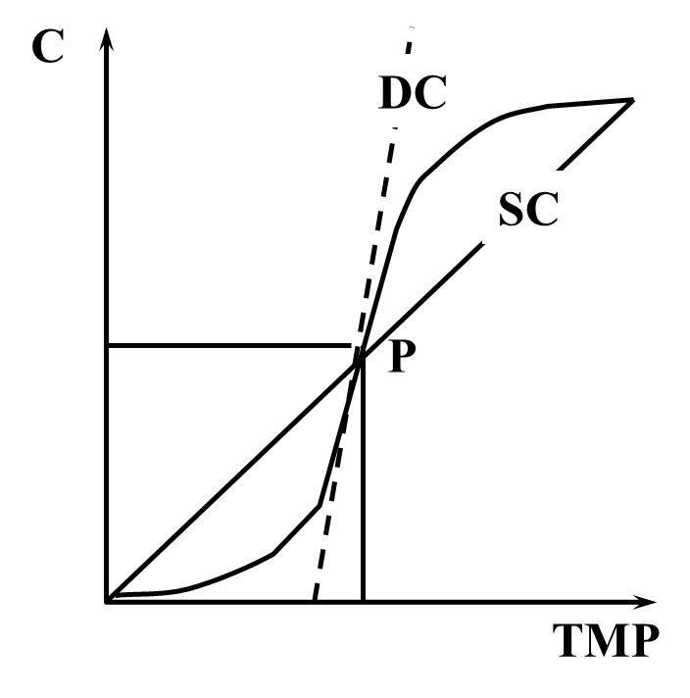

Wall components and Compliance:
Passive components: Conjonctive/elastine
Active acive components : Muscular media (Reflex vaso constriction/relaxation)

2- Visco-elasticity.
Calibre = Tension/ Visco-elasticity
Visco-elasticity ( delayed elasticity) is another vascular feature particularly related to the veins which accounts for:
1-the delayed caliber response C to the TMP ( Fluage F ) that interfere with the Dynamic compliance.
2- the lower TMP capable to maintain Q ( Relaxation R) than which was necessary to achieve it that interferes with the hysteresis phenomenon.
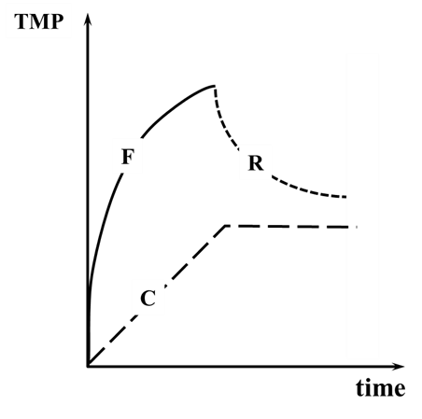

3- Reservoir effect
Compliance and visco-elasticity vary according to the wall veins components. The high compliance of the venous bed is responsible for the capacitive effect called “reservoir effect” that allows a great variation of volume with a small variation of pressure, so providing a variable flow according to the right heart necessity without a substantial venous pressure change^{19,20}.
4- Wall remodeling
The more the radius, higher the tension for the same TMP. The physiological response is the media thickening according to the Starling law…which reinforces the wall and reduces the compliance. This is a biologic response that limits the venous dilation attested by the wall thickening of the GSV when overloaded/strained by SFJ reflux.
The hysteresis, i.e the Caliber/volume reduction secondary to a TMP decrease, depends of the wall structure that consists in wall remodeling that can take long time (weeks) after refluxing SFJ disconnection ²¹.

References
1-Carl C. Arnoldi Venous Pressure in patients with Valvular Incompetence of the veins of the lower Limbs Acta Chir Scand 132:626-645, 1966
2-C.Franceschi. Insuffisance veineuse et fractionnement dynamique de la colonne de pression hydrostatique STV. Sang thrombose vaisseaux 2001 , Vol : 13 , Num : 5 , p. : 307 - 310
3-C.Franceschi.Dynamic fractionizing of the hydrostatic pressure, closed ans open shunt, vicarious varicose evolution : how heve these concepts made the treatment of varices evolve? Plébologi 2003,55,N°1,61-66
4- Franceschi C. Théorie et pratique de la cure Conservatrice et hémodynamique de l’insuffisance veineuse en ambulatoire. Precy-sous-Thil France Editions de l’Armançon;1988
5/M.Bailly CHIVA EMC 1991-92
6/ Zamboni P et al. Reflux Elimination Without any Ablation or Disconnection of the Saphenous Vein. A Haemodynamic Model for Venous Surgery Eur J Vasc Endovasc Surg 2001;21:361-369
7/ Franceschi C, Zamboni P. Principles of venous haemodynamics. Novapublishers. New York. 2010
8 -Franceschi C. La Cure Hemodynamique de l’Insuffisance Veineuse en Ambulatoire.Journal des Maladies Vasculaires. 1992 ; 22 (2) :91-95
9-Caggiati A. The saphenous venous compartments. Surg Radiol Anat 1999;21(1):29-34
10- Bjordal R. “Simultaneous pressure and flow recordings in varicose veins of the lower extremity” Acta Chir Scand 1970; 136:309-317
11- Recek C, Pojer H. Ambulatory pressure gradient in the veins of the lower extremity. VASA 2000; 29:187-90
12-Labropoulos N, Tiongson J, Pryor L, Tassiopoulos AK, Kang SS, AshrafMansour M, Baker WH. Definition of venous reflux in lower-extremity veins. J Vasc Surg. 2003 Oct;38(4):793-8ref]).
13-Franceschi C. Measures and interpretation of venous flow in stress tests. Manual compression and Parana manoeuver.Dynamic reflux index and Psatakis index. Journal des Maladies Vasculaires 1997;22(2):91–5
14- Franceschi. C, Bahnini A. Treatment of lower extremity venous insufficiency due to pelvic leak points in women Ann Vasc Surg 2005; 19:284-8
15- Franceschi C Anatomie fonctionnelle et diagnostic des points de fuites bulbo-clitoridiens chez la femme (Point C)Journal des Maladies Vasculaires Volume 33, numéro S1page 42 (mars 2008)
16-Franceschi C, Zamboni P. Principles of venous haemodynamics. Novapublishers. New York. 2010
17-Anliker m, Yates wg, Ogden e (1971) Transmission of small pressure waves in the canine vena cava. Am J Physiol 221: 644-51.
18- Bia d, Armentano r, Craiem d, Grignola j, Gines f, Simón a, Levenson j (2004) Smooth muscle role on pulmonary arterial function during acute pulmonary hypertension in sheep. Acta Physiol Scand 181: 359-66.
19- Bradley jg, Davis ka (2003) Orthostatic hypotension. Am Fam Physician 68: 2393-8.
20- Freeman r, Lirofonis v, Farquhar wb, Risk m (2002) Limb venous compliance in patients with idiopathic orthostatic intolerance and postural tachycardia. J Appl Physiol 93: 636-44.
21-Mendoza e, Berger v, Zollmann c, Homhoff m, Amsler f. Diameter-reduction of the great saphenous vein and common femoral vein after CHIVA.2013 Phlebologie

