Thursday, June 07, 2012

Dear Claude
As one of your admirers, I feel greatly honored to have you for this UIP
Consensus and deeply grateful to your critical contribution throughout many
crucial issues.
Indeed, as you are already aware of though the letters sent to the faculty
members altogether, it is about time to move on soon to start to write the
sections/chapters we organized. And we assigned/request to your contribution
to Chapters 2, 5, 6, & 12 altogether.
But Chapter 12 will remain as a highlight for this consensus, and I am sure
you and Paolo would fulfill the role superbly.
Chapter 12. Hemodynamic changes as a result of alternative interventions
Coordinate: Fedor Lurie & Paolo Zamboni
Write: Paolo Zamboni & Claude Franceschi
Assist to write: Lena Blomgren, Attilio Cavezzi, Claude Franceschi,
Erika Mendoza, Massimo Cappelli
Review: Attilio Cavezzi & Fausto Passariello
a. CHIVA (Claude Franceschi) (Erika Mendoza) (Massimo Cappelli)
b. Phlebectomy (Attilio Cavezzi)
I do thank you once again for your generous commitment to this important
consensus we all do look forward.
All the best,
BB

12. Hemodynamic changes as a result of alternative interventions
Write: Paolo Zamboni & Claude Franceschi
Assist to write: Lena Blomgren, Attilio Cavezzi, Claude Franceschi, Erika Mendoza,
Massimo Cappelli
a. CHIVA (Claude Franceschi) (Erika Mendoza) (Massimo Cappelli)
b. Phlebectomy(ASVAL) (Attilio Cavezzi)
Review: CHIVA - Attilio Cavezzi & Fausto Passariello
Phlebectomy (ASVAL) - Fausto Passariello
Coordinate: Fedor Lurie & Paolo Zamboni
Hemodynamic changes as a result of alternative interventions
a. CHIVA
CHIVA is the french acronym of : “Cure conservatrice et hemodynamique de l’Insuffisance Veineuse en Ambulatoire” i.e Conservative and hemodynamic treatment of the venous insufficiency in outpatients. [1,2]
The CHIVA hemodynamic result is supposed to comply with the purpose of this treatment. The latter is to reduce to normal the venous transmural pressure TMP in order to correct the venous caliber excess and restore the appropriate drainage of the tissues. The conservation, beside the potential graft sparing is per se an hemodynamic management aimed to hamper not the physiological drainage of the tissues . This is based on the assumption that the TMP excess is the hemodynamic final cause of the venous insufficiency, represented by varicose veins, edema, skin disorders and ulcer. So, a hemodynamic pattern that represents the mechanism of TMP regulation and its dysfunction has been proposed in 1988 (ref). On the one hand, it consisted of an anatomo-functional classification of the venous network in N1, N2,N3,N4 according to the hierarchical draining flow N3>N2>N1 or N3>N1 ( N3 = suprafascial triburaries> N2 =intra-fascial saphenous trunks and Giacomini vein>N1= deep veins) and N4 (interconnections N2>N3>N2 , N4l when longitudinal, e.g the “accessory GSV” and N4t when transversal, e.g “Leonard’s vein (FIG 1, 2). This classification previously defined by Duplex ultrasound [1,2] was confirmed by further anatomic studies [3]. On the other hand, this pattern describes the hemodynamic conditions that produce venous insufficiency and its various anatomo-functional configurations.
The pre and post CHIVA hemodynamic changes are compared easily when drawn on topographic and functional map.
These assumptions are based on the evidences provided by invasive [4,5]and non-invasive studies[7,8,9]and has been clinically and instrumentally validated by several studies and some trials (RCT) [10,11,12,13]

Schematically, we present successively the strategy and the implementation technics according to the various hemodynamic configurations and their correlative instrumental data , then the various clinical and instrumental tests that assess the expected outcomes and explain the failures.

1- Hemodynamic pattern and correction strategy

12-The hemodynamic pattern is made of various concepts. The first one is the TMP excess due to an excess of lateral endo-venous pressure ( LEP) or insufficient extra-venous pressure (EP). So, TMP can be reduced by external hemodynamic procedures, as compression that increases EP. CHIVA is an hemodynamic procedure that aims to reduce LEP. To do this, CHIVA strategy consists of 4 actions:
1/ Gravitationnal Hydrostatic Pressure (GHP) fractioning.
2/ Closed and open deviated shunts ( CS and ODS) disconnection.
3/ Veins and Open Vicarious shunts (OVS) preservation.
4/ Feasible in outpatients.
To do this, the various LEP components must be distinguished, assessed and treated individually.
121-The LEP is composed of GHP, lateral residual pressure (RP) and Valvo-Muscular Pump lateral (VMP) flow/pressure.
1211- Gravitational Hydrostatic Pressure (GHP) Fractioning.
Definition: The GHP column is the specific weight of the venous blood column I proportion with its vertical height from any lower limb level up to the heart. Its maximum value is at the foot in upright posture.
Behavior: (FIG 3)
Normally, GHP interferes pathologically only when the posture is favorable, i.e in upright still position while ( maximum height and GHP = 90 mmHg) it doesn’t in lying (minimum height and GHP). This resulting pathologic excess of TMP is restored to normal below the knee ( 30 mmHG) when walking thanks to column fractioning achieved by the alternate valve closure actioned by the VMP. This mechanism is called dynamic fractioning of the GHP (DFHP) (FIG4).
Pathology: the valve incompetence impairs the DFHP so that the GHP decrease is hampered during walking, in proportion to the height incompetent venous network and to the degree of valve closure impairment ( total or partial) (FIG 5, 6).
Location: The incompetent valves can be located anywhere (N1,N2,N3) and their extension is variable.
Diagnosis: Duplex US scan cannot assess the valve incompetence at rest but only by tests showing a trans-valve reflux ( valsalva manoeuver, squeezing, Paranà, Wundsdorf, oscillation maneuvers) (FIG 7,8,9)
CHIVA strategy: Beside their treatment by valve repair or prosthetic implant, CHIVA proposes to achieve a similar GHP fractioning effect by venous stepped disconnections. The latter are carried out along the incompetent column. They are selected in order to fractionate the column and preserve the drainage at the same time. To do this, the column is fractionated in segments no longer nor shorter than 50-60 cms and located such as they don’t hamper the physiological drainage. The latter is saved if, between 2 disconnections, a tributaryl/perforator inflow ( N2>N1, N3>N2, N3>N1) can achieve properly transfer of the physiological draining flow , i.e large enough ( low resistance) and aspired by its underlying valvo-muscular pump (VMP) [1,5] .Most of the time, these disconnections match with the shunts disconnections ( see below).
1212- Disconnection of the closed, open deviated and mixed shunts ( CS, ODS and MS ) . Whilst in both normal and venous incompetence the GHP is equally excessive in standing still position, they differ when walking (actioning the valvo-muscular pump (VMP)). The GHP decreases to normal below the knee in physiological condition (correct DFHP) whereas, in abnormal, it decreases in reverse proportion of the valve incompetence and according to their topographic configuration . Beside the rare total deep venous incompetence, most of these configurations are what we call “shunts”. The shunts are veins that receive anti-hierarchically (reverse hierarchical draining direction) blood from other veins (superficial N2,N3 or deep N1) through an escape point (EP) and redirect it in through a re-entry point (RP). CHIVA consists in disconnecting the CS and ODS at their escape points and respect the MS escape points.
12121- Closed shunts (CS): (Fig 10)
Definition: CS is a venous pathway, competent or not, that flows in closed circuit with the shunted veins, through its EP and RP, during the VMP diastole.
Behavior: During the VMP diastole, CS is overloaded through an EP by a flow made of N1blood, the pressure and velocity of which are proportional to the GHP and to the VMP power.
Location: EP are mostly located above the calf VMP and the re-entry-points at the calf, ankle and foot level.
Diagnosis: refilling time plethysmography is due to shunts but not specific. Doppler US is specific of CS when the reflux is activated by the Valsalva maneuver, while VMP diastolic reflux is seen also in OVS. The diastolic reflux time and volume is quite superior to the systolic antegrade flow.
Features: A superficial CS type is defined by its variable configurations according to its EP, venous pathways and RP. 2 examples: the CS N1>N2>N1 is overloaded by N1 and called Shunt 1. CS N1>N2>N3>N1, is called Shunt 3 where N3 is overloaded by N1+N2. Its treatment strategy is particular because of the absence of intermediate re-entry on N1. 4 other CS features are described, shunts 4,5,6 according to EP ( SFJ,SPJ, Peforators including pelvoperineal EP[15,16].) and the successive pathways combinations . Fig 18,19.
CHIVA strategy: Disconnecting the CS withoud hampering the physiological drainage .
Shunt 1, 4,5 and 6: EP disconnection at N1>N2 or N1>N3, this disconnection is sufficient to treat the CS (Fig 11). Nevertheless, it can be insufficient to fraction properly the GHP if is the underlying column is too high. Therefore an additional disconnection can be implemented just below an interposed re-entering perforator , above the “terminal” re-entry . This is possible if its caliber and underlying VMP are appropriate to absorb the flow/pressure. If it is not, the draining flow pressure can cause local matting and/or a by-pass. An example is represented by a CS made of the whole GSV trunk, from the SFJ down to the foot. An additional disconnection just below an intermediate RP located below the knee can be implemented.( FIG 12)
Shunt 3: The EP disconnection relieves properly the N1>N2 overload but leaves behind the N2>N3 reflux (Shunt 2:see below) (). The additional EP N2>N3 disconnection can treat properly N3 but hampers the overlying N2 drainage because of the absence of intermediate re-entry and leads to N2 stasis/thrombosis and by-pass/recanalization N2>N3, because hemodynamically incorrect FIG 13. N2>N3 disconnection alone treats N3 and provides the N2 reflux ablation and caliber reduction (suppresses the overload from N1), but leaves behind a too high column that secondarily can leads to a recurrent reflux through a forced N2 intermediate valve or perforator or through a N2>N3 recanalization/by-pass [14]. This procedure is called CHIVA 2 steps where the first step consists in N2>N3 disconnection and the second step in proximal N1>N2 disconnection when the reflux occurs along the follow up FIG 13bis. Therefore, a destruction of the competent underlying valves down to a RP perforator is combined at the same time with N1>N2 and N2/N3 disconnection FIG 13ter.

12122- Open deviated shunts (ODS).
Definition: ODS is a venous pathway, competent or not, that flows in open circuit with the shunted veins, through its EP and RP, during the VMP diastole
Behavior: They differ from CS because their escape points are not connected to N1, but only to the superficial network (N2 and/or N3), so that they are not overloaded by N1 and doesn't flow in closed circuit but open. In addition, they are called Open “deviated “shunts because the VMP diastolic reverse PG being physiologically greater than the antegrade , it can deviate backwards (reflux) the “normal” ascending flow when it can do it thanks to an incompetent vein. For example, an incompetent ascending tributary of the GSV drains back part of a competent GSV trunk ( N2>N3>N1) because its incompetence doesn’t prevent this preferential flow due to a greater PG N3>N1 than N2>N1.
Location: Most of the time on the saphenous territory
Diagnosis: Here also, only Dopper US is capable to diagnoses specifically the ODS. Yet, the ODS is also refluxing at the VMP diastole, BUT contrary to CS, Vasalva negative. Besides, the diastolic velocity, volume and time reflux is here , like CS superior to the systolic antegrade flow, also inferior ( not overloaded by N1) .
Features: ODS features are principally 2 types: shunt 2 and shunt 0 with an important pathological difference.
Shunt 2 consists of a refluxing saphenous ( GSV or SSV) tributary N3 overloaded by Part of N2 and re-entering into N1 ( N2>N3>N1) , so contrary to the physiological draining hierarchy and consequently pathologic[14]. Fig 14 A.
Shunt 0 consists of part of whole (except the terminal valve) refluxing saphenous trunk (GSV or SSV) fed by its competent and not overloaded tributaries. It can be considered “physiologic” because draining an supplied (not overloaded) in accordance with the physiological draining hierarchy N3>N2>N1 despite “abnormal” because “refluxing” .N1-N2 SFJ can be primary competent or previously disconnected ( Shunt 1 disconnection) Fig 11B
CHIVA strategy
Shunt 2 treatment consists in EP N2>N3 disconnection at the proximal end of N3. N3 is treated ( reflux no more overloaded). Besides, the escape point being thereby closed, it results in restore of N2 antegrade flow. N2 remains protected from the GHP excess by the proximal competent valves. It is the case when a segmental reflux of a GSV proximally competent ( competent arch and/or SFJ valves ) overloads an incompetent underlying tributary ( N2>N3>N1) down to a re-entry Fig 14B. ( CHIVA in SHUNT II + Telangectasia:Mapping and aestetic outcomes: http://www.youtube.com/watch?v=JScby8a0zZY)
Shunt 0 doesn’t need any treatment because drains “physiological” despite refluxing. It is the case when, for example a GSV shunt 1 is disconnected Fig 11B.

12123: ODS and CS combination. Fig 15
s http://www.dailymotion.com/video/x5q55p_chiva-shunt-i-et-ii_tech?search_algo=1
12123-Mixed shunts (MS)
Definition: MS is a venous pathway, competent or not, that plays the role of obstacle by-pass ( Open Vicarious Shunt OVS) during the VMP systole and the role of CS during the diastole. To do it, the EP and the initial part of the venous path is common to both while the terminal paths and RP are different and divergent. .
Behavior:2 examples:
First example: in case of femoral vein obstacle ( obstruction or narrow caliber), the calf VMP systolic flow is too powerful to be transmitted without resistance through the femoral vein. ThereforeN1 forces the SPJ valve ( EP) and refluxes into the Giacomini vein up to its junction with the GSV then re-enters into the common femoral vein through the competent GSV arch and SFJ (RPa). Thereby, an OVS activated by the VMP systole is formed. If the GSV below its junction with the Giacomini V is incompetent and refluxes down to N1 through a below knee perforator (RPb), a CS is formed. The latter shares the same SPJ EP and Giacomini pathway with the OVS, while their terminal pathways and rentries RPa and RP b diverge distally for the first one and proximally for other one.FIG 16A, 16 bisA
Second example : In case of left iliac venous obstacle, the femoral flow (N1) propelled by the VMP, can force and reflux through the SFJ valve (EP) then through the GSV arch and its upper tributaries (N3) and finally join the right femoral vein (N1) through the right GSV arch and its SFJ (RP a) . The OVS is formed. If the left GSV is incompetent and refluxing during the VMP diastole distally down to N1 through a perforator (RP b), a CS is formed. This CS shares with OVS the SFJ RP and the GSV arch while their successive pathways diverge and their re-entries are distinct. FIG 17 A, 17bis A
Location: MS are possible anywhere on condition that there are at the same time obstacles and venous incompetence
Diagnosis: The diagnosis is feasible only with Duplex US and relies on the assessment of successive diastolic and diastolic reflux in the same EP and initial pathway, that changes in unique diastolic flow in the RP and final pathway of the CS and unique systolic flow in the terminal OVS. A Doppler pressure measurement at the ankle , in supine position, can be performed when the part of TMP excess due to the obstacle ( residual pressure excess) has to be assessed.
CHIVA strategy
It consists in disconnection of the terminal branch of CS at it separation from the distal OVS branch, in order to treat the first one and preserve the other. FIG 16B, 16 bisB,17B, 17bisB)
2124- Combined deep and superficial venous insufficiency: Competitive reflux
The deep venous network incompetent can include CS detectable according to the superficial CS concept, and OVS due to obstructions when by-passed by superficial veins ( see above: MS). A particular configuration must be depicted. It occurs when a large superficial varicose vein doesn’t any consistent reflux, because a severe deep reflux impairs the TMP , so hampering the re-entry. It is called “competitive deep reflux” and corroborated by the Perthes maneuver when tourniquet placed at the root of the varice doesn’t result in collapse. Therefore, CS/ODS reflux decreases when deep reflux increases.
2125- Teupitz shunts classification ( FIG 18,19)
1213- Veins Preservation . While the gold standard in varicose treatment and other signs of venous insufficiency, is since Stripping up to EVLT is the veins ablation and although a recent attempt to preserve the GSV trunk on condition that its flow is or turns antegrade, CHIVA preserves all the saphenous trunks and OVS and most of their tributaries, competent or not. The veins are spared not only because of their possible use as graft, but also because of their physiological function, i.e to drain the tissues. Indeed, lack of vein hampers the drainage and so induces upstream tissue disorders and the resulting residual pressure excess forces the collaterals ( matting, varicosities, varicose recurrence). The CHIVA purpose is to maintain the “conduits” because biologically and hemodynamically necessary , provided that their hemodynamic “physiological” condition is restored, i.e ablation of overloading flow/pressure while preserving the proper draining flow.

122-Topographic and functional CHIVA mapping
The incompetent veins and shunts are identified by Duplex US Scan examination, then drawn as a map. This map is crucial to analyze any particular configuration, in order to plan the better treatment strategy. It is possible and usefull not only in chronic superficial and deep venous chronic disease but also in venous malformations where all the configurations described above can be seen. The less the disconnections ( limited to the EP and to few GHP fractions ) better the outcome, because the excess of them hampers the drainage. The disconnection average should 3 ( 1 to 7) .This point is important to avoid unpleasant surprises during learning curve, when the phlebologist keeps sticking to the prejudice that “the more you disconnect, better the outcome”. The following suggestion could help.
The anticipation of the clinical immediate result can be achieved by tying a tourniquet at the sites where the disconnections are planned and ask the patient to walk a little while. This method, in accordance to the Perthes maneuver, but more accurate, shows the varicose veins collapsing if the strategy/examination is correct. At the same time, the patient have a look to his future condition. (See SHUN II mapping, Perthes Maneuver, treatment, outcome: http://www.youtube.com/watch?v=6VHJbeCT4do and CHIVA hypodermitis, varices mapping, pethes, outcome http://www.youtube.com/watch?v=LhVsKs-uo3A
2-CHIVA tactics
Mini invasive surgery in local ( not necessarily tumescent) anesthesia in outpatients is most of the time feasible.
It consists in disconnections at the sites previously marked under the Duplex probe and in accordance with the mapping strategy. These disconnections are implemented with the best accuracy.
In order to achieve a precise and enduring disconnection, a division with not absorbable thread ligation is preferably performed, ablating 2 to 4 cms at the N3 end, preserving all the GSV arch normal tributaries , and at the performed SSV arch just below the Giacomini connection.
At the end of the operation, before placing light elastic stockings, the patient stands up and walks some steps in order to perform a Perthes test.
Then a preventive anti-coagulation is prescribed.
3- CHIVA indications:
Any venous incompetence with clinical clinical signs and sypmptoms, can be treated by CHIVA included the hemodynamic disorders of venous malformations (ref) and combined deep/superficial incompetence.
However, recurrences due to OVS effect secondary to veins ablation, are strategically limited because OVS disconnection/ablation leads quickly to new recurrence.
4- Results and failures [10,11,12,13,17]
Clinical and instrumental checking is performed 1 month later and further in case of clinical new event ( varicose and/or trophic disorders reccurence).
31-Success: Hemodynamically: not by-passed nor recanalized disconnections. Varicose veins caliber reduction. No reflux at Valsalva maneuver in treated N1>N2 or N3>N1 nor in the underlying veins. No diastolic reflux through the treated N1>N2 or N3>N1 WHILE reflux remains in the treated veins BUT no more overloaded. Clinically: Immediate varices collapse when walking and progressive caliber reduction with time (weeks) of the veins caliber in standing still position. Progressive but quick healing of signs and symptoms aimed by the treatment. See : Shunt I + II strategy + Treatment http://www.dailymotion.com/video/x5q55p_chiva-shunt-i-et-ii_tech?search_algo=1 and Perineal escape point: mapping, Perthes maneuver, treatment and outcome: http://www.youtube.com/watch?v=UHDEMwXPbhw
32-Failure:
Real failure:
Hemodynamically missed or by passed disconnections ( short, mid and long term follow up) assessed by Doppler reflux triggered by the dynamic tests (see 31 above) . Stasis/thrombosis due to lack of proper drainage ( too small or absent re-entry ). Clinically: lasting veins dilation in standing still position or varicose recurrence of the previously treated and skin disorders recurrence. The recurrence can be caused by by-passed or recanalized disconnections. They can be due to excessive disconnection when hampering the physiological drainage just like the recurrences secondary to extensive endo/extra ablative methods.
Success/failure confusion:
Venous reflux induced by squeezing/Paranà/Wundsdorf/Oscillation maneuvers while disconnections are not recanalized nor by-passed and valsalva maneuver negative, is NOT pathological but physiological ( draining the corresponding territory towards N1).
Transitory/pseudo failure:
Delayed constant collapse of varices while the hemodynamic condition are correct: can be achieved within 3 months ( delayed remodeling).
Short thrombosis
Extended GSVthrombosis after Shunt 3 valve destruction is frequent but spontaneously cleared within 1 month.
4: An Update Comprehensive Hand Book has been published[18].

References
- Franceschi C. La Cure Hemodynamique de l’Insuffisance Veineuse en Ambulatoire.Journal des Maladies Vasculaires. 1997 ; 22 (2) :91-95
- Franceschi C. Théorie et pratique de la cure Conservatrice et hémodynamique de l’insuffisance veineuse en ambulatoire. Precy-sous-Thil France Editions de l’Armançon;1988ref)
- Caggiati A. The saphenous venous compartments. Surg Radiol Anat 1999;21(1):29-34

- Bjordal R. “Simultaneous pressure and flow recordings in varicose veins of the lower extremity” Acta Chir Scand 1970; 136:309-317
- Recek C, Pojer H. Ambulatory pressure gradient in the veins of the lower extremity. VASA 2000; 29:187-90
- Franceschi C. Dynamic fractionizing of hydrostatic pressure, closed and open shunts , vicarious varicose evolution: how these concepts made the treatment of varices evolve? Phlebologie 2003 ; 56, (1) : 61-66
- Labropoulos N, Tiongson J, Pryor L, Tassiopoulos AK, Kang SS, AshrafMansour M, Baker WH. Definition of venous reflux in lower-extremity veins. J Vasc Surg. 2003 Oct;38(4):793-8ref]).
- Franceschi C. Measures and interpretation of venous flow in stress tests. Manual compression and Parana manoeuver.Dynamic reflux index and Psatakis index. Journal des Maladies Vasculaires 1997;22(2):91–5
- P.Zamboni and all: Minimally Invasive Surgical management of primary venous Ulcer vs. Compression Eur J vasc Endovasc Surg 00,1 6 (2003)
- Carandina S, Mari C, De Palma M, Marcellino MG,Cisno C, Legnaro A, et al.Varicose Vein Stripping vsHaemodynamic Correction (CHIVA): a long term randomised trial. European Journal of Vascular and Endovascular Surgery 2008;35(2):230–7
- Parés JO, Juan J, Tellez R, Mata A, Moreno C, Quer FX,et l.Varicose vein surgery: stripping versus the CHIVA Method: a randomized controlled trial. Annals of Surgery 2010;251(4):624–31
- Iborra-Ortega E, Barjau-Urrea E, Vila-Coll R, Ballon-Carazas H, Cairols-Castellote MA. Comparative study oftwo surgical techniques in the treatment of varicose veins of the lower extremities: results after five years of followup
- [Estudio comparativo de dos técnicas quirúrgicas en el tratamiento de las varices de las extremidades inferiores: resultados tras cinco años de seguimiento]. Angiología 2006; 58(6):459–68.
- P. Zamboni*, S. Gianesini, E. Menegatti, G. Tacconi, A. Palazzo, A. Liboni “Great saphenous varicose vein surgery without saphenofemoral junction disconnection” British Journal of Surgery Volume 97, Issue 6, pages 820–825, June 2010
- Franceschi. C, Bahnini A. Treatment of lower extremity venous insufficiency due to pelvic leak points in women Ann Vasc Surg 2005; 19:284-8
- Franceschi C Anatomie fonctionnelle et diagnostic des points de fuites bulbo-clitoridiens chez la femme (Point C)Journal des Maladies Vasculaires Volume 33, numéro S1page 42 (mars 2008)

- Mendoza E, Berger V, Zollmann C, Bomhoff M, Amsler F. Diameter-reduction of the great saphenous vein and common femoral vein after CHIVA. Phlebologie
- Franceschi C, Zamboni P. Principles of venous haemodynamics. Novapublishers. New York. 2010

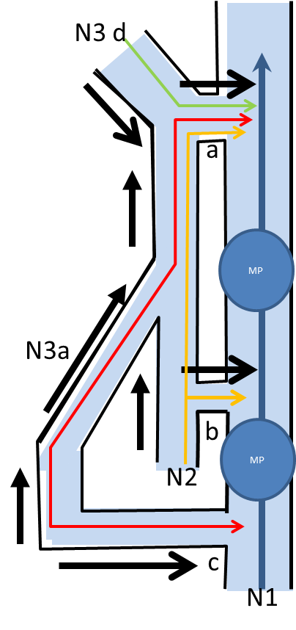
Figure 1. Venous networks hierarchy
N1: deep veins, N2: Saphenous trunks and arches, N3a: ascending GSV tributaries, N3d: descending arches tributaries, a: N2-N1 junction (here SFJ) , b: N2-N1 perforator, c: N3-N1 perforator, MP: muscular pump
Black arrow: Normal content outflow whatever the direction
Red line: normal N3a content outflow and direction, Green line: Normal N3d content and direction, Yellow line: GSV Normal content outflow and direction,Blue line: Deep venous outflow
Normal hierarchal drainage: N3>N2>N1, N3>N1, N3>N2>N1. Here N3a>N2>N1, N3a>N1, N3d>N2>N1. This is a GSV example but can be made of SSV and any N2-N1 or N3-N1 connections.

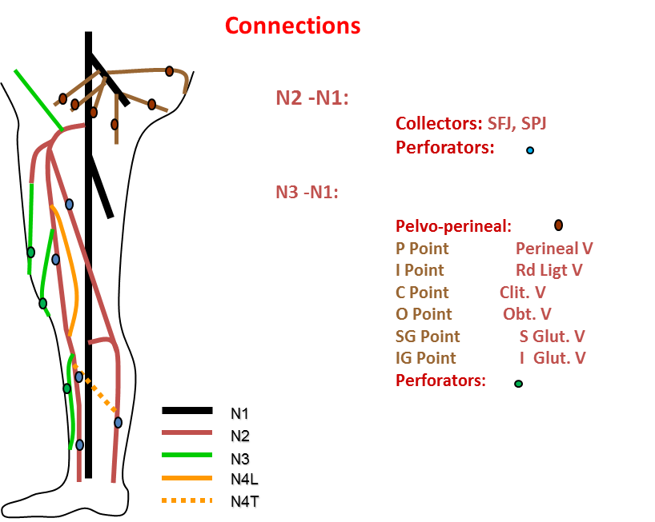

FIG: 2 : Hierarchical venous drainage, network classification and superficial >deep veins connection.
N1: Deep veins, N2: Sub Fascial supericical veins ( GSV, SSV, Giacomini) , N3: Suprafascial superficial veins ( GSV and SSV tributaries and extrasaphenous ),
N4L: N3 longitudinal inter-N2 connecting , N4T: N3 transversal inter-N2 connecting

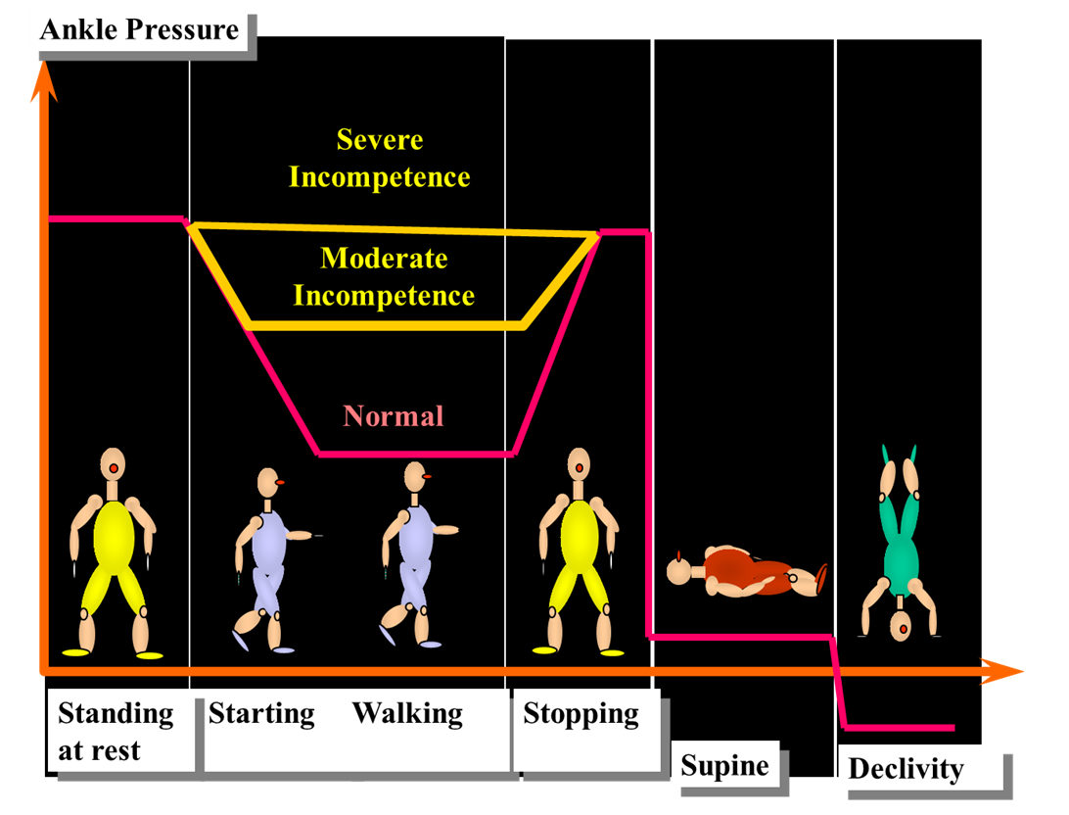

Figure 3: Venous incompetence and gravitational Hydrostatic Pressure
The invasive pressure measurement at the ankle shows no difference between normal and incompetent patients in various positions (standing still, lying down and elevated extremities) while the difference is dramatic during walking-like manoeuvers (decrease down to 30 mmHg in normal when it remains high proportionally to the incompetence in the patient.

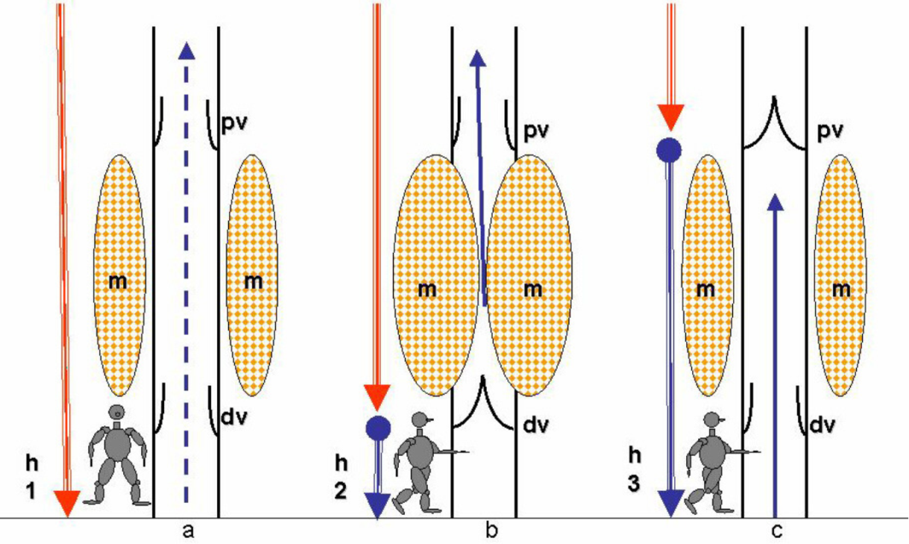
Figure 4. Physiological Dynamic Fractionation of Hydrostatic Pressure DFHP: alternate valve closure reduces hydrostatic pressure HSP by fractioning the height of the venous blood column. Effect of the valvulo-muscular pump VMP of the calf when walking HSP: Hydrostatic pressure. h: Height of venous blood column m: calf VMP muscles. Dv : distal calf VMP valve pv: proximal calf VMP valve. a: Standing immobile. No DFPH :VMP at rest. Open VMP valves. h1: maximum height. b :Walking. DFHP: distal VMP valve closed by VMP systole. h2 : reduced eight at the dv level c: :Walking. DFHP: proximal VMP valve closed by VMP diastole. h3 : reduced eight at the pv level.
From “ Principles of l Venous Hemodynamics. C.Franceschi, P.Zamboni Nova Science Publishers 2009 “

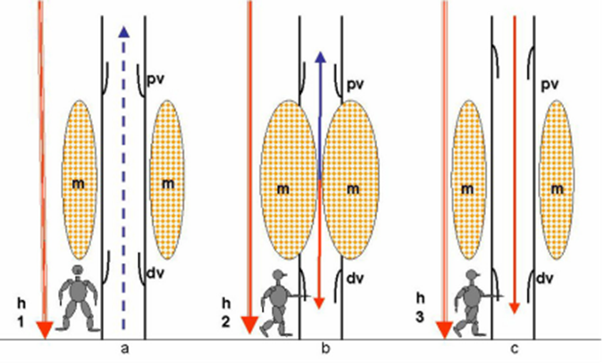

Figure 5. Impaired Dynamic Fractionation of Hydrostatic Pressure DFHP in case of deep venous incompetence DVI. Due to deep valves incompetence, valvulo-muscular pump VMP valve alternate closure is no more waterproof and does not achieve a complete fractionation of the venous blood column. h: Height of venous blood column m: calf VMP muscles. Dv : incompetent distal calf VMP valve pv: incompetent proximal calf VMP valve. a: Standing immobile. No DFPH :VMP at rest. Open VMP valves. h1: maximum height. b :Walking. DFHP: distal VMP valve remains open despite the VMP systole. h2 : no HSP reduction at the dv level c: :Walking. DFHP: proximal VMP valve remains open despite the VMP diastole. h3 : no HSP reduction at the pv level.
From “ Principles of l Venous Hemodynamics. C.Franceschi, P.Zamboni Nova Science Publishers 2009 “

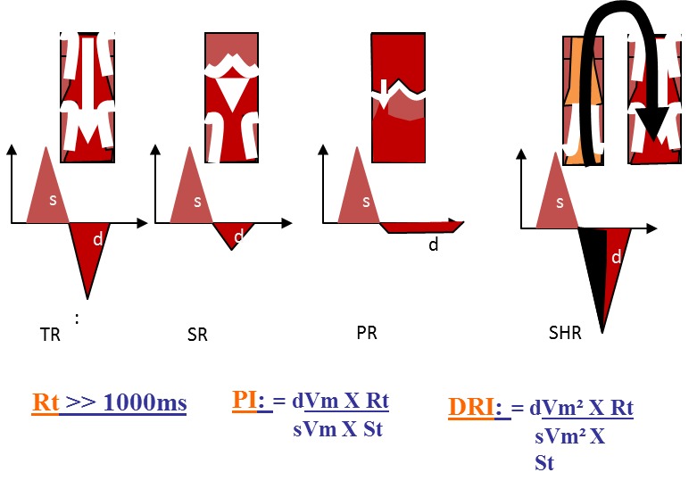

Figure 6: Diastolic Reflux grades in deep and superficiel veins except the perofartors.
Diastolic refluxes: s: MP systole, d: MP diastole
TR: Total reflux, SR: Segmental reflux, PR:Partial reflfux, SHR: Shunt reflux
Rt : diastolic reflux time , s: systolic flow velocty, d: diastolic reflux velocity, flux , dVm: Diastolic reflux mean velocity, sVm: Systolic flow mean velocity.
PI: Psatakis Index, DRI: dynamic reflux index

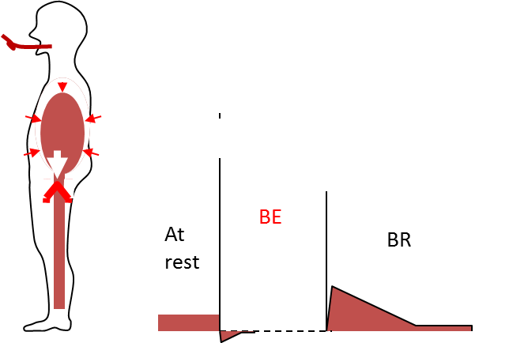

Figure7. Valsalva maneuver : normal ( valsalva negative ) attests valves competence : The blocked expiration (BE) reverses strongly the pressure gradient that induces only a negligible short and small reflux thanks to the correct competence of the underlying valves. At the blockage release (BR) , the pressure gradient turns cardiopetal and induces an ascending flow.

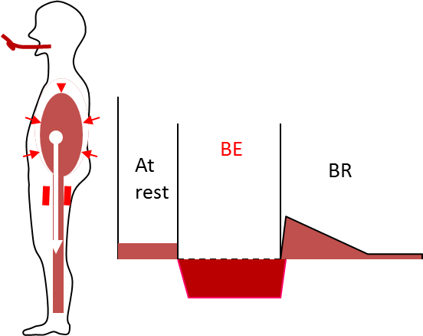

Figure 8. Valsalva maneuver :pathological reflux( valsalva positive )
Valsalva is Positive when valves are Incompetent . Reverse Flow appears when blowing ( Blocked expiration BE ) and at release (BR)

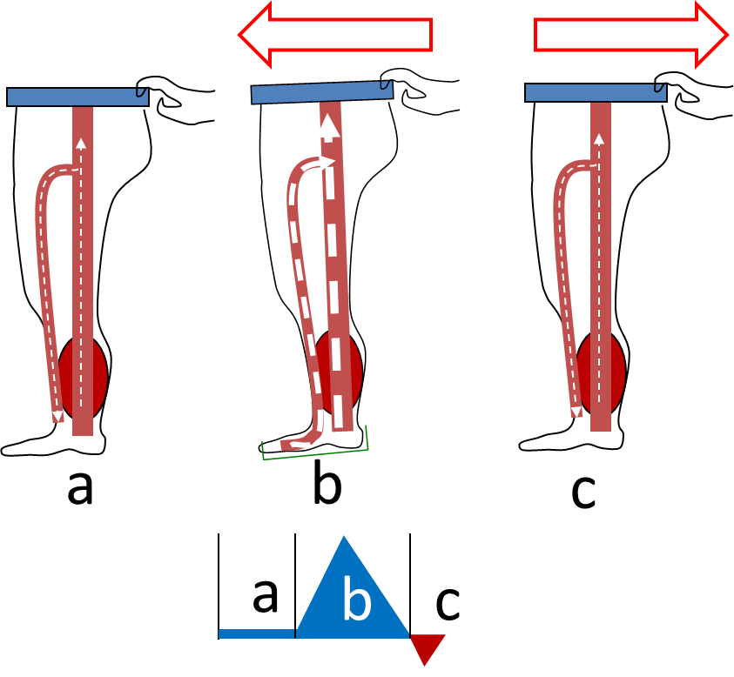
Figure 9 : Paranà maneuver
a: at rest, b: slight push at the waist triggers a proprioceptive reflex calf and sole pumps activation ( systole) followed by c < 1000ms : slight pull (diastole ).

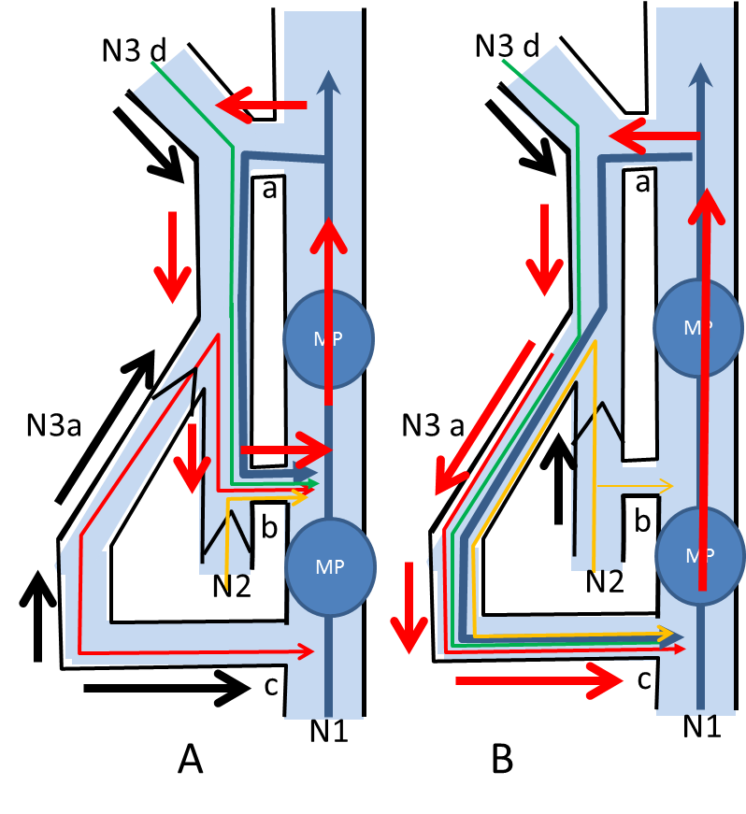

Figure 11: Closed shunt 1 disconnection and shunt 0
N1: deep veins , N2: Saphenous trunks and arches, N3a: ascending tributaries, N3d: arches descending tributaries, a: N2-N1 junction ( here SFJ) , b: N2-N1 perforator.Black arrow: Normal outflow whatever the direction, Red arrow: Overloaded flow whatever the direction. Red line: normal N3a outflow whatever the direction, Green line: Normal N3d outflow the direction, Yellow line: Normal GSV outflow whatever the direction , Blue line: Deep venous outflowA: Closed shunt N1>N2>N1: Reflux VALSALVA POSITIVEEscape point (here SFJ a) . Shunt 1 : N2 overloaded by N1 and re-entry N2-N1 b.
B: N1>N2 disconnection D. GHP column fractioned + N1>N2 overloading suppressed = Shunt0, physiological drainage despite reflux (VALSALVA NEGATIVE)

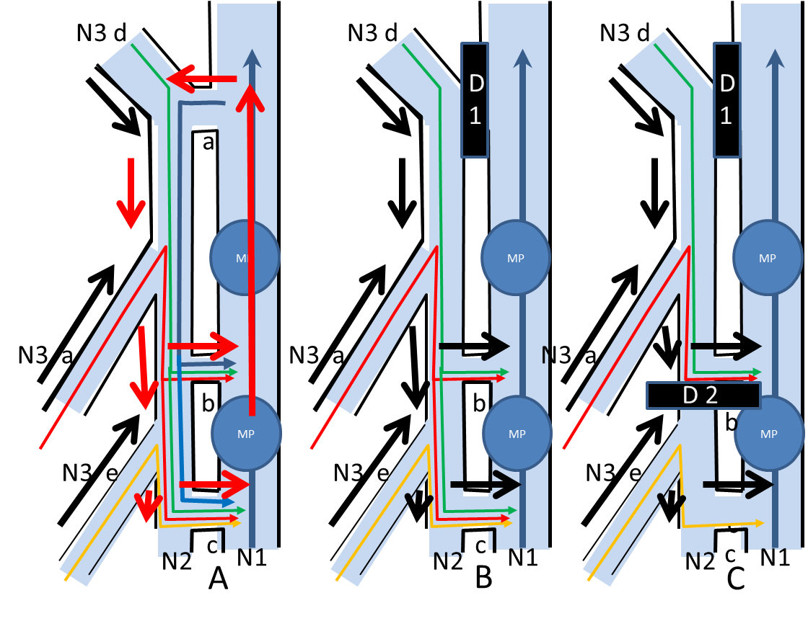

Figure12: Hemodynamic and conservative strategy : an example of 2 staged re-entries Shunt 1.
GHP fractionation( D1) restores the DHPF at the groin level and disconnections suppress the CS N1>N2>N1 no more VALSALVA POSITIVE and drain through 2 staged re-entries b and c. If the is extended all along the trunk, the GHP can be not sufficiently fractioned by D1. In that case, an additional GHP fractioning is implemented just below re-entry b.

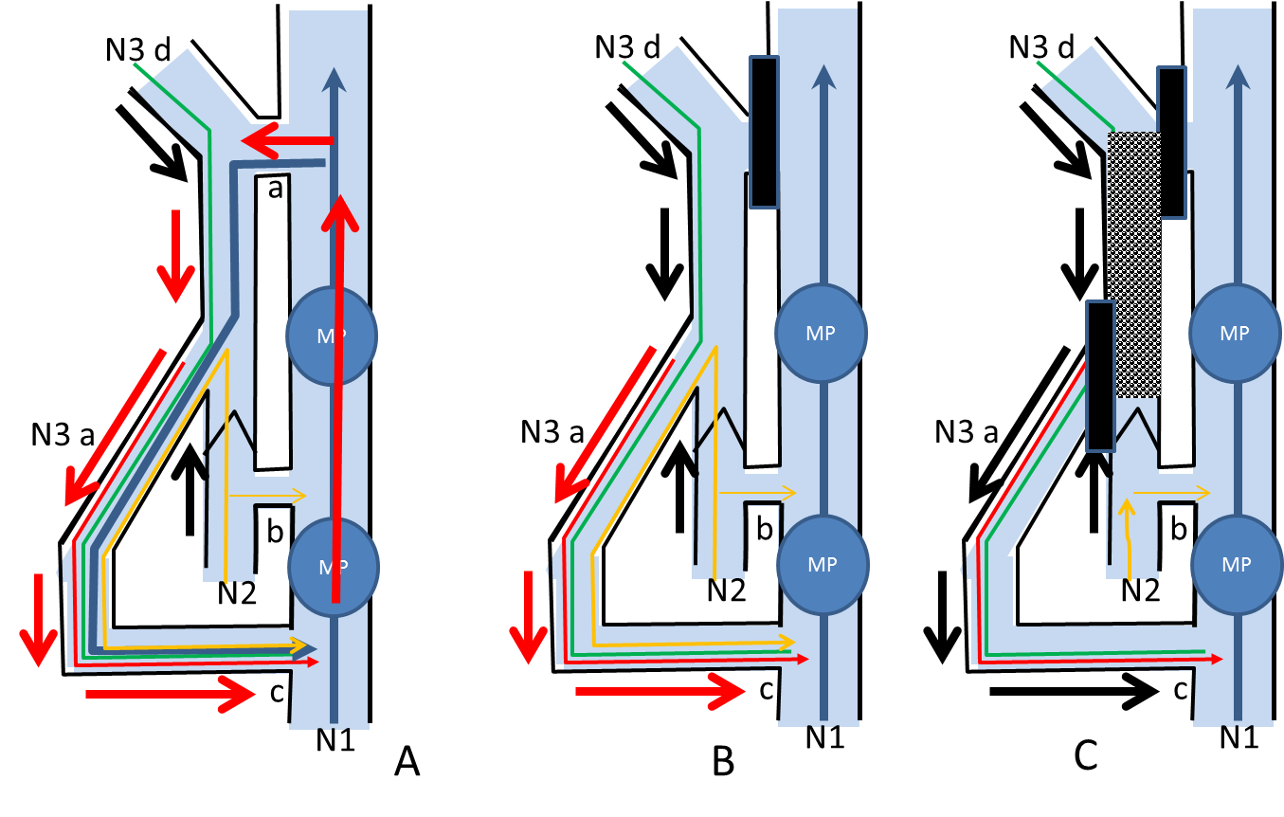
Figure 13. Closed shunt 3 management
N1: deep veins , N2: Saphenous trunks and arches, N3a: ascending tributaries, N3d: arches descending tributaries, a: N2-N1 junction ( here SFJ) , b: N2-N1 perforator, c: N3-N1 perforator, MP: muscular pump, o:obstacle.Black arrow: Normal outflow whatever the direction, Red arrow: Overloaded flow whatever the direction. Red line: normal N3a outflow whatever the direction, Green line: Normal N3d outflow the direction, Yellow line: Normal GSV outflow whatever the direction , Blue line: Deep venous outflow
A: CS type shunt 3: VMP Diastolic phase: N1>N2>N3>N1. . Here N1 overloading SFJ a (escape point) and GSV refluxing down into a refluxing tributary N3 then to antegrade re-entry perforator c then into N1 (VALSALVA POSITIVE).
B: The EP disconnection relieves properly the N1>N2 overload but leaves behind the N2>N3 reflux VALSALVA NEGATIVE.
C: The additional EP N2>N3 disconnection can treat properly N3 but hampers the overlying N2 drainage because of the absence of intermediate re-entry and leads to N2 stasis/thrombosis and by-pass/recanalization N2>N3, because hemodynamically incorrect.
N2>N3 disconnection alone treats N3 and provides the N2 reflux ablation and caliber reduction (suppresses the overload from N1), but leaves behind a too high column that secondarily can leads to a recurrent reflux through a forced N2 intermediate valve or perforator or through a N2>N3 recanalization/by-pass. This procedure is called CHIVA 2 steps where the first step consists in N2>N3 disconnection and the second step in proximal N1>N2 disconnection when the reflux occurs along the follow up. Therefore, a destruction of the competent underlying valves down to a RP perforator is combined at the same time with N1>N2 and N2/N3 disconnection.

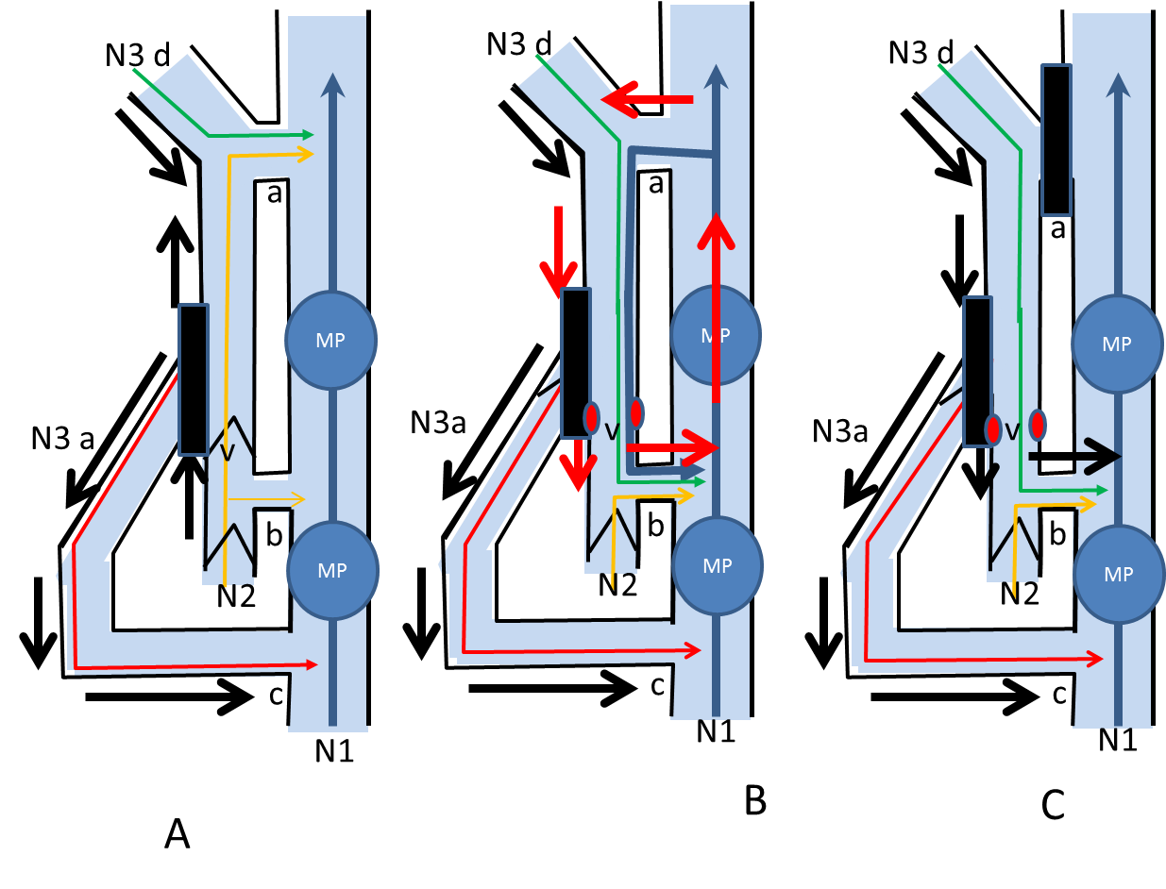
Figure 13bis. Closed shunt 3 management
N1: deep veins , N2: Saphenous trunks and arches, N3a: ascending tributaries, N3d: arches descending tributaries, a: N2-N1 junction ( here SFJ) , b: N2-N1 perforator, c: N3-N1 perforator, MP: muscular pump, o:obstacle.Black arrow: Normal outflow whatever the direction, Red arrow: Overloaded flow whatever the direction. Red line: normal N3a outflow whatever the direction, Green line: Normal N3d outflow the direction, Yellow line: Normal GSV outflow whatever the direction , Blue line: Deep venous outflow
A: 1rst Step of the shunt 3 2steps strategy (CHIVA 2): N2>N3 disconnection
N2>N3 disconnection alone treats N3 and provides the N2 reflux ablation and caliber reduction (suppresses the overload from N1), but leaves behind a too high column that secondarily can lead to a recurrent reflux
B: Recurrent reflux through a forced N2 intermediate valve v down to an underlying perforator b = shunt1 .
C: 2nd Step of the shunt 3 2steps strategy: proximal shunt 1 N1>N2 disconnection = shunt0 when the reflux occurs Therefore, a destruction of the competent underlying valves down to a RP perforator is combined at the same time with N1>N2 and N2/N3 disconnection

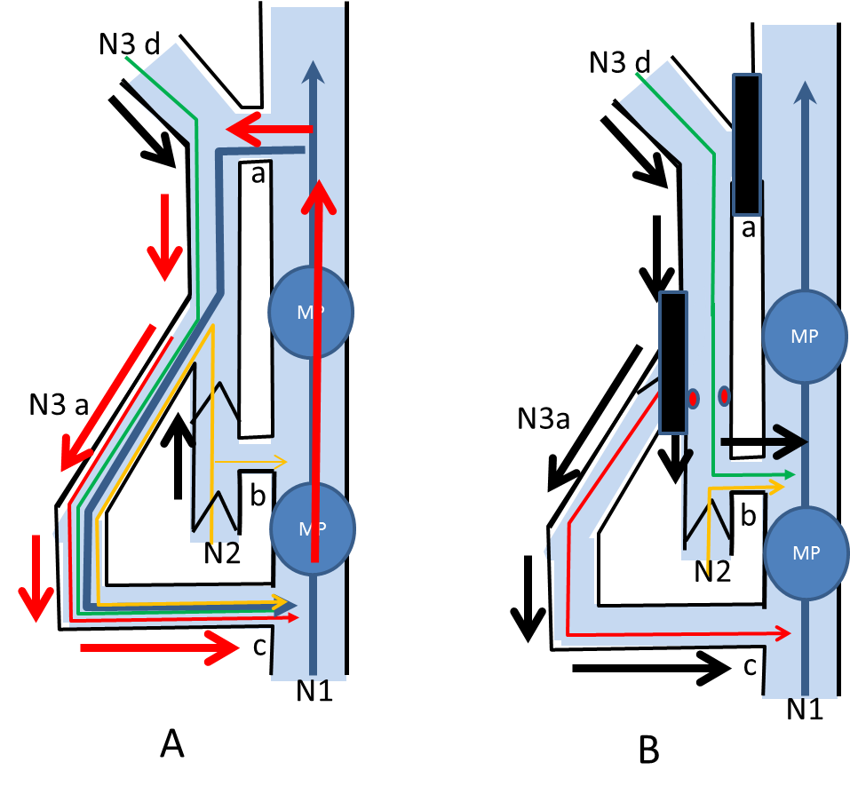
Figure 13 ter. Closed shunt 3 management
N1: deep veins , N2: Saphenous trunks and arches, N3a: ascending tributaries, N3d: arches descending tributaries, a: N2-N1 junction ( here SFJ) , b: N2-N1 perforator, c: N3-N1 perforator, MP: muscular pump, o:obstacle.Black arrow: Normal outflow whatever the direction, Red arrow: Overloaded flow whatever the direction. Red line: normal N3a outflow whatever the direction, Green line: Normal N3d outflow the direction, Yellow line: Normal GSV outflow whatever the direction , Blue line: Deep venous outflow
Shunt 3 One step procedure: valve intra-operative destruction combined at the same time with N1>2 and N2>N3 disconnection + leads to B: Shunt 0 (“physiological” reflux) in treated N3 .

Figure 14. Open deviated shunt (ODS) : Shunt 2. VALSALVA NEGATIVE
N1: deep veins , N2: Saphenous trunks and arches, N3a: ascending tributaries, N3d: arches descending tributaries, a: N2-N1 junction ( here SFJ) , b: N2-N1 perforator, c: N3-N1 perforator, MP: muscular pump, o:obstacle.Black arrow: Normal outflow whatever the direction, Red arrow: Overloaded flow whatever the direction. Red line: normal N3a outflow whatever the direction, Green line: Normal N3d outflow the direction, Yellow line: Normal GSV outflow whatever the direction , Blue line: Deep venous outflow
A: ODS: N3a VALSALVA NEGATIVE ,overloaded by N2 (and normal triburatary N3d . N2 not overloaded (segmental proximal reflux VALSALVA NEGATIVE (SFJ a competent).
B: N2>N3 shunt 2 disconnection d leads to Shunt 0 (“physiological” VALSALVA NEGATIVE and proper territory draining reflux).

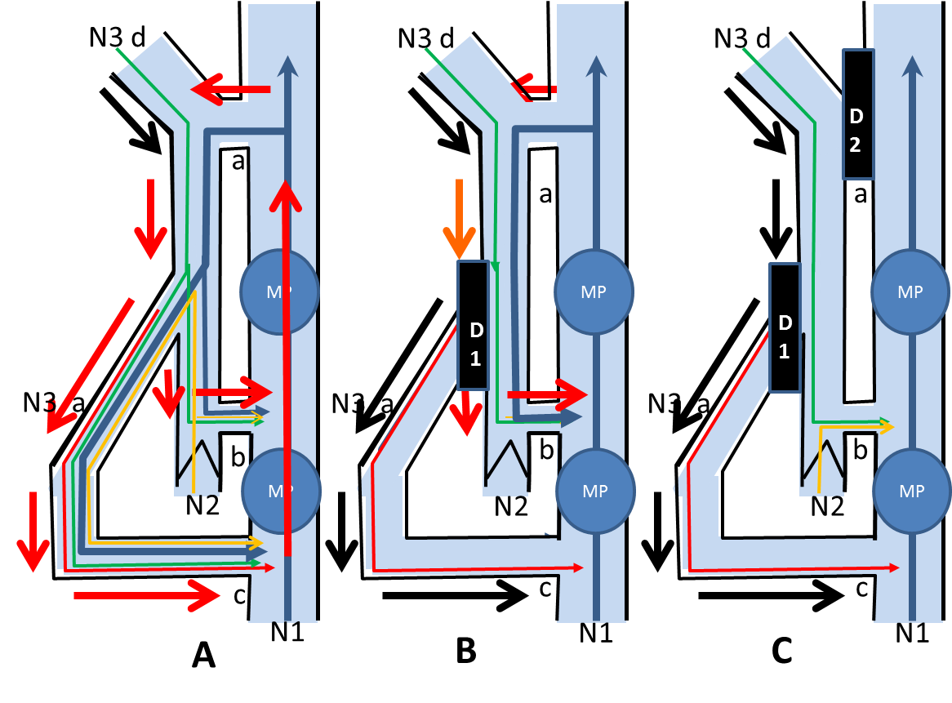

Figure 15. Shunt 1 + Shunt 2 combination
N1: deep veins , N2: Saphenous trunks and arches, N3a: ascending tributaries, N3d: arches descending tributaries, a: N2-N1 junction ( here SFJ) , b: N2-N1 perforator, c: N3-N1 perforator, MP: muscular pump, o:obstacle.Black arrow: Normal outflow whatever the direction, Red arrow: Overloaded flow whatever the direction. Red line: normal N3a outflow whatever the direction, Green line: Normal N3d outflow the direction, Yellow line: Normal GSV outflow whatever the direction , Blue line: Deep venous outflow
A: CS SHUNT1 N1>N2>N1 ( re-entry b) VALSALVA POSITIVE overloaded by N1. ODS : N2>N3a>N1 ( reentry c ). VALSALVA POSITVE ,overloaded by N1 + N2 (and normal tributary N3d) .
B: N2>N3 shunt 2 disconnection (D1) : N3a no more overloaded reflux but overlying GHP column not disconnected neither the Shunt1 ( risk of recurrence).
C: N1>N2 shunt 1 disconnection
D1 + D2 leads to N2 and N3a Shunts 0 (“physiological” VALSALVA NEGATIVE and proper territory draining reflux).

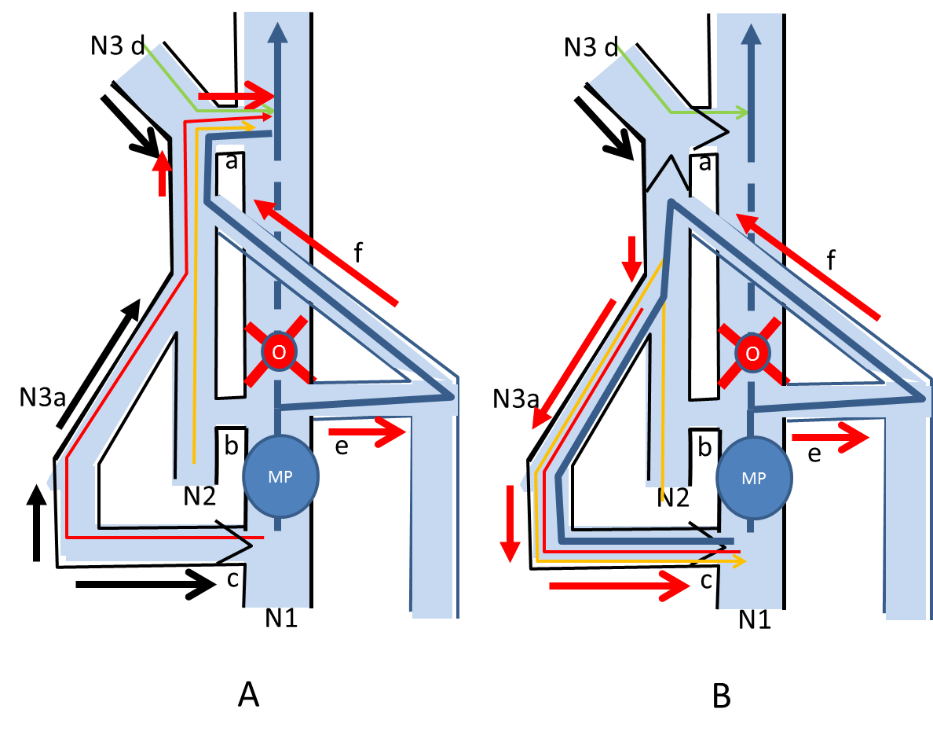

Figure 16. Mixed shunts (MS) : an example of femoral vein obstruction combined with GSV incompetence
N1: deep veins , N2: Saphenous trunks and arches, N3a: ascending tributaries, N3d: arches descending tributaries, a: N2-N1 junction ( here SFJ) , b: N2-N1 perforator, c: N3-N1 perforator, e: SPJ, f: Giacomini vein MP: muscular pump, o:obstacle.Black arrow: Normal outflow whatever the direction, Red arrow: Overloaded flow whatever the direction. Red line: normal N3a outflow whatever the direction, Green line: Normal N3d outflow the direction, Yellow line: Normal GSV outflow whatever is direction , Blue line: Deep venous outflow
A: MP systole: OVS activated. obstacle to the flow (O) (here femoral vein) , Open Vicarious Shunt ( N1> refluxing perforator c > antegrade N2 ( GSV and SFJ) re-entry a but overloaded by N1flow.
B:MP diastole: CS type 3 activated. N1>N2>N3>N1. obstacle to the flow (O) (here iliac vein) , Open Vicarious Shunt ( N1> refluxing SFJ and N3d d overloaded by N1, N3a and N2 ), re-entry >N1 not designed ( can be through the antegrade opposite GS arch and SFJ then into the opposite femoral vein.

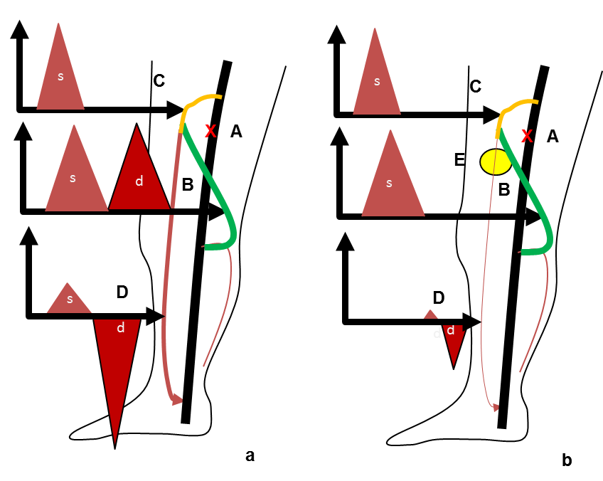

Figure16 bis : Mixed shunt: an example of femoral vein obstruction combined with GSV incompetence
s: systolic flow, d : diastolic flow
a: A: femoral vein hemodynamic obstacle ( not necessarly obstruction) , B: common escape point (SPJ) , SSV arch and Giacomini vin to the OVS and CS, C: OVS branch (GSV arch SFJ ) where it drains into the common femoral vein during the systole. D: Diastolic reflux of the CS branche made of the GSV trunk. CS
b: changes after the GSV trunk disconnected below the arch (E). The CS branch is diconnected and the reflux is shunt 0. The OVS is preserved and continues to by-pass A.

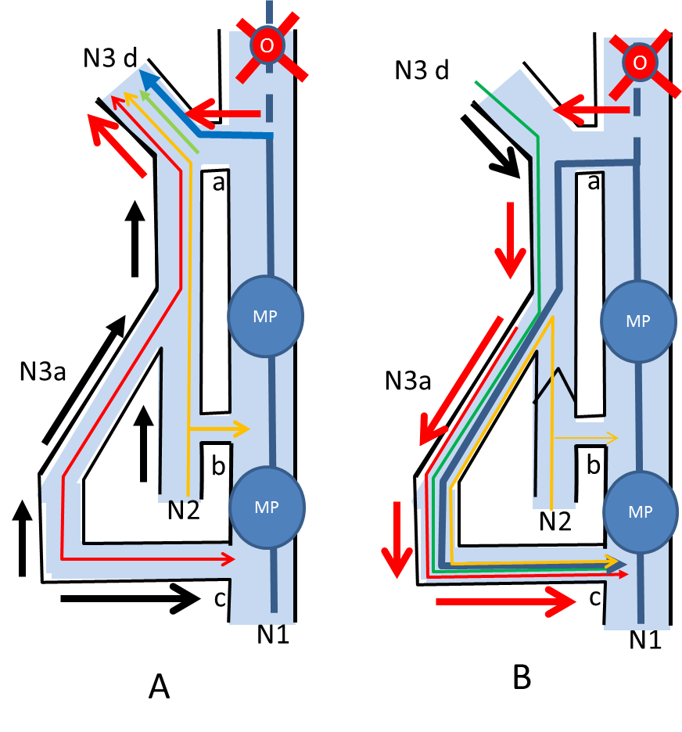
Fig 17 Mixed shunts (MS) : an example of ILIAC vein obstruction combined with GSV incompetence

N1: deep veins , N2: Saphenous trunks and arches, N3a: ascending tributaries, N3d: arches descending tributaries, a: N2-N1 junction ( here SFJ) , b: N2-N1 perforator, c: N3-N1 perforator, MP: muscular pump, o:obstacle.Black arrow: Normal outflow whatever the direction, Red arrow: Overloaded flow whatever the direction. Red line: normal N3a outflow whatever the direction, Green line: Normal N3d outflow the direction, Yellow line: Normal GSV outflow whatever the direction , Blue line: Deep venous outflow
Iliac vein obstacle O. GSV varicosis.
A: MP systole: OVS activated. obstacle to the flow (O) (here iliac vein) , Open Vicarious Shunt ( N1> refluxing SFJ and N3d d overloaded by N1, N3a and N2 ), re-entry >N1 not designed ( can be through the antegrade opposite GS arch and SFJ then into the opposite femoral vein.
B: MP diastole: CS type 3 activated. N1>N2>N3>N1. . Here N1 overloading SFJ a (escape point) > Arch and GSV refluxing down into a refluxing tributary N3 then to antegrade re-entry perforator c then into N1
In MS, OVS and CS have the same escape point (here SFJ) and a common proximal refluxing pathway (here the arch) but their distal segment and re-entry are different : N3d up to the opposite femoral vein for the OVS and N2>N3 down to perforator c for CS.

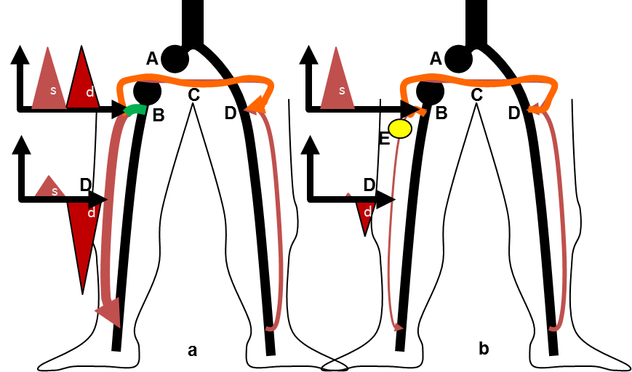

Figure17 bis: Mixed shunt: an example of Iliac veine obstruction combined with GSV incompetence
s: systolic flow, d : diastolic flow
a: A: Right iliac vein obstruction , B: common escape point (SFJ) and GSV arch to the OVS and CS, C: OVS branch ( Spontaneous palma) to the opposite GSV arch SFJ D where it drains into the common femoral vein during the systole. D: Diastolic reflux of the CS branche made of the GSV trunk. CS
b: changes after the GSV trunk disconnected below the arch (E). The CS branch is diconnected and the reflux is shunt 0. The OVS is preserved and continues to by-pass A.

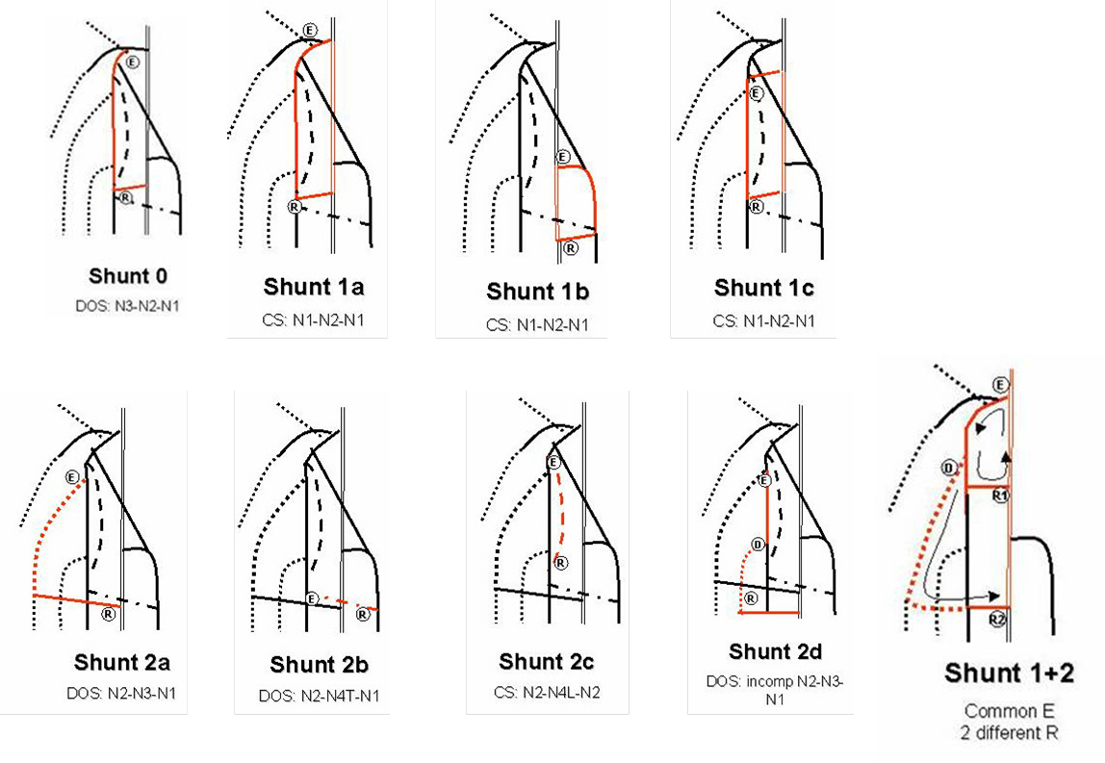
FIG 18: Teupitz Shunts classification : shunts 0, 2 , 3 and 1+2

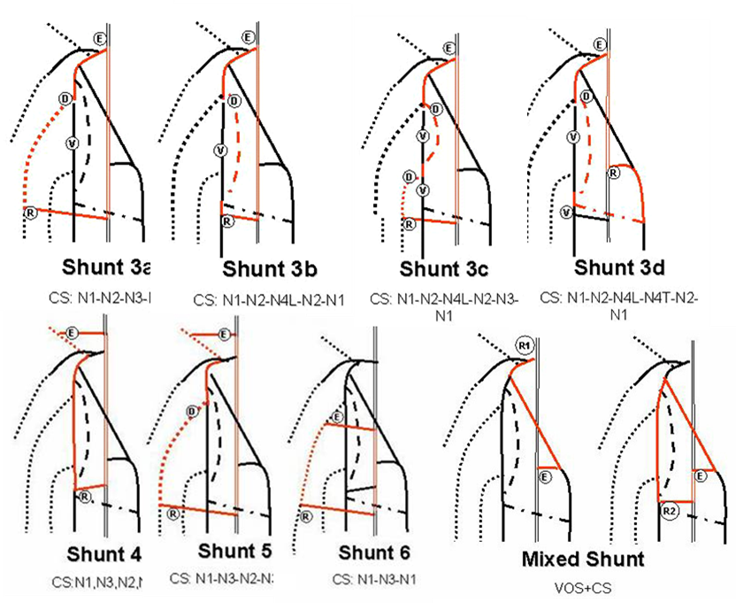
FIG 19: Teupitz Shunts classification : shunts 3,4,5,6 and mixed shunts

