Chap 6. The hemodynamic basis of diagnostic tests in chronic venous disease a

Write: Greg Moneta & Alun Davies
Assist to write: Attilio Cavezzi, Pier Luigi Antignani, Claude Franceschi, George
Gerulakos, Nicos Labropoulos, Erika Mendoza, Ken Myers, Alfred
Obermayer, Carl-Erik Slagsvold, Massimo Cappelli, Tomo Ogawa
Review: Seshadri Raju
Coordinate: BB Lee
a. Color duplex ultrasound (Attilio Cavezzi) (Claude Franceschi) (Erika Mendoza)
(Massimo Cappelli)
b. Laser Doppler
c. Plethysmography ( i. Strain gauge; ii. Air; iii. Photo )
d. Venography
i. Contrast (Ascending, descending: Kistner’s grades of severity)
ii. IVUS
e. CTV (Tomo Ogawa)
f. MRV(Tomo Ogawa)

Measurements of volume, pressure, flow, resistance, velocity, microcirculation, venoarteriolar reflex. Measurement of edema. Hemodynamic measurements that predict the development of skin changes and ulceration.
Changes in above parameters in the presence of different clinical conditions:

Reflux: superficial venous reflux, perforating vein incompetence, deep venous reflux, gonadal vein and pelvic vein reflux, venous malformations.
Obstruction: Popliteal, common femoral, superficial femoral, iliac
Reflux and obstruction: Combination of reflux and obstruction in the same limb
Phlebolymphedema: Combined CVD and lymphatic insufficiency

The hemodynamic basis of diagnostic tests in chronic venous disease: Color duplex ultrasound (CDU)
Ultrasounds, from the pencil CW that allowed for the first time, almost 40 years ago, a live, non-invasive and repeatable blood flow velocity and direction measurement , to today’s CDU that shows at the same time the flow ( color and BFlow) and the vessels (Bmode). They provided a not yet overcome tool capable to improve both hemodynamics knowledge and diagnosis of the venous disease.
The velocity and direction of the flow are precious hemodynamics data because related to the variations of the pressure gradient (PG) . The variations of the venous caliber is correlated with the variations of the trans-mural pressure (TMP) and the wall compliance. According to the location of the obstructions and incompetent valves, specific patterns of each pathologic hemodynamic configuration can be classified in various patterns. Therefore, an hemodynamic classification has been proposed, consisting in Open vicarious shunts (OVS) Closed shunts (CS) and Open deviated shunts (ODS ) (see Chapter 5 , 2).
The deep and superficial veins are, mostly, with the CDU checkable from the foot to the vena cava. The evaluation will be accurate and detailed vein in proportion, not only the technology of the device, but especially of the venous hemodynamics model that defined the protocol implemented. It is obvious that the quality of the CDU protocol will improve the treatment strategy. [1,2, 3]
First of all, we will expose the mechanism of the various tests, then their interpretation from normal to various abnormal hemodynamics configurations.

- CDU and hemodynamics tests
- Respiration.
121- Normally, the spontaneous respiration activates the respiratory pump (RP) that aspires the underlying venous blood whose the cardiopete flow varies according to breathing depth and strength. Its incidence is maximal proximally and decreases distally. The flow variation induced by breathing changes with the posture. In upright position, this flow is cardiopetal lasts only the inspiratory period, whilst in supine position, it lasts all the respiratory cycle, beginning with the expiration and ending with the inspiration with a pic at the end of the expiration.[4] (FIG 1)
122- In case of venous obstacle interposed between a patent vein and the RP , the amplitude of the respiratory variation of the flow decreases (amortizes) and the minimum velocity increases in proportion to the resistance of the obstacle, particularly demonstrative at the groin in case of iliac and or cava vein obstruction.
123- The Valsalva Maneuver (VM) is a blocked expiration ( closed glottis) that reproduces the same phenomenon that occurs during defecation , delivery and weight bearing. This maneuver compresses the right atrium and the cava vein so that it reverses the cardiopetal venous pressure gradient (PG) in cardiofufgal. This effect is proportional to the strength and the speed of the maneuver, which is difficult to standardize and measure unless the patients blow into a gauge. We suggest , in daily practice, to blow into a blocked straw, intending to unblock it, in order to perform an easy and reproducible VM. For a better achievement, VM should be quickly performed after a deep inspiration to develop a fast and strong retrograde gradient. The blocked expiration (BE) is followed by a release (BR). In normal individuals, the BE reverses the PG, dilates the veins , closes the valve leaflets and can produce a flow, but short and low. BR restores the cardiopetal PG and triggers a consecutive antegrade flow (Fig 2). The correct VM performance is attested by the onset of this BR cardiopetal flow. In case of valve incompetence, BE triggers a pathologic flow, i.e longer and faster than below the competent valves (Fig 3). This pathological flow is always reversed in the incompetent escape/leak points ( perforators , SFJ and SPJ). But never forget that it can produce also a “paradoxically” antegrade flow in some veins. It’s the case for the descending tributaries of the GSV when fed by an upper incompetent perforator and where a pathological BE antegrade flow precedes a physiological identically oriented BR flow (Fig 4).
The rate of the BE flow depends not only on the BE strength but also on the capability of the underlying venous bed to receive it dilating more ( compliance/extra-venous pressure/ rate of previous filling). Therefore, VM will be more demonstrative when the distal venous volume is previously reduced by some leg movements ( muscular pump action in upright position). On the other hand, if competent valves are interposed between the RP and the incompetent veins, the latter will not show a relevant reflux during BE. This is particularly obvious for the incompetent superficial veins ( N2,N3 ) when their upper perforators and/or SFJ-SPJ are competent.
- Muscular pump (MP) activation
MP aspires the distal blood when relaxing (diastole) and propels it upwards when contracting (systole) thanks to the upstream and downstream valves that alternately close and open allowing at the same time a unidirectional cardioptetal flow and the Gravitational Hydrostatic Pressure Fractioning (HPDF) [3,5]. In upright position, the HPDF achieves below the knee a pressure lower than above ,i.e a cardiofugal PG that causes a cardiofugal flow ( superficial and/or deep) , retrograde (i.e reflux in GSV) or “paradoxically” antegrade ( i.e GSV descending tributaries draining pelvic leaks) (Fig 4).
131- MP tests are designed for testing the venous flow (rate and direction) during the systolic and diastolic phases of the MP, particularly the calf pump. So far, the theoretical ideal test conditions ( walking, running) is not available in daily practice. Some maneuvers try to resemble these conditions.
Paranà maneuver consists of a slight push-pull at the waist of the patient in order to trigger a proprioceptive isometric reflex contraction of the calf (Fig 5) . Oscillation maneuver consists of accompanying a forward slight oscillation of the body with a hand on the patient’s waist. Wundsdorf maneuver consist of a toes voluntary flexion . Squeezing can be manual or performed with a cuff inflation. It is further from the physiological ideal condition than the latter because it doesn’t simulate properly the MP behavior . Indeed, it may not activate the same muscles/veins ( it may compresses veins not physiologically squeezed by the muscles , particularly the superficial veins). On an other hand, the calf squeezing is not always properly feasible ( pain, hypodermitis, skin changes, ulcer, big calf). However, it can be useful in supine and sitting position.
132- MP diastolic reflux grading
A reliable grading of the MP diastolic reflux would provide a tool improving the diagnosis accuracy but mostly rating the hemodynamic outcomes of the treatments. However the hemodynamic pathological significance of the reflux should be interpreted according its cause. Indeed, a reflux ( retrograde according to the valves direction) is not necessarily pathological in terms of hemodynamics ( excess of TMP) and an antegrade flow is not necessarily hemodynamically physiological . The first one can be “physiologic” if not overloaded ( draining only its proper territory) and the second one can be “pathological” if draining more than its proper territory. So far, various methods are proposed according to the time, amount and velocity of the reflux and the systolic/diastolic reflux ratio :
1321- Refluxing time (RT): “The cutoff value for reflux in the superficial and deep calf veins is greater than 500 ms. However, the reflux cutoff value for the femoropopliteal veins should be greater than 1000 ms. Outward flow in the perforating veins should be considered abnormal at greater than 350 ms. Reflux testing should be performed with the patient standing” ([6]
1322- Reflux ratio:
Psatakis proposed a ratio ( Psatakis Index PI) amount of diastolic reflux/ amount of systolic antegrade flow. RT doesn’t take in account the amount of reflux and IP doesn’t take in account the reflux time. The Reflux Dynamic Index (RDI) where the ratio is ((mean reflux velocity)² X reflux time))/ ((mean systolic velocity)² X systolic time)) takes in account both reflux time and amount. The reflux can be “total” when all of the valves above the measured reflux are totally absent or incompetent, so that the time and peak of the reflux are almost symmetrical to the systolic outflow ( PI = RDI=1) . It can be “partial” when valves are not totally incompetent and the reflux is slowed down through the valve by a small leak point so that the reflux time is longer and the velocity lower than the systolic outflow ( PI=1 and RDI <1 PI). It can be “segmental” when the valves overlying the incompetent one store part of the systolic outflow so that only a small part of the systolic outflow refluxes and the reflux time is almost equal to the systolic but its peak is lower( PI and RDI ). When the reflux amont is superior to the systolic PI=1 and RDI <1 PI. The reason is an open deviated flow (ODS) or Closed shunt (CS) (see below) [7]
. Fig 6.
133- Antegrade reflux
The systole increases the cardiopetal PG and can produce retrograde flow through the connections ( SFJ, SPJ and perforators) so called escape points of open vicarious shunts (OVS) between the superficial and deep veins. See below.
134- Venous Pressure measurement: Bartolo
Bartolo proposed a Doppler pressure measurement of the posterior tibial vein at the ankle similarly to the arterial, i.e with a Pencil CW Doppler and a cuff. The cuff must be deflated promptly in order to increase not artifactually the venous pressure ( obstacle to the venous flow increases the residual pressure (RP) (See chap 5 ,2). Considering that the cuff must press also the surrounding tissues, any excessive tissue resistance ( i.e hypodermitis ) will overvalue the venous pressure. On an other hand, ulcer/pain can be forbid this measurement. The supine position must be horizontal in order to measure selectively the RP and not the gravitational Hydrostatic Pressure (GHP. This non-invasive method is very useful in order to assess the relative responsibility of RP excess ( edema, trophic disorders, ulcer) in case of combination with valve incompetence and/or lymphatic disease.) Fig 7 (ref)
135- Venous caliber measurement [Zamboni ref]
The venous caliber varies with the TMP and the compliance. Its value can be taken in account to assess roughly the disease grade. Its postural variation can approach a pressure assessment ( REF ZAMBO) . Its reduction after an hemodynamic treatment reflects the decrease of flow/pressure overload [8] (Zamboni).

2- CDU and hemodynamic changes
- Normal individual.
Venous Hemodynamics changes can be found in asymptomatic individuals. On the other hand, the CDU examination can result normal in venous symptomatic patients ( pain, edema, skin changes). This is the case in obese individuals, people working in still upright position and hot environment, sportsmen, and patients with cardiac insufficiency. Therefore, a normal CDU examination doesn’t mean “no venous drainage impairment” because the impairment can be due to these “functional” causes.
- Venous obstruction.
Obstruction increases the resistance to the flow. It results in increase of the RP component of the intravenous pressure (IVP) and consequently of the trans-mural pressure (TMP). The resistance depends on its location and its extension and decreases in proportion of the number and caliber of the collateral pathways/by-passes (open vicarious shunts OVS). OVS is defined as a shunt by-passing an obstacle , fed by the distal blood through an escape point and connecting proximally the main stream through a re-entry point.
221- CDU mode B imaging can show the obstruction and its cause ( thrombosis, compression, hypoplasia, stenosis) , the dilated underlying veins and the overloaded collateral veins. CDU color/power Doppler and B flow imaging can visualize the stenotic lumen and the by-passing flows.
222- PW and CW Doppler measure the direction and velocity of the flow upstream, in the collaterals and in the stenosis. The respiratory modulation distally to the obstruction is impaired in proportion to the resistance, thus to the RP. The compents of the OVS are assess at rest and by the squeezing and Paranà maneuvers. The Doppler pressure measurement at the ankle is performed in horizontal supine position in order to select the RP value, independently of the GHP that is null in this posture. The normal values are around 20 mmHg. ( Fig 7)
Supine position is preferable for the obstruction assessment. It allows the imaging of the structural changes of the Cava , gonadal , iliac and lower limbs veins. CW and PW Doppler assess the flow velocity upstream and in the collaterals and its variations according to the respiration( TP) and distal squeezing. Upright position is necessary to assess the collateral flows activated by the MP systole.
223- Cava vein obstruction can be by-passed by several OVS. The most frequent are the retrograde hypogastric vein and the OVS made successively of the SFJ escape point , the retrograde GSV arch then its retrograde upper GSV tributaries ( superficial epigastric, lateral circonflex iliac, lateral pudendal ) that connect to the superior cava vein tributaries through the thoracic superficial veins reentry-points.
224- Common Iliac vein obstruction can be by-passed by the same ways as for the cava vein obstruction.
The external iliac and femoral veins above the SFJ can be bypassed by the deep tributaries ( MP systole refluxing obturator and/or the deep femoral vein up to the hypogasrtic vein). When by-passed by the superficial veins, the OVS can be mostly made successively of the systole refluxing SFJ escape point, the retrograde GSV arch, the retrograde upper GSV tributaries ( superficial epigastric, lateral circonflex iliac, lateral pudendal ), then the abdominal superficial veins and/or the anastomotic veins that connects to the opposite femoral vein through the antegrade opposite arch and SFJ. The latter is sometimes called “spontaneous Palma”. (Fig 8A)
225- The femoral vein obstruction below its junction with the femoral vein junction can be by-passed by a femoral collateral and/or the deep femoral vein, and/or the GSV flow fed by a distal escape point perforator and/or by the Giacomini vein fed by the SPJ escape point.
226- The popliteal vein obstruction can be passed by the same path ways. (Fig 8B)
227- Below the knee, the leg veins obstruction can be by-passed by their deep collaterals and exceptionally by the superficial veins.
- Valve incompetence
The valve incompetence can be seen in Bmode imaging, but only when the leaflets are visible and reverse during the tests. The amount depends on the GP inversion rate , thus proportionally the power , strength and velocity of the tests performance. The grade can be assessed by the RT, PI and/or DRI. Color Doppler shows the changes of the flow direction but not its grade. This is important to know because , particularly when the PRF is low, the physiological short reflux can be mixed up with a pathological. For this reason, any Color Doppler reflux must be checked by a Pw/Cw Doppler.

231- Lower limbs.
The venous network is made of the deep network (N1) where the superficial veins drain hierarchically through the SFJ, SPJ and tributaries. Saphenous tributaries and other suprafacial veins are named network 3 (N3), and subfascial superficial veins ( Saphenous trunks and Giacomini vein) are named network 2 (N2). The physiological drainage hierarchy is N3>N2 >N1 or N3>N1 [3,9, 10,11] . FIG 9
(First of all, we must outline that a segmental diastolic reflux doesn’t mean a valve incompetence. Two frequent examples are demonstrative. The first one is when a popliteal reflux combined with a SSV reflux is ablated by the disconnection of a combined SPJ . The second one is a segmental GSV reflux drained by an interposed inward perforator ( Shunt 0) or ablated by the disconnection of an incompetent tributary ( Open deviated shunt type 2 ). On an other hand, a destroyed valve (incompetent) doesn’t reflux if the underlying valve is competent and there is no intermediate outflow. This is demonstrated when the GSV and SFJ reflux ablation by the incompetent tributary disconnection in CS type (3). These examples are detailed below.
Beside the OVS, the closed shunts (CS) are made of a venous pathway overloaded during the MP diastole by a competent collateral with witch it is connected by a proximal connection named escape point and a distal connection named re-entry point .Their flow runs in diastolic closed circuit , N1>N2>N3>N1. The open deviated shunts (ODS) are venous pathways that differ from CS by the absence of closed circuit effect because the re-entering diastolic flow doesn’t turn back through the escape point: N2>N3>N1 instead of N1>N2>N3>N1 (ref). Both are overloaded in a reverse hierarchical way by abnormally feeding others veins. Shunt 0 is a refluxing vein that respects the draining hierarchy and drains its own territory (N2>N1 or N3>N1) as explained above and represented by the residual reflux after SFJ (N1>N2) disconnection in closed shunt of the GSV trunk N2 re-entering through a distal trunk perforator(N2>N1) [8].
. The mixed shunts are made of a combination of CS and OVS that share the same escape point and part of their downstream venous extension. In order to define the most frequent patterns and use them to clarify the items for venous disease survey and therapeutic controls, an exhaustive classification of shunts has been proposed by the Teupitz meeting of the European CHIVA association (Fig 10, 11,12).
2311- Deep venous incompetence in lower limbs.
The deep veins are directly checked in upright position from the ankle up the groin while the iliac incompetence is assessed indirectly by reflux at the proximal the common femoral vein induced by the VM. The incompetence grade is assessed by various tests and measured according to the elected measurement method described above.
An exhaustive assessment of N1 can strongly help for an efficient therapeutic strategy: the best location for valve repair and/or transplant, prosthetic valve or deep venous shunts disconnection. For example, a double femoral vein, with an incompetent collateral A and a competent collateral B forms a deep closed shunt , the A disconnection lead to the reflux ablation while the draining outflow remains possible through the competent B. Other configurations as CS made of deep and femoral vein, double popliteal vein, leg deep veins are possible. After CS disconnection or valve reconstruction , no more reflux will be recorded above the site of the procedure (popliteal vein) , while a reflux remains below but relieved from total to segmental(Fig 13)
2312-Superficial venous incompetence
An incompetent valve will not cause any reflux if there is no refluxing tributary or any entering perforator interposed with an underlying competent valve. On the other hand a reflux can occur between two competent valves in an entering perforator or a connection with a refluxing tributary is interposed.
Two different superficial conditions of venous incompetence must be pointed out: with and without competent N2-N1 and N3-N1 connections ( SFJ, SPJ, perforators).
23121-Superficial venous incompetence with competent connections with deep veins.
The superficial>deep connections are competent when the incompetent superficial veins reflux during the MP diastolic activation ( paranà, oscillation, wundsdorf) down to the deep veins (N1) through inward perforators (re-entry N2>N1, or N3>N1 or N2>N3>N1) BUT DO NOT REFLUX during the VM. i.e. no flow ( or neglectable) at VB phase , and no reflux is induced in the proximal perforator nor the SFJ/SPJ. These shunts are named Open Deviated Shunts (ODS) because during the MP diastole the PG is favorable to a flow downwards to the calf pump, so deviating the flow from the competent tributaries. Such a case is frequent when a diastolic reflux along the GSV is not induced by the VM because the SFJ valve is competent. So the superficial veins ( N2,N3) are not overloaded by the deep veins (N1). When the saphenous trunk (N2) reflux is Valsalva negative, the re-entry perforator (s) can be located on the same saphenous trunk (shunt 0) or distant from the trunk were it connects through a tributary (N3) (Shunt 2) Fig 1O, 11. The first case is a “normal” GSV flow content fed by a “physiological” flow despite its direction because it drains hierarchically well into the deep veins (N2>N1) despite through a distal perforator instead of the SFJ. In the second case, N2 still drains its “normal” content to N1 but indirectly through a refluxing tributary (N2>N3 ) which it overloads and finally an inward re-entry ( N2>N3>N1 contrary to the physiological hierarchy N3>N2>N1). The N3 overload is proportional to the length of the overlying refluxing segment of the GSV trunk , sometimes including the so called pre-terminal valve because it is the last one the terminal valve at the SFJ. N3-N2 disconnection will restore an antegrade flow in the GSV trunk and ablate the overloaded reflux in the incompetent tributary (N3) that drains its flow henceforth physiological despite retrograde. Distinction between the OVS shunt 2 and CS shunt 3 where the SFJ is incompetent could be crucial for deciding the best therapeutic strategy and reduce the rate of recurrence [12] . Sometimes, a reflux at the SFJ terminal valve can be triggered by the VM (Valsalva positive) and NOT by the MP dynamic tests diastole because the valve competence is forced by the PG produced by VM is higher ( stronger) VB PG than which of the MP test. This phenomenon is called by Cappelli “ terminal valve dissociation” .
23122- Superficial venous incompetence with incompetent connections with deep veins
Superficial venous incompetence with incompetence of one or more N2-N1 and N3-N1 escape points ( SFJ, SPJ, perforators, pelvo-perineal escape points) show a diastolic flow at the dynamic tests ( paranà, oscillation, wundsdorf) and squeezing . Here, contrary to the ODS, Valsalva is positive, i.e. relevant flow induced by VM . This finding demonstrates the presence of one or more closed shunts (CS) (FIG 10,11, 12). The escape point from N1 is searched by following the refluxing veins up to one or more escape points . Then the refluxing veins are followed down to one or more re-entries (diastolic inward perforators) and additional underlying escape points (PM diastole and VM refluxing perforators). According to the location of the escape points and the pathway of reflux through N2 and N3 successive segments , a topographic and hemodynamic “mapping” can be reported. A classification of these various configurations have been proposed (CF) ( fig 10,11,12). The theoretical potential escape points as described by the anatomists are numerous and manifold but, in daily practice, only some of them are sufficiently relevant to be hemodynamically and anatomically detectable by CDU. They are located from the popliteal fossa up to the inguinal duct and buttock. They can be, from bottom to top: the posterior tibial and medial gastrocnemial perforators, the SPJ, the mid-thigh femoral perforator (Dodd), the SFJ, the Perineal escape Point ( P Point fed by the internal pudendal vein connecting down the refluxing perineal veins ), the inguinal escape point ( IPoint fed by the ligt Teres vein through the inguinal duct, clitoiridian point (C Point fed the bulbo-cavernous vein ) both connecting down to one or more GSV descending tributaries), and the superior and inferior gluteal escape points ( SGP and IGP fed by the correspondent superior and inferior gluteal veins and connecting most of the time with the sciatic vein then a superficial vein or to the marginal vein in case of venous malformation( ref CF). An important feature of the descending tributaries of the GSV must be underlined. Normal descending flow, particularly in the upper GSV tributaries , is not differentiated from a descending overloaded CS by the MP maneuvers but ONLY BY THE VM test which is VM negative in normal cases and positive in pelvo-perineal CS (FIG4).
2314-Perforating veins incompetence
So far, all perforators were seen mysterious, controversial and usually suspected and sentenced as the cause of varices, ulcers and recurrence. For this prejudice, still today, many doctors search all the perforators in order to ablate them. However, this assumption is hemodynamically contradicted the past invasive studies [13,14] and today’s daily CDU data [ 3,5,10]

that show clearly a different and more diversified behavior of the perforators . Particularly, they show that the most of the large perforators depicted by CDU below the knee are just enlarged by the diastolic inflow re-entries in proportion to the amount of the additional flow and pressure spilling through one or more overlying escape points. Two combined conditions must necessarily exist to produce a perforator reflux because the valve incompetence is necessary but not sufficient in absence of PG reverse and vice versa. In addition, The more the angle formed by the incompetent perforator with the deep flow direction is open, easier the reflux ( see pitot’s tubes chap 5 2).CDU can show clearly inflow and outflow through the perforators thanks to VM , dynamic MP and squeezing tests, and by the way allows to understand their significance according the normal and abnormal functioning of the deep and/or superficial veins .
23141-Continuously refluxing perforators is most of the time due to a deep venous obstruction and the perforator plays the role of an escape point of a superficial natural by-pass (OVS) and increases with the systolic phase of the MP action (Paranà) and squeezing.(see above obstruction)
23142-Systolic reflux can occur when a deep obstacle turns hemodynamically significant as the Mp systolic flow/pressure and flow increase overflows into the incompetent perforator. Therefore, some deep obstacles, despite not evident, but more resistant (when overloaded) than the superficial vein can be responsible for a reflux through an incompetent perforator.
23143- MP diastolic or Valsalva reflux occurs most of the time through the incompetent perforators , at the level or above the popliteal fossa , the underlying perforators playing the role of re-entry. The reason is the high inverted PG produced by the powerful calf pump diastole on either side of the knee. The reflux of the potentially various incompetent perforators ( escape points) (see above superficial venous incompetence ) is exhibited only are by both VM and diastolic MP dynamic and squeezing tests. In case of multiple incompetent perforators, some of them doesn’t show any reflux when hemodynamically more resistant than the others (competitive reflux) and they can ”surprisingly” be activated by the ablation of the competitive ones.
When the systolic reflux is smaller the diastolic inflow, the systolic reflux is called “compensated” and the pathologic incidence is considered not significant.
241-Combination of deep and superficial venous incompetence in the same limb.
Both superficial and deep venous incompetence can be responsible for TMP excess and its clinical consequences and their respective responsibility can be known by the CDU examination . We have described above the specific hemodynamic data for each condition. However, their combination can change the hemodynamic behavior of one of them, particularly the superficial venous incompetence. Indeed, the deep venous competence represents a necessary condition for a proper function of the MP, here in terms of activating the superficial shunts ( CS and ODS) reflux. NO pump efficiency, NO superficial shunt reflux. The most demonstrative case of “deep venous competitive reflux” (DVCR) is the “strange” absence of Doppler diastolic reflux in a large sinuous GSV ( valves destroyed , thus incompetent) when the deep venous incompetence is severe. Already been more than a century ago, Perthes asked his patients to walk with a tourniquet at the proximal end of the varicose GSV . He retained the deep veins correct when the GSV collapsed and impaired when they didn’t. Therefore, in such cases, a GSV reflux that “paradoxically” is reactivated or increased after a deep valve incompetence repair, attests for the success of the operation. It only remains to treat the GSV shunt (Fig 14) . Indeed, the amount of the shunts reflux at Doppler is inversely proportional to the grade of deep venous incompetence of the deep veins connected with the re-entry. Therefore it depends also of the respective location of the re-entry and of the deep incompetent veins. A “good” diastolic reflux can be produced when the re-entry connects to a competent deep veins whereas other deep veins are incompetent. Here relies the interest of the MP tests compared to squeezing because closer to the real functioning of the MP, particularly actioning the muscle-vein specifically involved in walking .
251-Combination of valve incompetence and obstruction in the same limb
Combination of obstruction and valve incompetence in the same limb are mostly shown in the so called “postphlebitic disease”. There is a mix of the CDU signs described above for both conditions. The clinical challenge consists of discriminating the proportion of TMP excess they produce respectively, in order to predict the positive effect their respective treatment. Sometimes, this combination forms a so called “mixt shunt”. It is the case when beneficial OVS and maleficent CS are formed by the same escape point refluxing into a same initial portion , thus a diastolic reflux following a systolic reflux in the same direction and vein. Then, this portion branches in two divergent pathways corresponding respectively to the CS and OVS terminal portions. The CS reflux of the terminal portion is only diastolic and connects distally to its specific re-entry while the OVS reflux is only systolic and connects proximally to its specific re-entry. Therefore, an additional CDU challenge is to recognize their common and independent portion in order to treat the CS effect without hampering the OVS. (Fig: 12,15A,15B).
261-Gonadal reflux:
Gonadal reflux is responsible for varicocele totally pelvis located the in female and partially extra-pelvic in male.
At their origin and their upper portion, both male and female refluxing gonadal veins are similar and show a reflux at the CDU trans abdominal wall examination. Fed by the cava vein on the right side and the renal vein on the left, the reflux can be modulated by breathing but turns to antegrade in supine declivitous position (Trendelenburg position). When the left gonadal vein reflux remains continuous in the latter position, i.e is antigravitational, a renal vein hemodynamic stenosis at the aorto-mesenteric path is strongly suspected ( Nut cracker syndrome) (Fig 16).
The distal part of the gonadal veins is different in female and male. In male, the gonadal vein is easy to check in upright position and shows peri-testicular varices that reflux during VB (Valsalva positive). In the female, the gonadal vein ends in the pelvis around the ovaries. The Valsalva reflux and varicose veins is shown by the intra-vaginal CDU probe but can be elicited also by a external trans perinea probe ( low frequency probe, e.g abdominal convex).
271-Pelvo-perineal reflux
The pelvo-perineal reflux can concern the parietal and /or visceral tributaries of the hypogastric veins. The hypogastric veins contain no valves but don’t normally reflux because their tributaries are normally competent. Therefore, they reflux only when at least one of their tributaries is incompetent. Their tributaries are anatomically divided into two groups. The visceral group that drain the rectum, bladder, prostate and genitals in male and rectum, bladder, uterus, vagina , superficial genitals in female. The visceral tributaries are responsible of a high rate of lower limbs varicose veins in women because of the pregnancy event strains strongly the pelvic veins. Some of pelvo-perineal leaks disappear spontaneously along the post-delivery weeks/months, while others remain refluxing.
2711-The pelvic veins reflux concerning the visceral tributaries of the hypogastrics is practically specific of women, and more precisely multipara while the parietal tributaries can be involved in both genders , often in a congenital venous malformation context or post phlebitis ().
The intra-vaginal examination doesn’t show the Valsalva reflux of the distal visceral tributaries, particularly the pudendal and bulbo-cavernous veins. That’s why trans perineal CDU investigation, in Trendelenburg gynecologic position is preferable, and can show these veins down to the perineo-pelvic skin so at the same time the perineal, labial, teres ligament tributaries () .
Pelvic varicose veins and gonadal reflux are almost constant and asymptomatic in multipara women. Sometimes they can be responsible for a pelvic congestive syndrome .
These refluxes are not necessarily transmitted to the superficial pelvi-perineal veins. When they do it, they form the so called “pelvo-perineal leaks Fig 17. When these leaks are induced by VM and MP and squeezing maneuvers, they represent the escape point of underlying CS. The resulting shunts can be made of whichever superficial veins ( N2:GSV/SSV and N3: saphenous /extarsaphenous tributaries) due to the complexity and variety of the superficial veins anastomosis. This complexity can be such as to for example make a left leak point responsible for right lower limb varices. () The internal pudendal veins reflux through the perineal veins at the so called P Point Fig 18 (Perineal Point : superficial pelvic aponeurosis point perforated by the perineal vein , at the posterior edge of the perineum transversum i.e underneath the posterior quarter of the genito-crural fold).P Point can connections with whichever superficial veins of the lower limbs [15],. The clitoridian veins reflux is fed by the bulbo-cavernous vein through the so called C Point ( Clitoridian Point : Plexus veni Com mnicans (Clitori et Bulbus vestibuli) [16] towards the anterior labial vein and its anastomotic connections with whichever superficial veins of the lower limbs. The teres ligament vein refluxes through the called I Point Fig 18 ( Inguinal Point: superficial annulus of the inguinal duct passed through by the teres ligament vein in female and genital vein in male). This reflux can connect to whichever superficial varicose veins of the lower limbs.
The parietal tributaries can reflux in the femoral and /or GSV end through the obturator vein down to the O Point ( Fig 19) ( obturator point) located at the medial groin where the obturator vein joins the common femoral vein and/or the GSV end. SG Point and IG Point are respectively the escape point fed by the superior and inferior gluteal veins. These the gluteal veins reflux through the superior and inferior gluteal veins through the SG Point and IG point ( see above pelvic leaks).
172-Venous malformation
The most of the time, the venous malformation combines truncular and extratroncular dysembryogenesis and is associated with superficial capillary angioma and lymphatic impairment.
The truncular part of the malformation is characterized by a compliance varying according to the wall structure anomalies and the modification of the anatomically normal ly located : valve absence/incompetence, trunks dilated, hypoplasic, absent. Nerveless, these trunks can be hemodynamically assessed with CDU and related to the various shunts exposed above about the non malformative venous disease. Different are the extartruncal malformations that doesn’t play any consistent draining role and appear as very low /static flow in the muscles, the articulation, arount the neuro-vascular bundles , under and intra cutaneous. This complexity , in patient who frequently can’t stand the upright still position ( faint) necessary to a long and exhaustive CDU examination, makes an exhaustive assessment difficult except if the great part of the examination is performed on an inclined proclive bed ( anti-Trendelenburg). On the other hand, no congenital varicose veins can be secondary to a vascular malformation that increases the RP , as arteriovenous fistule . Therefore, checking any hemodynamic signs of fistule is mandatory in order to avoid catastrophic treatments.

- Labropoulos N, Leon LR Jr. Duplex evaluation of venous insufficiency. Semin Vasc Surg. 2005 Mar;18(1):5-9.
- Nicolaides AN, The International Consensus Group“ The investigation of chronic venous insufficiency. A Consensus Statement”. Circulation 2000, 102 (20):e126
- Franceschi C, Zamboni P. Principles of venous haemodynamics. Novapublishers. New York. 2010
- Franceschi Claude. Investigation vasculaire par ultrasonographie Doppler.: Masson Paris; 1977.P 15-18
- Franceschi C. Dynamic fractionizing of hydrostatic pressure, closed and open shunts , vicarious varicose evolution: how these concepts made the treatment of varices evolve? Phlebologie 2003 ; 56, (1) : 61-66
- Labropoulos N, Tiongson J, Pryor L, Tassiopoulos AK, Kang SS, AshrafMansour M, Baker WH. Definition of venous reflux in lower-extremity veins. J Vasc Surg. 2003 Oct;38(4):793-8ref]).
- Franceschi C. Measures and interpretation of venous flow in stress tests. Manual compression and Parana manoeuver.Dynamic reflux index and Psatakis index. Journal des Maladies Vasculaires 1997;22(2):91–5.

- Mendoza E, Berger V, Zollmann C, Bomhoff M, Amsler F. Diameter-reduction of the great saphenous vein and common femoral vein after CHIVA. Phlebologie

- Franceschi C. La Cure Hemodynamique de l’Insuffisance Veineuse en Ambulatoire.Journal des Maladies Vasculaires. 1997 ; 22 (2) :91-95
- Franceschi C. Théorie et pratique de la cure Conservatrice et hémodynamique de l’insuffisance veineuse en ambulatoire. Precy-sous-Thil France Editions de l’Armançon;1988ref)
- Caggiati A. The saphenous venous compartments. Surg Radiol Anat 1999;21(1):29-34
- P. Zamboni*, S. Gianesini, E. Menegatti, G. Tacconi, A. Palazzo, A. Liboni “Great saphenous varicose vein surgery without saphenofemoral junction disconnection” British Journal of Surgery Volume 97, Issue 6, pages 820–825, June 2010
- Bjordal R. “Simultaneous pressure and flow recordings in varicose veins of the lower extremity” Acta Chir Scand 1970; 136:309-317
- Recek C, Pojer H. Ambulatory pressure gradient in the veins of the lower extremity. VASA 2000; 29:187-90
- Franceschi. C, Bahnini A. Treatment of lower extremity venous insufficiency due to pelvic leak points in women Ann Vasc Surg 2005; 19:284-8
- Franceschi C Anatomie fonctionnelle et diagnostic des points de fuites bulbo-clitoridiens chez la femme (Point C)Journal des Maladies Vasculaires Volume 33, numéro S1page 42 (mars 2008)

Figure 1 : Femoral vein 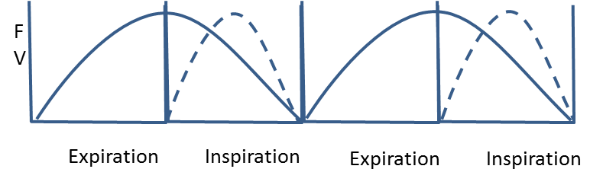
Figure 1 : Femoral vein flow variation according the respiratory pump and posture
Solid line: Supine position, dotted line: upright standing position

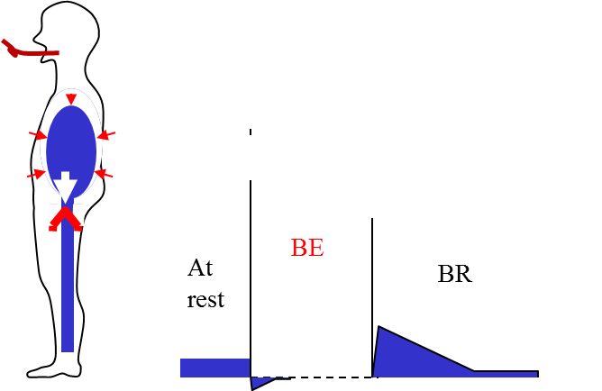

Figure 2 . Valsalva maneuver : normal ( valsalva negative ) attests valves competence : The blocked expiration (BE) reverses strongly the pressure gradient that induces only a negligible short and small reflux thanks to the correct competence of the underlying valves. At the blockage release (BR) , the pressure gradient turns cardiopetal and induces an ascending flow.

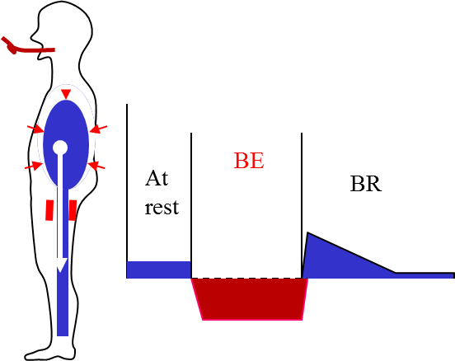

Figure 3. Valsalva maneuver :pathological reflux( valsalva positive )
Valsalva is Positive when valves are Incompetent . Reverse Flow appears when blowing ( Blocked expiration BE ) and at release (BR)

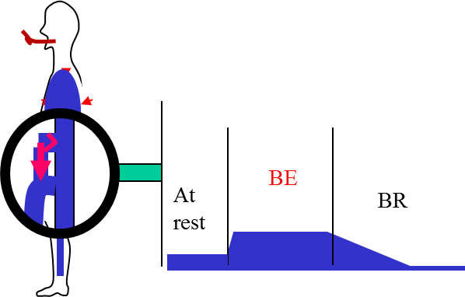

Figure 4. Valsalva maneuver :pathological but normal direction flow ( valsalva positive )
Contrary to the majority of the veins, the normal DESCENDING flow of the SAPHENA ARCH TRIBUTARIES is blocked by the Valsalva manoeuver ( BE) while it is patholigic when occuring at this BE phase. On the other hand , at the release phase (BR) , in both normal and abnormal condition, an antgrade flox id induced.

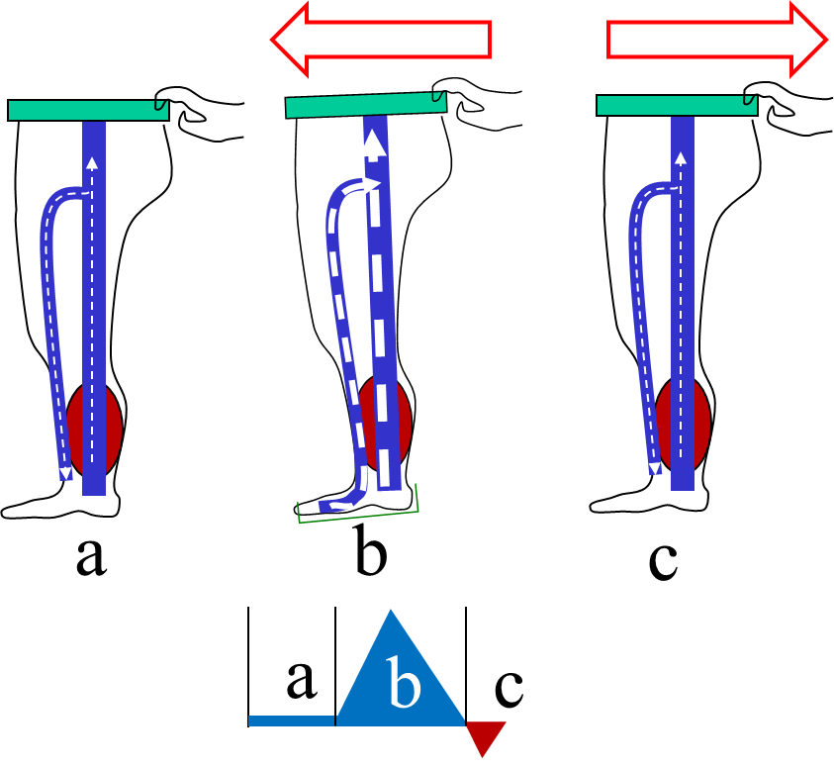
Figure 5 : Paranà maneuver
a: at rest, b: slight push at the waist triggers a proprioceptive reflex calf and sole pumps activation ( systole) followed by c < 1000ms : slight pull (diastole ).

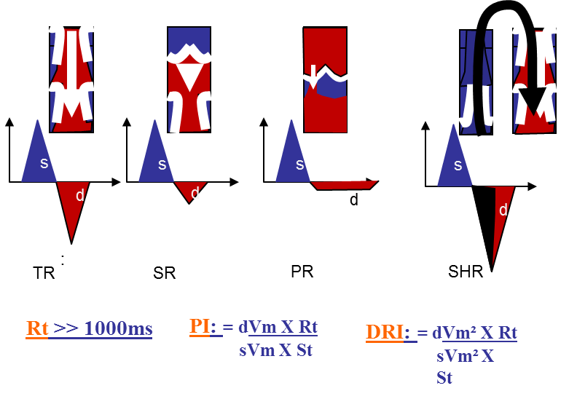
Figure 6: Diastolic Reflux grades in deep and superficiel veins except the perofartors.
Diastolic refluxes: s: MP systole, d: MP diastole
TR: Total reflux, SR: Segmental reflux, PR:Partial reflfux, SHR: Shunt reflux
Rt : diastolic reflux time , s: systolic flow velocty, d: diastolic reflux velocity, flux , dVm: Diastolic reflux mean velocity, sVm: Systolic flow mean velocity.
PI: Psatakis Index, DRI: dynamic reflux index

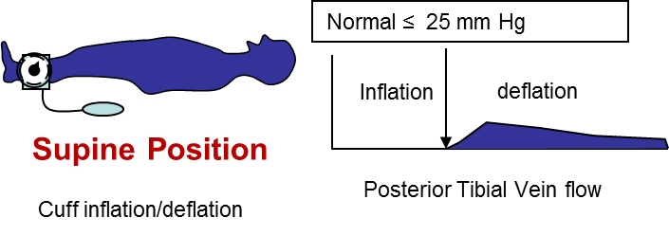
Figure 7: Doppler Venous pressure measurement

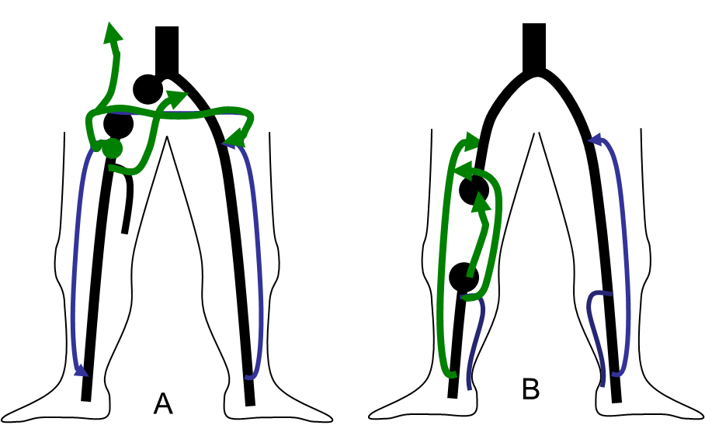Figure Figure 8. Deep venous obstruction and open vicarious shunts
A: Iliac / common femoral veins obstruction
B: Femoro-popliteal obstruction

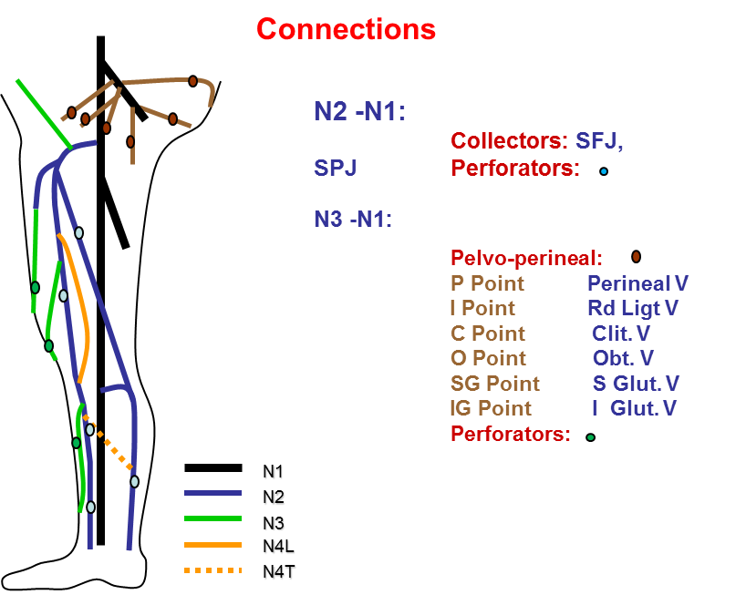
FIG: 9 : Hierarchical venous drainage, network classification and superficial >deep veins connection.
N1: Deep veins, N2: Sub Fascial supericical veins ( GSV, SSV, Giacomini) , N3: Suprafascial superficial veins ( GSV and SSV tributaries and extrasaphenous ),
N4L: N3 longitudinal inter-N2 connecting , N4T: N3 transversal inter-N2 connecting

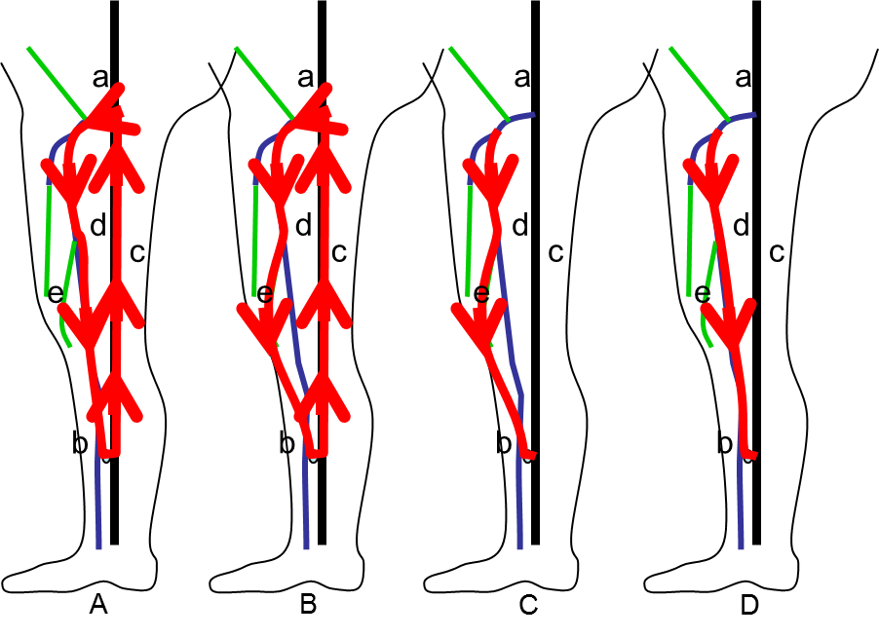
FIG: 10 ODS and superficial CS shunts : GSV Examples
Black line: deep venous veins, Bleue line: competent GSV portions, Green line: competent GSV tributaries
a: SFJ, b: reentry perforator, c: Deep venous veins coonected to the GSV, e: GSV tributary
A and B: closed shunts CS by diastolic closed circuit where the escape point N1>N2 is the refluxing SFJ and the re-entry a N1>N2 perorator b. A: CS type 1 ( N1>N2>N1) overloaded by N1 made only fo the GSV trunk. B: CS type 3 ( N1>N2>N3>N1) through the upper GSV trunk then the tributary (N3). The upper GSV trunk is overloaded by N1 and the refluxing tributary is overloded b both the GSV (N2) and N1.
C and D: Open deviated shunts forming the same pattern as B except the absence of closed circuit thanks to the SFJ a competence N2>N1. C: ODS type 2 ( N2>N3>N1) where the refluxing tributary is overloaded only by the GSV. D: ODS type 0 (N2>N1) where the GSV trunk is not overloaded ( drains its tributaries « pysiologically » despite refluxing).

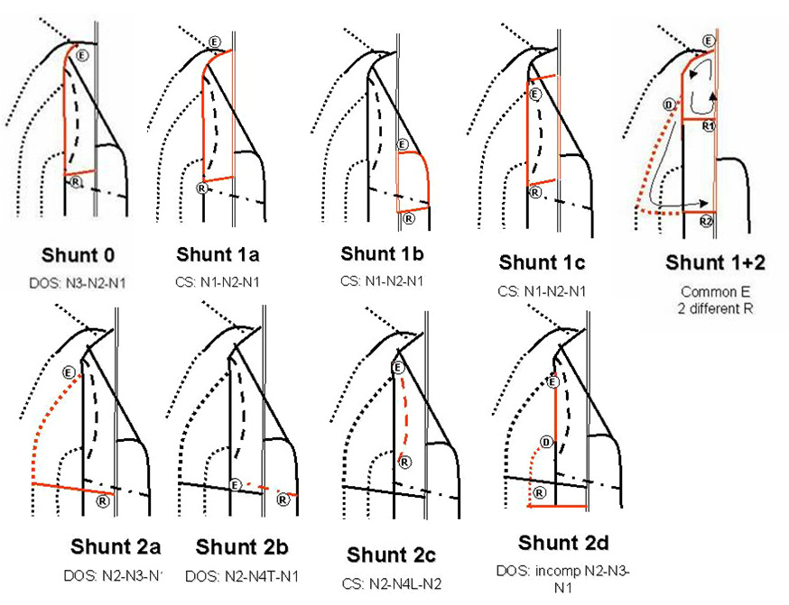

FIG 11: Teupitz Shunts classification : shunts 0, 2 , 3 and 1+2

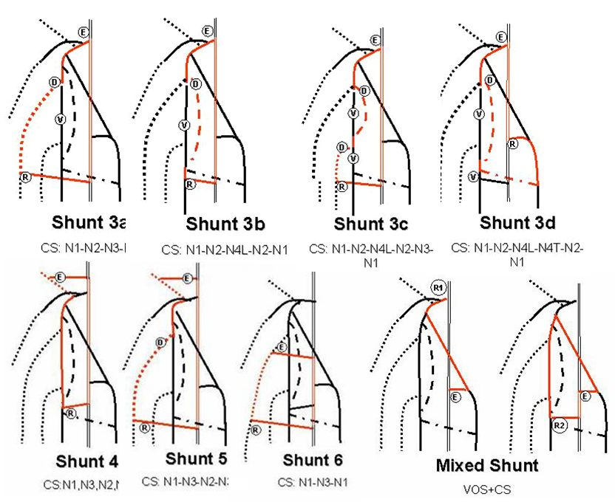

FIG 12: Teupitz Shunts classification : shunts 3,4,5,6 and mixed shunts.

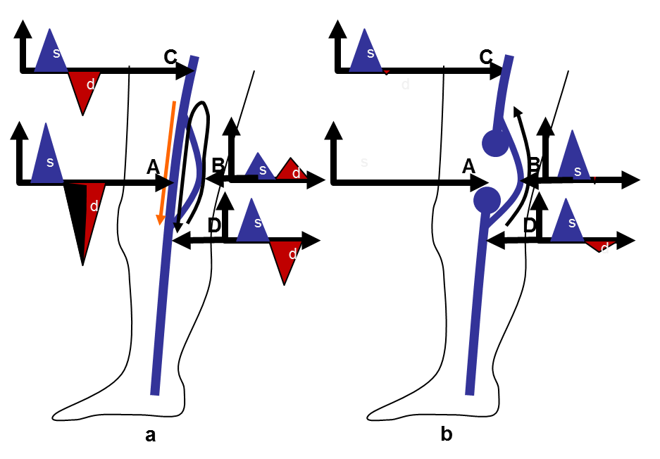
Fig 13: Deep closed shunt: an example of functionning and disconnection effect.
s: MP systole , d: MP diastole, A: incompetent femoral collateral vein, B competent femoral collateral vein, C: incompetent femoral vein, D: incompetent popliteal vein
a: before disconnection: A: diastolic reflux grade closed shunt overloaded by B, B: antgrade systolic and diastolic flow, C and D: diastolic total reflux
b : after disconnection: A: ablated systolic and diastolic flow (disconnection) B, B: antegrade increased vicarious flow and no pathologic reflux, C: abalted pathologic reflux D: Total reflux reduced to segmental

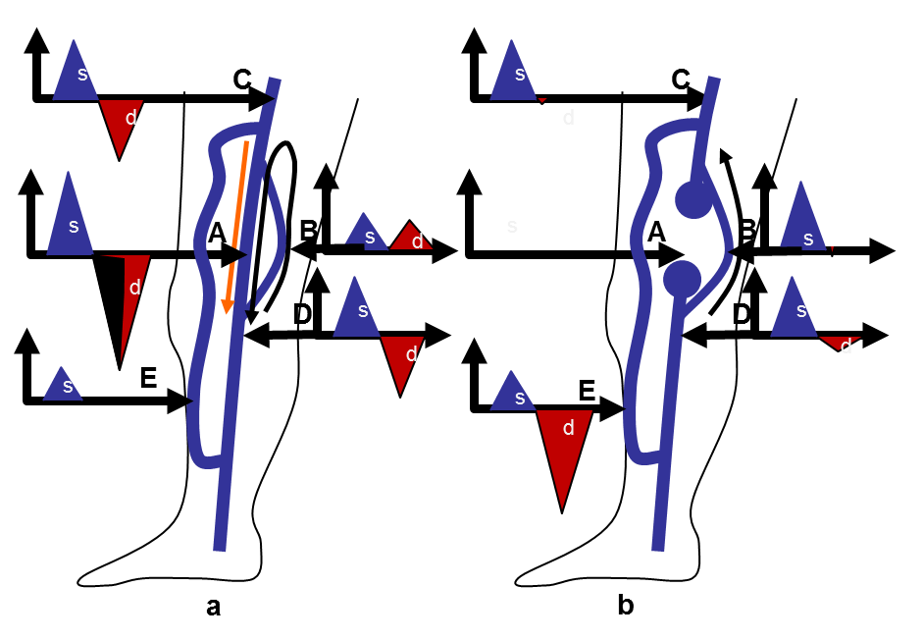
Fig 14: Deep closed shunt: an example of functionning and disconnection effect.
s: MP systole , d: MP diastole, A: incompetent femoral collateral vein, B competent femoral collateral vein, C: incompetent femoral vein, D: incompetent popliteal vein
a: before disconnection: E: Varicose GSV but not refluxing because of a competeive deep diastolic A,C and D.
b : after disconnection: E: GSV CS allowed by the know more effective calf pump ( deep venous veins imparment reduction)

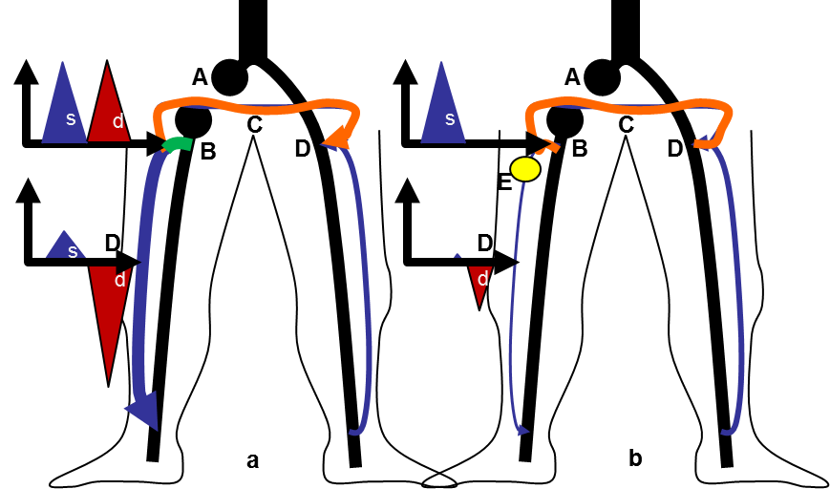

Figure15 A: Mixed shunt: an example of Iliac veine obstruction combined with GSV incompetence
s: systolic flow, d : diastolic flow
a: A: Right iliac vein obstruction , B: common escape point (SFJ) and GSV arch to the OVS and CS, C: OVS branch ( Spontaneous palma) to the opposite GSV arch SFJ D where it drains into the common femoral vein during the systole. D: Diastolic reflux of the CS branche made of the GSV trunk. CS
b: changes after the GSV trunk disconnected below the arch (E). The CS branch is diconnected and the reflux is shunt 0. The OVS is preserved and continues to by-pass A.

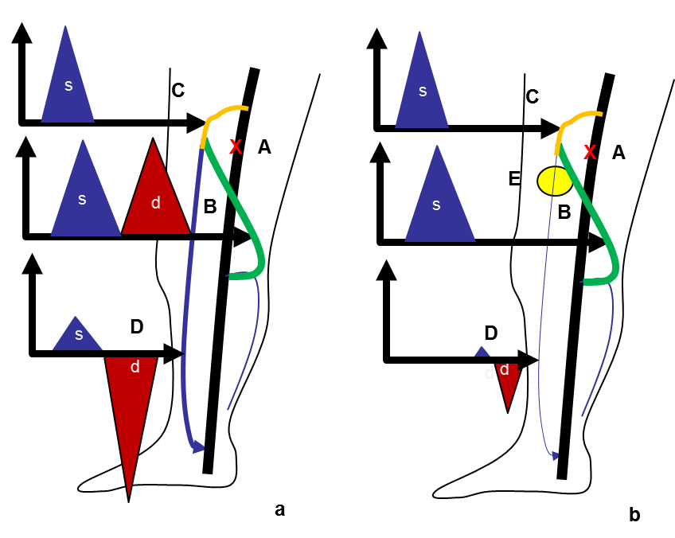

Figure15 B : Mixed shunt: an example of Iliac veine obstruction combined with GSV incompetence
s: systolic flow, d : diastolic flow
a: A: femoral vein hemodynamic obstacle ( not necessarly obstruction) , B: common escape point (SPJ) , SSV arch and Giacomini vin to the OVS and CS, C: OVS branch (GSV arch SFJ ) where it drains into the common femoral vein during the systole. D: Diastolic reflux of the CS branche made of the GSV trunk. CS
b: changes after the GSV trunk disconnected below the arch (E). The CS branch is diconnected and the reflux is shunt 0. The OVS is preserved and continues to by-pass A.

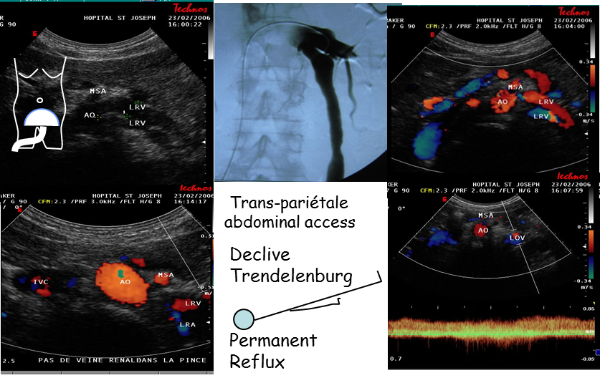
Fig 16: Nutcraker syndrome
CDU Abdominal access of the left genital vein in women. Data correlated to venography: severe aorto-mesentric compression of the left renal vein, dilate ovaric vein, permanent ovaric reflux despite the anti-gravitational posture ( declive Trendelenburg).

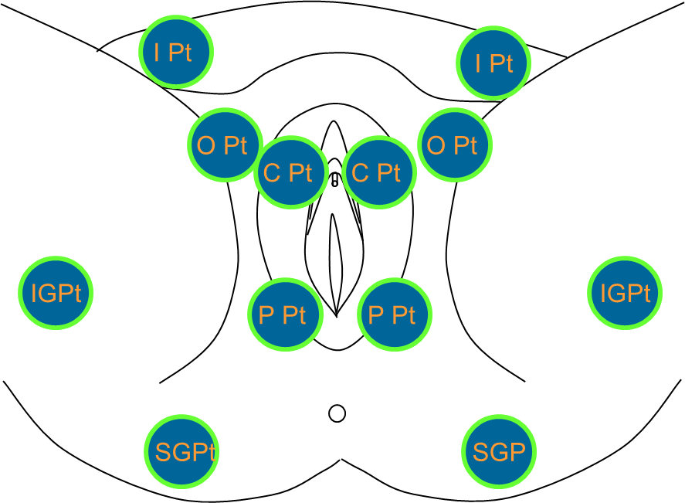

FIG 17: Plevo-perineal leak points

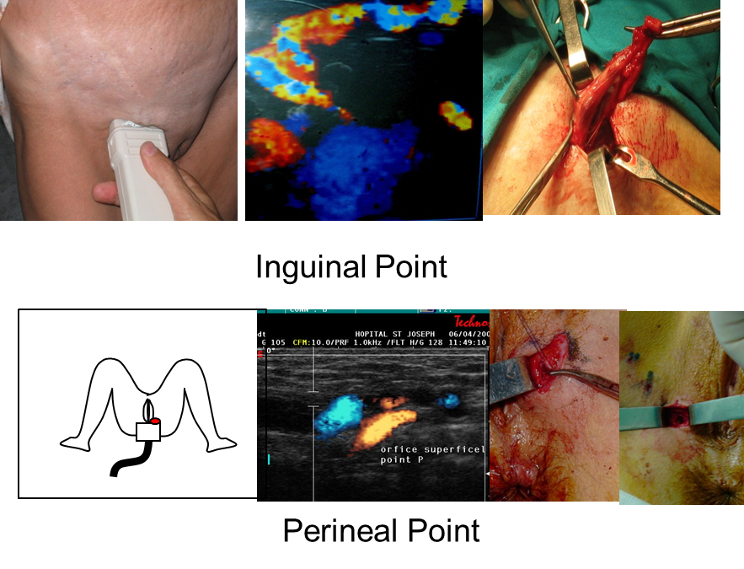
Fig 18: I Point and P Point
I point reflux: upright position + Valsalva maneuver, and operative confirmation
P Point reflux: Gynecologic position + Vaasalva maneuver, and operative confirmation

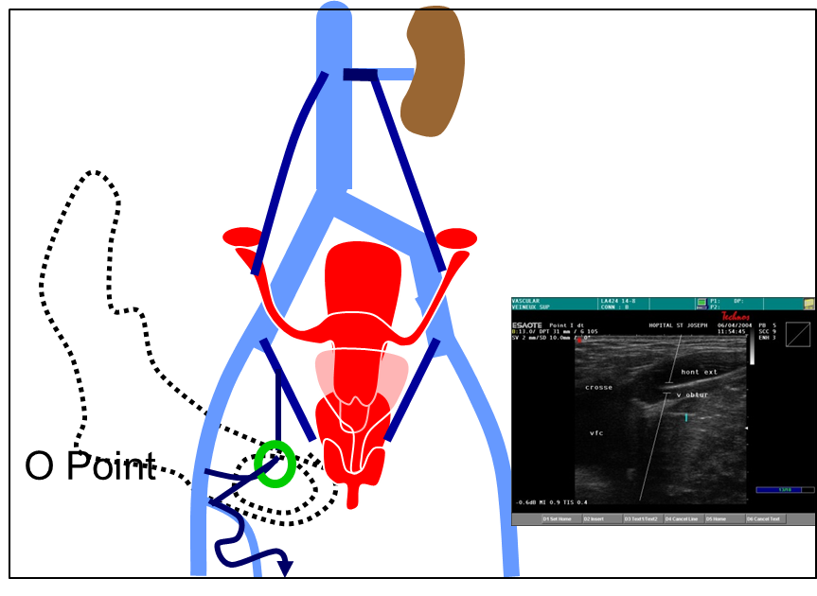
Figure 19: Obturator escape point: O Point

