Article: Hémodynamique du nutcracker syndrome : diagnostic, incidences thérapeutiques
C. Franceschi, M. Greiner, A. Bahnini
Journal des Maladies Vasculaires 03/2008; 33. · 0.24 Impact Factor

Traitement chirurgical hémodynamique des ulcères veineux rebelles

O. Tazi

M.-D. Petit

I. Lazareth

C. Franceschi

Journal des Maladies Vasculaires (Impact Factor: 0.24). 03/2008; 33. DOI: 10.1016/j.jmv.2008.01.017

Available from: Fausto Passariello
Download
Plain Text
◄
Haut du formulaire
Bas du formulaire
►
Page 1
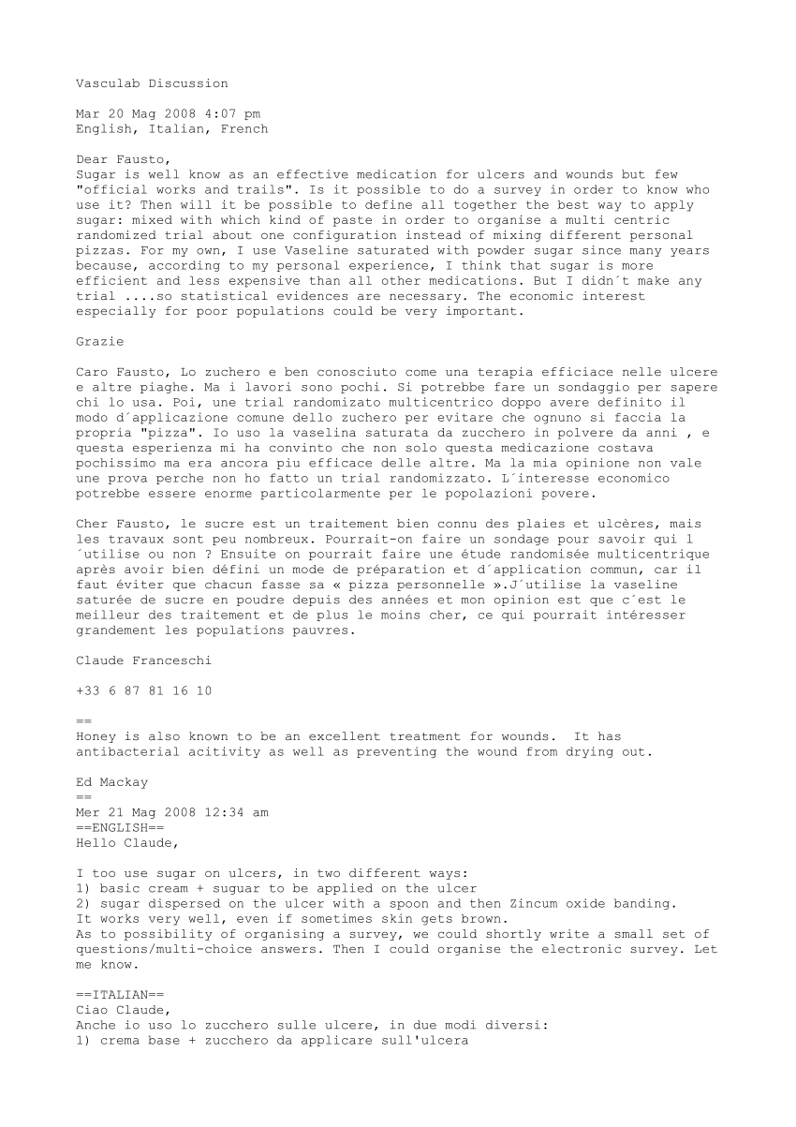
Page 2
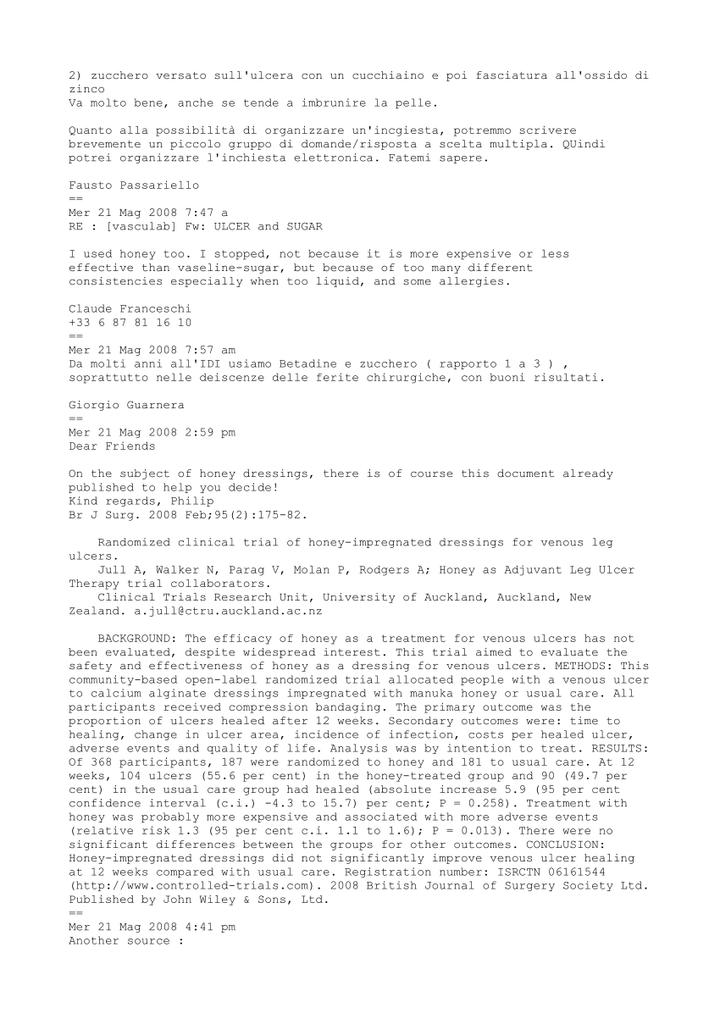
Page 3
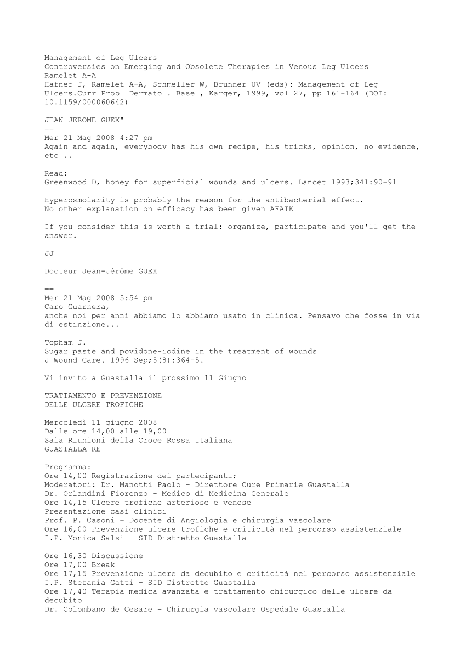
Page 4
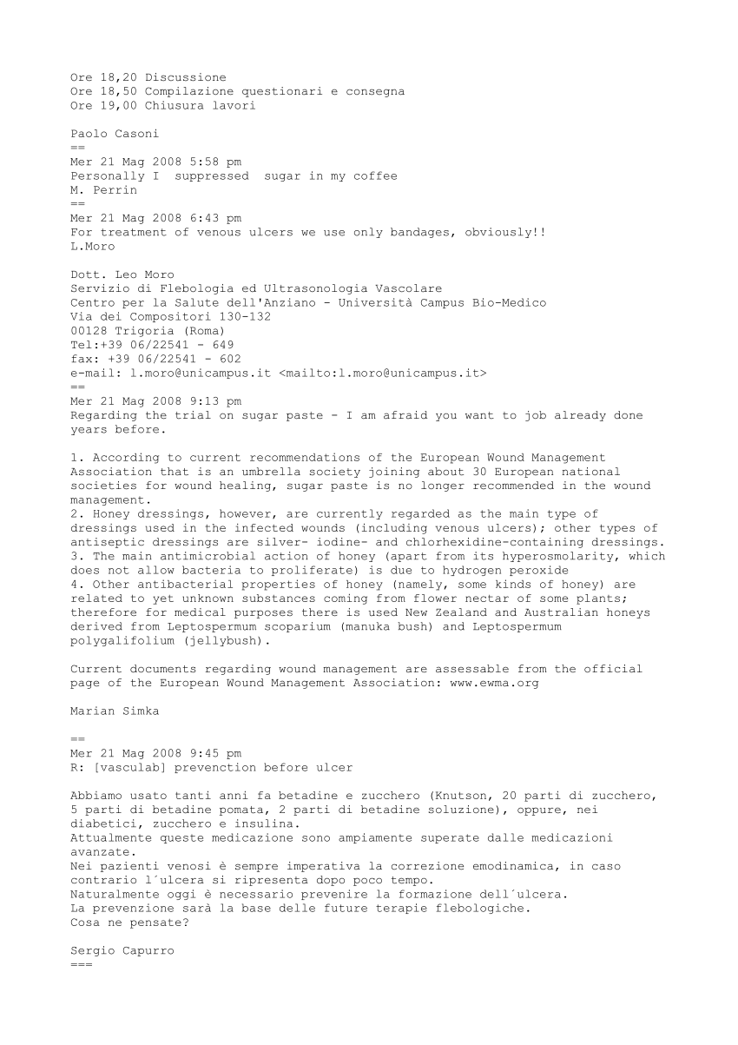
Page 5
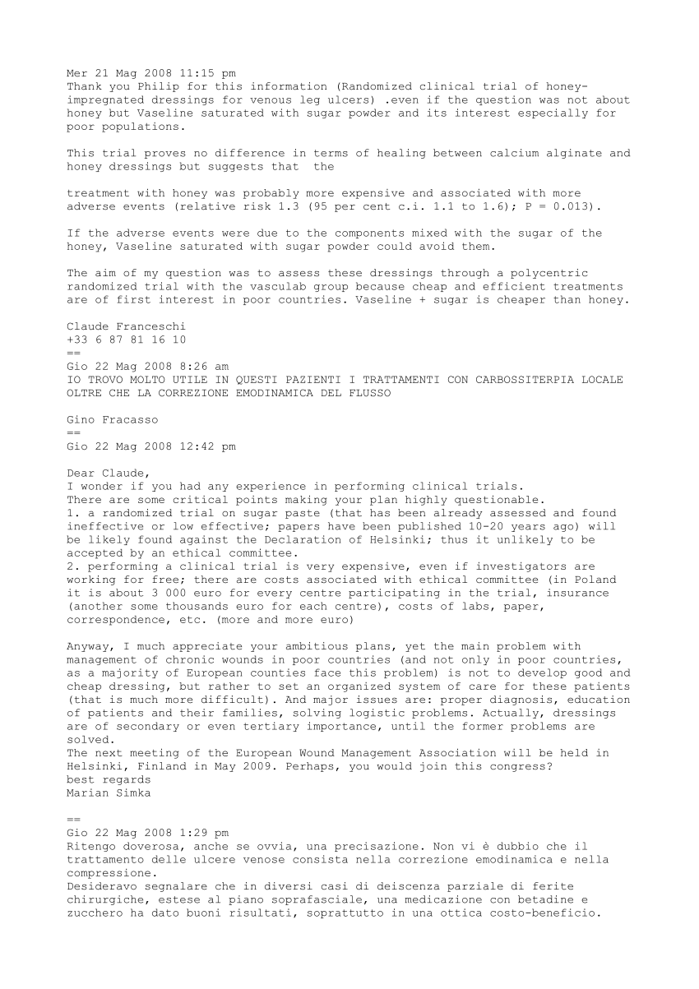
Page 6
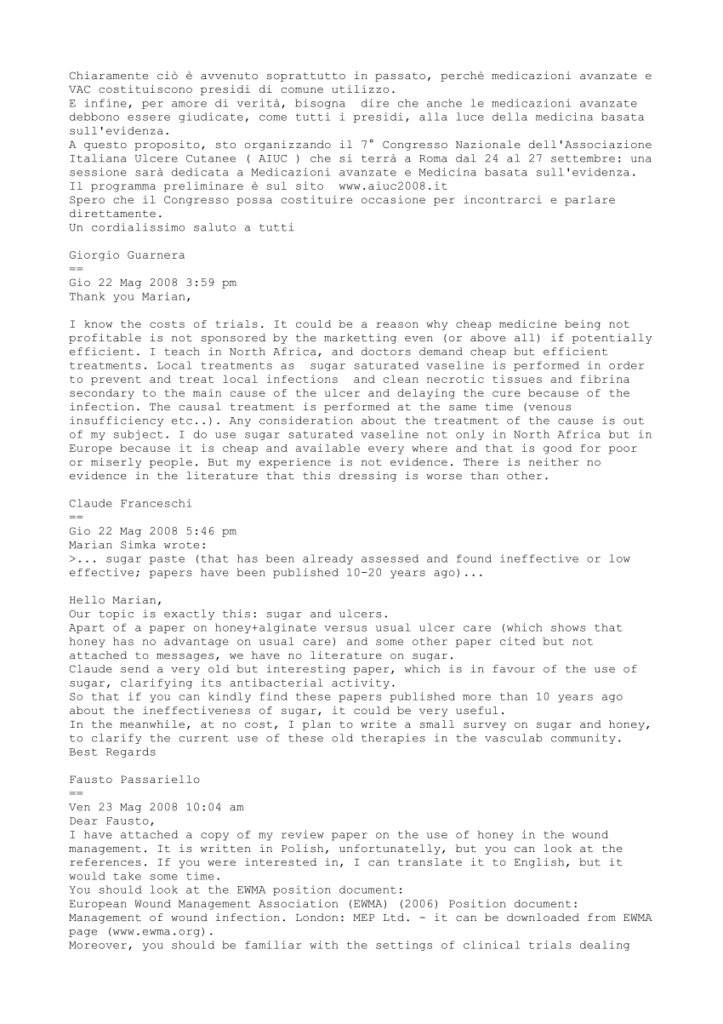
Page 7
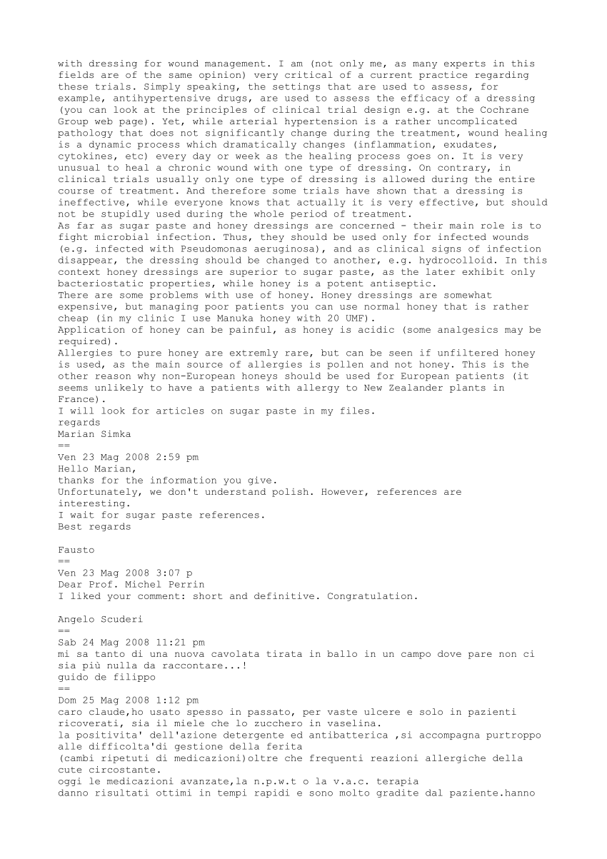
Page 8
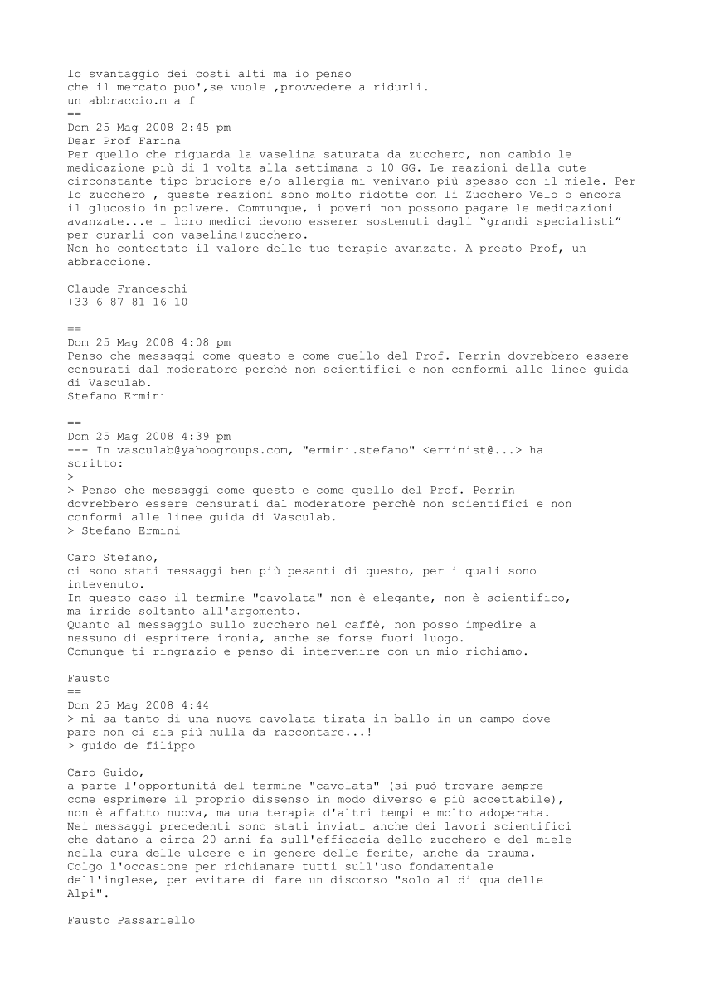
Page 9
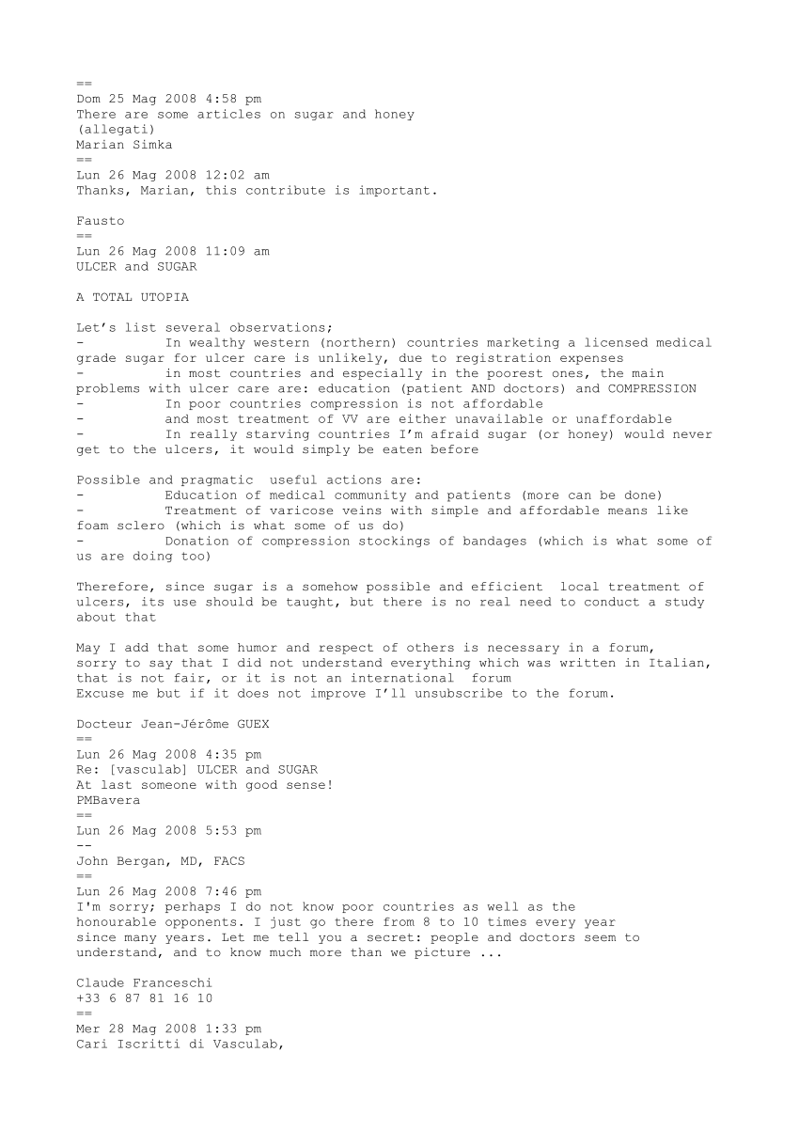
Page 10
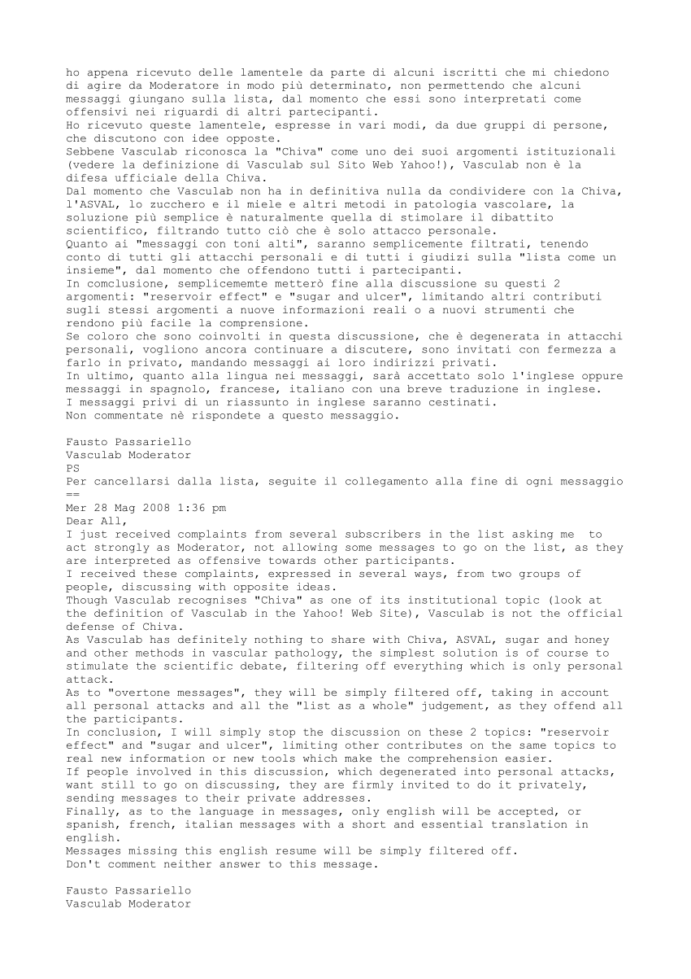
Page 11
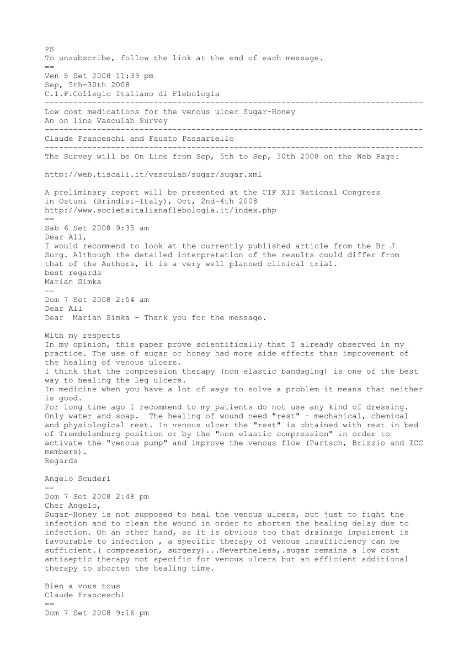
Page 12
Page 13

Page 14

- ResearchGate

- Q&A

- Publications

- Jobs

Haut du formulaire

Bas du formulaire

- 3

Claude Franceschi
Add your degree
Edit
Consultant Angiologist
Edit
Hôpital Paris Saint Joseph · vascular consultant
Edit

a
a
a
a
18.15
Add your publications

Your profile is 95% complete.

OVERVIEW CONTRIBUTIONS INFO STATS RG SCORE

YOUR PUBLICATIONS Edit list

Sorted by: Newest

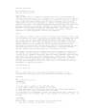
Show dataset

Source

Dataset: sugar discussion
Claude Franceschi, Fausto Passariello
Publish resources Remove

0 requests
Publish full-text

Article: Emangiomi e malformazioni vascolari
C. Laurian, O. Enjolras, A. Bisdorff, C. Franceschi, V. Marteau
[Show abstract]
EMC - Tecniche Chirurgiche Vascolare. 09/2014; 19(3):1–11.
Publish full-text Publish resources Remove

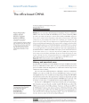
Read full-text

Source

Article: The office based CHIVA
Fausto Passariello, Stefano Ermini, Massimo Cappelli, Roberto Delfrate, Claude Franceschi
[Show abstract]
Journal of Vascular Diagnostics. 09/2013; J Vasc Diagnostics(1):13-20.
Publish resources Remove

0 requests
Publish full-text

Article: Additional information and comments to the article review citing CHIVA.
C Franceschi, P Zamboni, O Pares, J Juan, A Bahnini, E Mendoza, R Cuaranta, F Passariello, M Cappelli, S Ermini, R Delfrate
Phlebology 11/2012; 27(6):327. · 1.92 Impact Factor
Publish full-text Publish resources Remove

0 requests
Publish full-text

Article: CHIVA effectiveness score: the correct one is below.
C Franceschi
European journal of vascular and endovascular surgery: the official journal of the European Society for Vascular Surgery 07/2012; 44(3):351; author reply 352. · 2.92 Impact Factor
Publish full-text Publish resources Remove

0 requests
Publish full-text

Article: Chirurgia dell’arteria vertebrale
C. Laurian, F. Gigou, A. Mallios, B. George, V. Marteau, C. Franceschi
[Show abstract]
EMC - Tecniche Chirurgiche Vascolare. 03/2012; 17(1):1–15.
Publish full-text Publish resources Remove

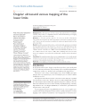
Read full-text

Source

Article: Doppler ultrasound venous mapping of the lower limbs.
Aldo Innocente Galeandro, Giovanni Quistelli, Pietro Scicchitano,Michele Gesualdo, Annapaola Zito, Paola Caputo, Rosa Carbonara, Giuseppe Galgano, Francesco Ciciarello, Sandro Mandolesi, Claude Franceschi, Marco Matteo Ciccone
[Show abstract]
Vascular Health and Risk Management 01/2012; 8:59-64.
Publish resources Remove

0 requests
Publish full-text

Article: The recurrent cervical swelling syndrome.
C Franceschi, S Gianesini, A Bahnini, C Laurian, E Menegatti, P Zamboni
[Show abstract]
Phlebology 06/2011; 27(2):90-2. · 1.92 Impact Factor
Publish full-text Publish resources Remove

0 requests
Publish full-text

Article: So as to avoid any misunderstanding about Cure Conservatrice et Hemodynamique de l'Insuffisance Veineuse en Ambulatoire (CHIVA).
C Franceschi
Phlebology 08/2010; 25(4):212; author reply 213. · 1.92 Impact Factor
Publish full-text Publish resources Remove

0 requests
Publish full-text

Article: The unsolved puzzle of multiple sclerosis and venous function.
Claude Franceschi
Journal of neurology, neurosurgery, and psychiatry 05/2009; 80(4):358. · 4.87 Impact Factor
Publish full-text Publish resources Remove

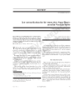
Read full-text

Source

Article: Low cost medications for the venous ulcer. Sugar-Honey: an on line Vasculab Survey.
Claude Franceschi, Fausto Passariello
Acta Phlebologica. 04/2009; 10(1):41-4.
Publish resources Remove

0 requests
Publish full-text

Article: Hémodynamique du nutcracker syndrome : diagnostic, incidences thérapeutiques
C. Franceschi, M. Greiner, A. Bahnini
Journal des Maladies Vasculaires 03/2008; 33. · 0.24 Impact Factor
Publish full-text Publish resources Remove

0 requests
Publish full-text

Article: Traitement chirurgical hémodynamique des ulcères veineux rebelles
O. Tazi, M.-D. Petit, I. Lazareth, C. Franceschi
Journal des Maladies Vasculaires 03/2008; 33. · 0.24 Impact Factor
Publish full-text Publish resources Remove

0 requests
Publish full-text

Article: Anatomie fonctionnelle et diagnostic des points de fuites bulbo-clitoridiens chez la femme (Point C)
C. Franceschi
Journal des Maladies Vasculaires 03/2008; 33. · 0.24 Impact Factor
Publish full-text Publish resources Remove

0 requests
Publish full-text

Article: Bilan hémodynamique de la maladie postphlébitique
C. Laaengh Massoni, C. Franceschi
Journal des Maladies Vasculaires 03/2008; 33. · 0.24 Impact Factor
Publish full-text Publish resources Remove

0 requests
Publish full-text

Article: Hémodynamique de la maladie postphlébitique : conséquences diagnostiques et thérapeutiques
C. Franceschi
Journal des Maladies Vasculaires 03/2008; 33. · 0.24 Impact Factor
Publish full-text Publish resources Remove

0 requests
Publish full-text

Article: Diagnostic ultrasonique des obstructions terminales du canal thoracique
C. Franceschi, A. Bahnini, C. Laurian
Journal des Maladies Vasculaires 09/2006; 31(4):27-27. · 0.24 Impact Factor
Publish full-text Publish resources Remove

1 request
Publish full-text

Article: Traitement chirurgical des malformations vasculaires des membres
C Laurian, C Franceschi, D Herbreteau, O Enjolras
[Show abstract]
EMC - Chirurgie 04/2004; 1(2):100-124.
Publish full-text Publish resources Remove

0 requests
Publish full-text

Article: Ambulatory conservative hemodynamic management of varicose veins: critical analysis of results at 3 years.
Massimo Cappelli, Raffaello Molino Lova, Stefano Ermini, Adolfo Turchi, Giuseppe Bono, Amine Bahnini, Claude Franceschi
[Show abstract]
Annals of Vascular Surgery 08/2000; 14(4):376-84. · 1.03 Impact Factor
Publish full-text Publish resources Remove

0 requests
Publish full-text

Article: [Measures and interpretation of venous flow in stress tests. Manual compression and Parana manoeuver. Dynamic reflux index and Pstakis index].
C Franceschi
[Show abstract]
Journal des Maladies Vasculaires 06/1997; 22(2):91-5. · 0.24 Impact Factor
Publish full-text Publish resources Remove
123
- SUMMARY
- PUBLICATIONS · 46
100% of RG SCORE
25.7 TOTAL IMPACT
  - Articles · 45
  - Conference Papers
  - Datasets · 1
  - Full-texts
- QUESTIONS
- ANSWERS
- FOLLOWERS · 22
- CITATIONS · 66
- OPEN REVIEWS
- RESEARCH FEEDBACK
42 of your publications don't have full-texts yet
View them now and upload the full-texts to make your research visible.
View publications

TOP CO-AUTHORSView all

Fausto Passariello 14.91 · 13.53 · (4)
Centro Diagnostico Aquarius
Follow

Paolo Zamboni 40.56 · 431 · (2)
Universita degli studi di Ferrara

Frederic Gigou 27.85 · 70.07 · (2)
Clinique Saint Faron Mareuil les Meaux 77100

Michele Gesualdo 26.65 · 75.09 · (1)
Università degli Studi di Bari Aldo Moro

Annapaola Zito 25.68 · 65.7 · (1)
Università degli Studi di Bari Aldo Moro

34 FOLLOWINGView all

22 FOLLOWERSView all

TOP JOURNALS
- Journal des Maladies Vasculaires (14)
- Chirurgie (3)
- Phlebology (3)
- Phlébologie (2)
- La Presse Médicale (2)
Import contactsInvite your colleagues
© 2008‐2015 researchgate.net. All rights reserved.About us · Contact us · Developers · News · Privacy · Terms

