Chapter 11

The Chiva Results

Paolo Zamboni

University of Ferrara, Italy.

Probably, a new method of treating varicose veins and CVD was never fully and longer studied than the CHIVA strategy. Pathophysiologic changes induced by CHIVA procedures are extremely interesting models of either venous haemodynamics or patho-physiology.
We can divide results of haemodynamic correction CHIVA in functional and clinical one.

A. Functional Results

Venous function can be assessed invasively, by the means of duplex, ambulatory venous pressure (AVP), and non invasively, by the means of photoplethysmography (PPG)-light reflection reography (LRR), or air plethysmography (APG) (see chapter 8).

1. Duplex scanning

One of the most debated point of the so called CHIVA 1 procedure is the reverse flow downward the re-entry perforator obtained after high ligation (see chapter 10). Many investigators considered it a reflux [108,211]. Postoperative duplex investigation in CHIVA 1 procedure demonstrates significantly different haemodynamic parameters of the reverse flow without change of compartment as compared to preoperative reflux.
Particularly, peak systolic velocity (PSV), peak diastolic velocity (PDV) and resistance index (RI) as an impedance parameter derived from the formula
RI = PSV/PSV-PDV are significantly different (G. Tacconi, E. Menegatti personal communication EVF Annual Meeting Barcellona 2008). Furthermore draining reverse flow corresponds to significant reduction of the cross sectional area of the GSV, which is in turn correlated to reduction of venous volume (Figure 11.1).

Figure 11.1. Top panel: preoperative reflux wave assessed 15 cm below the SFJ in type I shunt. Bottom panel: draining reverse flow assessed in the same position 6 months after CHIVA 1 procedure. The significant change in PSV PDV and RI are indicated as Vsp, VTD, and IR respectively on the left side of the Doppler trace of the top and bottom panel. Particularly, RI passed from 3.10 to 0.60 clearly indicating the modification of flow impedance obtained by CHIVA 1 procedure. In addition the dramatic reduction of the cross sectional area of the GSV are apparent by comparing the preoperative saphenous eye image with that obtained postoperatively.
Therefore, reverse flow of drainage without change of compartment is observed also in human physiology and is classified as shunt 0 (see chapter 5). In addition, the significance of the draining reverse flow is testified by the relationship between it and the improvement of functional parameters like AVP and APG described in the next paragraphs.

2. AVP (ambulatory venous pressure)

The fall of venous pressure occurring with exercise represents the functional reserve of the venous system of the lower limbs and closely correlates with the clinical class of CVD [23,183,184]. It can be measured by the means of a needle transducer inserted into a foot vein, assessing the pressure at rest in standing (hydrostatic pressure), and after exercise (usually 10 tip-toe movements). In addition, it permits to assess the refilling time RT, i.e. the time to return from the minimal pressure value reached stopping the exercise to the initial value in standing position (Figure 11.1). Parameters can be assessed also excluding the superficial reflux by encircling the thigh with a tourniquet. Although some overlap exists between AVP values obtained in either healthy or insufficient veins of the lower limbs, such a measure is widely considered the gold standard in the evaluation of venous function.
Seventythree patients underwent preoperatively and 6 months postoperatively AVP assessment by the means of classic puncture with a needle transducer of a foot vein, after a CHIVA I procedure. CHIVA I contemplated SF disconnection plus flush ligation of the tributaries at the saphenous trunk complemented by multiple stab avulsions (see chapter 10). The preoperative value assessed after ten tip-toe exercise was 50.13+6.56 mmHg; it passed to 28.82+7.14 mmHg six months postoperatively. The difference between pre and postoperative measurements was statistically significant using both Student 's t and Wilcoxon' s tests (p<0.001) [270].

3. LRR (light reflection reography)

The same group of 73 patients underwent to LRR evaluation preoperatively and 6 months postoperatively. LRR and PPG are both non -invasive methods capable to give a rough estimation of the calf muscular pump based on the slope of the curve obtained with tip-toe exercise. More precisely both methods can assess refilling time non-invasively (Figure 11.1) [19,214]. Refilling time measured preoperatively was 10.12+2.6 seconds. After CHIVA I procedure was prolonged to 19.80+4.91seconds, confirming the finding measured by the means of EVT (Figure 11.2). The difference between pre and postoperative measurements was statistically significant using both Student 's t and Wilcoxon' s tests (p<0.001) [270].

4. APG (air plethysmography)

APG permits to extrapolate four parameters which investigate several aspect of venous function [19,58,59]. Total Volume (TV), which is the amount of blood to be found in the venous reservoir, and measures the change in volume (in ml air) produced by the passage from the supine position with the leg raised at 45° to the standing position.
Venous Filling Index (VFI), the volume variation produced in a limb in a defined time by the passage from the supine to the standing position. VFI is related to the severity of the reflux and is expressed in ml air/sec.
Ejected Fraction (EF) which is the rate of the reduction of TV after a single tip toe movement. It reflects the calf muscular systole.
Residual Volume Fraction (RVF), the rate of reduction of TV obtainable after ten tip toe movements. This index is linearly and significantly related to ambulatory venous pressure measurement (Figure 11.3).

Figure 11.2. Ambulatory Venous Pressure. Top panel: Normal Values P:Pressure. PAE: P after exercise < 30mmHg , ΔP: PEA variation between a and b conditions. RT: refilling time after exercise , i.e. the time necessary to return to the resting pressure, > 18 sec. Normal PAE drop and RT are due to normal haemodynamics which allows the valvulomuscular pump to achieve the dynamic fractionation of the hydrostatic pressure (DFHP). a:In the case( a) the spontaneous PAE is to high > 30 mmHg and RT too short. b: A tourniquet at the proximal thigh corrects the values up to normal. Why? Because the tourniquet closure of the superficial at the thigh restores the DFHP, pressing and so disconnecting a superficial closed shunt probably due to a great saphenous reflux in that case. Bottom panel: The preoperative value assessed after ten tip-toe exercise was 50.13+6.56 mmHg, passed to 28.82+7.14 mmHg six months postoperatively. Refilling time measured preoperatively was 10.12+2.6 seconds. After CHIVA I procedure was prolonged to 19.80+4.91secondsThe difference between pre and postoperative measurements was statistically significant using both Student 's t and Wilcoxon' s tests (p<0.001).

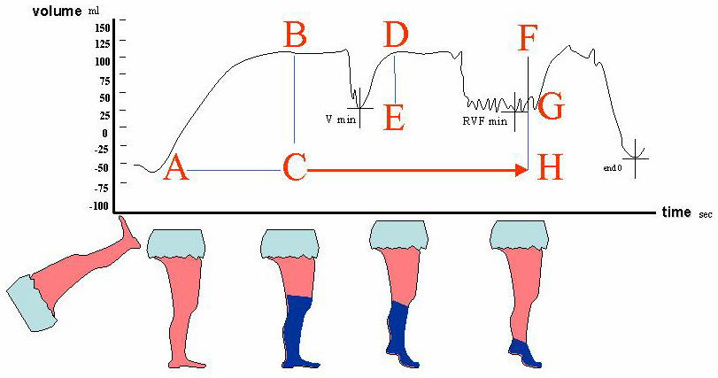
Figure 11.3. APG Trace. TV n.v. < 130ml; total volume of blood in the venous reservoir of the leg = segment BC. VFI n.v. < 2 ml/sec; time for refilling of blood the leg passing from leg elevation to the standing posture = BC/AC. EF n.v. > 55%TV; expelled volume with just one tip-toe exercise, systolic ejection fraction of the calf pump = DE/BC %. RVF n.v. < 30%TV; residual volume in the venous reservoir of the leg = GH/BC%.
APG examination was performed in all cases between 8 and 10 a.m. at the same temperature (23C°), just before CHIVA was performed for correction of chronic venous insufficiency.
Interestingly, APG were measured after simple disconnection of varicose tributaries from the main saphenous trunk, the so called first step of CHIVA II procedure (see chapter 10) [252].
All air-gas plethysmographic parameters, with the exception of Ejection Fraction (EF), significantly improved: Venous Volume (VV) changed from 150 ml ± 9 to 119 ± 6 and 114 ml ± 7 after 1 and 6 months, respectively (p <0.0001), Venous Filling Index (VFI) from 4.9 ml/sec ± 0.5 to 2.3 ±0.2 both after 1 and 6 months, respectively (p <0.0001), and Residual Volume Fraction (RVF) from 42 ml ± 3 to 29.8 ± 2 and 30.2 ± 2 after 1 and 6 months, respectively (p <0.0001).
In the graphics of Figure 11.4 and Figure 11.5 the improvement of VFI and RVF is well apparent, so demonstrating that reflux in the GSV is firmly suppressed by the disconnection of the TV containing the re-entry PV, just eliminating the gradient between the reflux point (i.e. the SFJ) and the re-entry point in the deep veins.
Reflux doesn’t exist more until the reappearance of the gradient. Reflux did recur in 15% of the patients in which a re-entry perforating vein newly developed. This time opening of the perforator was found on the main GSV trunk.
Reflux elimination achieved by the elimination of the gradient determines significant improvement in venous function, as assessed by means of APG, and it is not related to a false finding measured by diplex scanning.

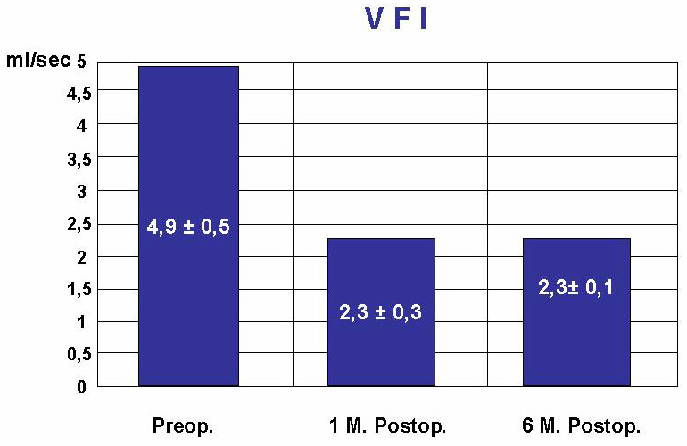
Figure 11.4. VFI changes after 1st step CHIVA 2 PROCEDURE Eur. J. Vasc. Endovasc. Surg. 2001.

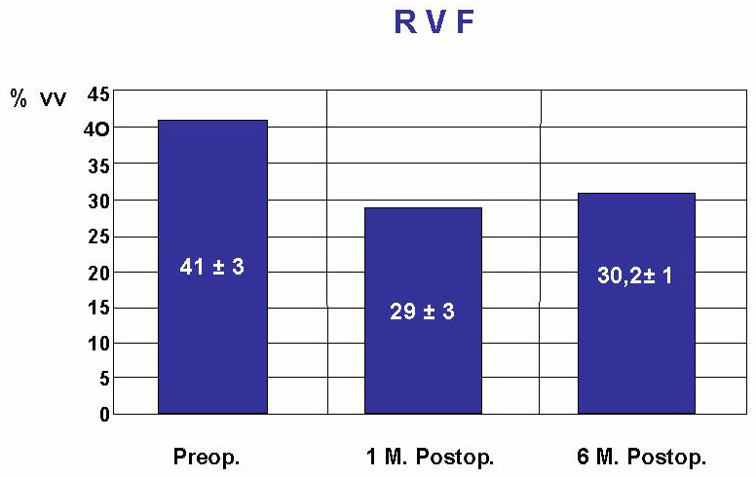
Figure 11.5. RVF changes after 1st step CHIVA 2 PROCEDURE Eur. J. Vasc. Endovasc. Surg. 2001.

5. Long Term APG Assesment

Non invasive air gas plethysmography was used for assessment of changes in venous function in a randomized study comparing CHIVA (CHIVA I and CHIVA I +II) to compression in course of active primary ulcers.
Parameters were assessed at the time of randomization and repeated six months and three years later, respectively (Table I).
In the haemodynamic CHIVA group, all four parameters, with the exception of the ejection fraction, significantly improved 6 months after the operation. However, after three years, only Residual Volume Fraction was found to be consistently corrected and significantly improved. However, this is the more important parameter since correlates with AVP and represents the net-volume of blood which remains stowed in the hold of the leg veins after exercise [251].
Interestingly, RVF was found in pathological values only if SF recurrence occurred.

Table I. Pre and postoperative APG parameters assessed in the surgical group. Grey cells describes postoperative parameters significantly different as compared to preoperative assessment (p < 0.001)

APG assessment | TV | VFI | EF | RVF
Preoperative | 170 ± 54.6 | 6.7 ± 3.4 | 48 ± 12.5 | 40 ± 15.7
6 m. after surgery | 134 ± 44.1  (-25%) | 3.0 ± 51  (-44%) | 57.0 ± 18.1 | 29 ± 15.1  -31%
3 y. after surgery | 141 ± 42.5  (-16%) | 5.35 ± 2.03  (-5.92%) | 54.0 ± 14.3  (+12%) | 22.5 ± 14.7  -35%
Ulcer recurrence | 136.5 ± 6.3  (+2%) | 7.9 ± 4.0  (+21%) | 40.0 ± 14.1  (-24.5%*) | 65.5 ± 6.3  +14%

B. Clinical Results

Clinical results were evaluated in several prospective long term studies, including a meta-analysis which compared haemodynamic CHIVA to stripping [47,56]. More specifically, the results for both stripping and CHIVA homogeneous data available in perspective studies, have been classified by the same examiner into three groups, using Hobbs classification as follows:
- “Healed” – complete absence of visible varices. Results: stripping = 46%, CHIVA = 60%.
- “Improved” – residual or newly formed varices visible, but of slight clinical importance. Results: stripping = 45%, CHIVA = 39%.
- “Unchanged” – complete recurrence of varicosities. Results: stripping = 9%, CHIVA = 1%.
After statistical analysis, using the Pearson test with Bonferroni’s modification, the results of CHIVA therapy at the 3-year follow-up point were better than those obtained from the stripping procedure at the same follow-up point (P <0.001).
Clinical results are usually evaluated by the means of Hobbs score. The assessment in CHIVA evaluation was performed by an independent assessor who had not been involved in previous surgical decision making and operative procedure. Hobbs score is measured according to the following criteria [47,56,131,132,140]:

Objective assessment:

-class A: no visible and palpable varicose veins
-class B: a few visible and palpable varicose veins with diameter < 5 mm
-class C: remaining or newly formed varicose veins with diameter > 5 mm
-class D: insufficient main trunks and perforator
In addition, functional and cosmetic results were self-assessed by the patients, at the time of the last examination in Hospital, using a simple analogue scale well explained by the indipendent assessor to the patients theirselves:

Subjective assessment:

-class A: no inconvenience
-class B: slight functional or cosmetic imperfection, but satisfaction with the result
-class C: appreciable functional or cosmetical failure; improvement but dissatisfaction with the result
-class D: unaltered or increased inconvenience
The four classes, both subjectively and objectively assessed, were divided in accord with the preoperative hemodynamic pattern (Shunt I or III) and tested for significance by chi squared test.
Hobbs score was measured in 186 consecutive haemodynamic correction CHIVA I procedure with 72 months of mean follow-up. CHIVA I procedure was applied in all cases irrespectively of the type of shunt.
Overall saphenous vein patency recorded was 94%, with a mean diameter measured at mid thigh of 4.6 mm as compared to 6.2 mm recorded preoperatively. When patency was demonstrated the saphenous flow was reversed and with low velocity.
Total recurrences/residual varicose veins registered were 11%, 8% for Shunt I and 16 % for Shunt III, respectively.
Symptoms improved in 97% of cases, no-ulcer recurrences were observed in the out-come of the 19 patients in pre-operative clinical class 5 or 6.
Hobbs score: These results are also summarized in Table II. Better results obtained with this technique in patients with Type I Shunt as compared to those objectively and subjectively assessed in Type III Shunt are statistically significant (chi squared=22.144, p<0.0001). However, overall evaluation of the technique demonstrated 84% of patients in class A, 11% in class B, 4% in class C and 1% in D (chi squared p<0.0001).
This study was really important since demonstrated successful the application of CHIVA I procedure mainly in patients with the out-let of the re-entry perforator on the GSV (Shunt I) (Table II): 92% of disappearance of varicose veins, 99% of saphenous vein patency and when the functional and cosmetic result were subjectively and objectively assessed, we registered excellent and good results (Class A and B of the scale) in 98% and 94% of the cases, respectively.
This finding is not surprising and previous clinical reports of CHIVA technique showed satisfactory results for Type I Shunt but deluding cosmetic results for persistent or recurrent varicose veins in the Type III Shunt, the Achille's heel of the CHIVA theory prior of the introduction of CHIVA in two steps.
Such a results analysis led to consider alternative haemodynamic procedure for type III shunt, which was investigated in a further tailored study.

Table II. Results in chiva 1 group; Mean follow-up 72 monts

 | Type I SHUNT | Type III SHUNT  with  re-entry | Type III SHUNT  without  re-entry | Type III SHUNT  “short  or deep” | TOTAL
VARICOSE  VEINS  DISAPPEARANCE | 172/186 92% | 16/27 59% | 81/92 87% | 32/35 91% | 89%
VARICOSE  VEINS REDUCTION WITH  EXERCISE | 9/186 5% | 8/27 30% | 4/92 4% | 2/35 6% | 7%
REFLUX SITE:  Sapheno-Femoral  Perforators  Sapheno/Tributar | 2/186 1%  6/186 3%  6/186 3% | 1/27 4%  1/27 4%  27/27 100% | 3/92 3%  6/92 7%  2/92 2% | 1/35 3%  1/35 3%  3/35 9% | 2%  4%  11%
SAPHENOUS VEIN PATENCY | 184/186 99% | 27/27 100% | 74/92 80% | 35/35 100% | 94%
SAPHENOUS  VEIN  THROMBOSIS | 2/186 1% | 0/27 0% | 18/92 20% | 0/35 0% | 6%
SYMPTOMS  IMPROVEMENT | 183/186 98% | 27/27 100% | 84/92 91% | 35/35 100% | 97%
SUBJECT.EVAL*  Class A  Class B  Class C  Class D | 162/186 87%  21/186 11%  2/186 1%  1/186 1% | 8/27 30%  16/27 59%  2/27 7%  1/27 4% | 74/92 80%  14/92 15%  3/92 3%  2/92 2% | 30/35 86%  3/35 9%  2/35 6%  0/35 0% | 81%  16%  3%  1%
OBJECT. EVAL.*  Class A  Class B  Class C  Class D | 172/186 92%  4/186 2%  6/186 3%  2/186 1% | 16/27 59%  3/27 11%  7/27 26%  1/27 4% | 81/92 87%  5/92 1%  3/92 1%  3/92 1% | 32/35 91%  4/35 11%  1/35 3%  0/35 0% | 89%  5%  4%  2%

Table III. Hobbs score after first step CHIVA II procedure at 18 months F-up

SUBJECTIVE EVALUATION  Class A  Class B  Class C  Class D | 35 pts 87.5%  5 pts 12.5%  0 pts 0%  0 pts 0%
OBJECTIVE EVALUATION  Class A  Class B  Class C  Class D | 35 pts 87.5%  5 pts 12.5%  0 pts 0%  0 pts 0%

Clinical Results of Chiva in two Steps Procedure

40 limbs in 40 patients (26 female, 14 male mean age 52 y.o.) with demonstrated duplex incompetence both of the sapheno-femoral junction (SFJ) and the main GSV trunk with the re-entry perforator located on a tributary [252].
A preoperative skin map was obtained by duplex in order to identify the point where the superficial tributary had to be interrupted. This point correponds to the origin of the varicose TV from the GSV (see chapter 9-10).
All operations were performed under local anaesthesia and consisted in the disconnection of the origin of the TV containing the "re-entry" PV from the main trunk of the GSV. It is mandatory to perform a technically perfect flush ligation on the GSV trunk in order to firmly transform the refluent GSV into a GSV with a forward flow during muscular contraction, but no Doppler-detectable reverse flow during muscular relaxation. The proximal tract of the dilated TV was avulsed through multiple mini-incision technique, sparing the segment immediately above the re-entry PV opening.
Patients were discharged hours after surgery with elastic stockings exerting 20-30 mmHg of pressure at the ankle.
Objective and subjective assessment by using the Hobbs score of the surgical results through the records of the independent assessor are showed in table III.
In all cases after 1 month from the operation duplex investigation demonstrated a GSV with a forward flow during muscular contraction, but no reflux during muscular relaxation. Neither insufficient TV nor PV along the GSV were found.
After 6 months 34 patients maintained such a result. In contrast, six patients (15%) presented with an asymptomatic reflux in the GSV. In these 6 patients, at duplex scanning, the main difference, as compared to the pre-operative examination was the presence of a re-entry PV on the main GSV trunk. No insufficient TV were found in all cases.

Clinical Results of Chiva in Primary Venous Ulcers

Haemodynamic CHIVA procedure was further evaluated in a randomized study comparing CHIVA to compression in the treatment of primary venous ulcers [251].
Surgery, in local anaesthesia, consisted in high-ligation complemented by proximal avulsion of the insufficient tributaries (Type I presentation), or in flush ligation and division from the GSV of the insufficient tributaries (Type III presentation).
Patients began to walk 1 hour after the procedure with the ulcer covered by advanced dressing and wearing an elastic stocking exerting 20-30 mmHg of ankle pressure. Patients were discharged within 3 hours and were seen twice a week the first week, and subsequently weekly till the ulcer was healed. Patient follow-up examination occurred every six months along a period of 3 years [24,25].
The difference in ulcer area between the conservative and the CHIVA group, 11 cm2 (3-12) and 10 cm2 (2,6-11,8), respectively, was not significant.
The healing rate was 96% in a period of 63 days (21-180) in the compression group as compared to 1OO% in 31 days (17-53) recorded in the CHIVA group. No significant difference was demonstrated concerning the rate of healing. However, there was a highly significant (p<0.005) difference in the healing time between the two groups.
Finally, ulcer did recur in 9 cases in the compression group along the follow-up (38%) and in 2 cases in the surgical group (9%). The difference is statistically significant (p < 0.05). Recurrence analysis by the survivor function of the Kaplan-Meyer estimation is given in Figure 11.6; a significantly better out-come has been demonstrated in the surgical group: p<0.02.

Figure 11.6. Survivor function illustrating ulcer recurrence according to treatment. The better outcome of patients who underwent CHIVA surgery is well apparent.
Ulcer recurrences occurred in two cases as above described. The first case was related to sapheno-femoral recurrence, whereas the second one to further development of a sapheno-popliteal reflux.
Two patients (29%) showed a saphenous reflux after 6 and 30 months, respectively, following the first step procedures for type III hemodynamic presentation: the occurrence of the development of a new re-entry perforator located on the GSV is well established, as above reported. In these two cases we performed the second surgical step, represented by high ligation.

Quality of Life Assesment

In the same study, SF36 quality of life questionnaire was evaluated. Before interventions no significant differences were found out in the score of the SF-36 questionnaire between the CHIVA and the compression [251].

Figure 11.7. Median score differences (end of observation-baseline) are shown for the 8 domains explored by the SF 36 questionnaire. *P<0.05 comparing baseline to end of treatment values, P<0.05 comparing surgery vs compression. PF= Physical functioning, RP= Role-physical limitation, BP= Bodily pain, GH= General health, VT= Vitality, SF= Social functioning, RE= Role-emotional limitation, MH= Mental health.

Randomized Controlled Trials

Stripping procedure is the gold standard in CVD treatment since demonstrated in several RCT to be superior to either sclerotherapy, or high ligation alone, whereas there were no randomised studies assessing in a long-term period the value of conventional stripping versus other surgical procedures [56].
For such a reason, 150 patients affected by CVI, CEAP clinical class 2-6, were randomised to stripping or to CHIVA, preceded by pre-operative Duplex mapping. End-points were: objective and subjective results assessed by the means of the Hobbs score (Hobbs score ranges from 1 to 4,with 4 representing the worst result), either by an independent assessor or by the patients at their own control, respectively; rate of recurrences assessed both by physical and duplex examinations in both groups.
Mean follow-up lasted 10 years, 26 patients were lost, resulting in 54 patients (32 females, and 22 males) in the stripping group, and in 70 patients (59 females, and 11 males) in the CHIVA one. Subjective Hobbs score was not statistically different in both groups. On the contrary, objective assessment resulted significantly better in the CHIVA group (1.94 ±0.09 vs 2.24±0.12, P<0.038). Varicose veins recurrence rate was significantly higher in the stripping group as compared to CHIVA (18% and 35%, respectively, P<0.04), without significant differences in the rate of recurrences from the sapheno-femoral junction.
This study demonstrates that varicose veins more easily recur along time in the Stripping group. Since, no significant differences were found in recurrences from the sapheno-femoral junction, such result could be speculatively related to the presence of a draining saphenous system in the CHIVA group.
At 3 years follow-up the differences above reported were not significant in this and in other RCT, comparing the 2 techniques (Figure 11.8).

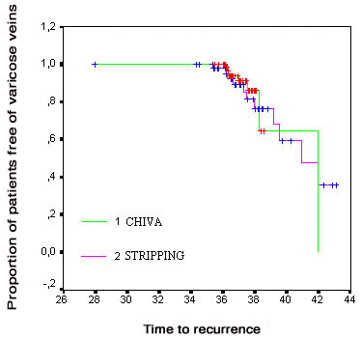
Figure 11.8. This figure shows the survival curve of recurrences at 3.y No significant differences were found between the two techniques at 3 years. In the stripping group the recurrences were caused by pattern # 1,2,3. To the contrary, in the CHIVA group were caused by pattern # 1 and 4 (see Fig.11.10).
In contrast, along the period 3-10 years the different recurrence rate in the two groups becomes well apparent and significant, Mantel test P= 0.004, Tarone test P=0.007, and Breslow test P=0.014. It is noteworthy that, between 3-10 years, in the stripping group the recurrences were caused exclusively by pattern # 5, whereas in the CHIVA patients they were attributable to pattern # 4 (Figure 11.9).
The varicose veins recurrence rate was significantly higher in the stripping group (CHIVA 18%; stripping 35%, P<0.04), without significant differences in the rate of recurrences from the sapheno-femoral junction. The associated risk of recurrence at ten years is increased of more than two times in the stripping group (OR 2.2, 95% CI 1-5, P=0.04).
This RCT demonstrates that varicose veins more easily recur along time in the stripping group. Since, no significant differences were found in recurrences from the sapheno-femoral junction, such result could be speculatively related to the presence of a draining saphenous system in the CHIVA group.

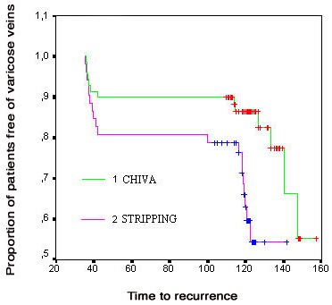
Figure 11.9. Along the period 3-10 years the different recurrence rate in the two groups becomes more and more evident and significant. It is noteworthy that, between 3-10 years, in the stripping group the recurrences were caused exclusively by pattern # 5, whereas in the CHIVA patients they were referred again to new pattern # 4 (see Fig 11.10).
Duplex analysis of the pattern of recurrence is particularly interesting (Figure 11.10). We identified five different haemodynamic patterns of recurrences, differently distributed in the two treatment groups. The presence of combined patterns was the rule in the stripping group, while in the CHIVA group a single pattern of recurrence was more common.
- Type 1 recurrence consists of sapheno-femoral recurrence. We found 2 patients out of 70 corresponding to 2.9% in the CHIVA group, and 3 patients out of 54, corresponding to 5.5 % in the stripping group (NS Student's t test).
- Type 2 recurrence: consists of reflux coming from the pelvis, through a venous pathway located or in the groin or the perineum, with no associated sapheno-femoral reflux (21). This was present in 1/70 pts, 1.4 % in the CHIVA group vs 2/54 pts, 3.7 % in the Stripping group, NS (Student's t test).
- Type 3 recurrence: consists of duplex ultrasound evidence of incompetent thigh perforators not present at the time of the first procedure. This development was not found after ten years in the CHIVA patients (0/70 pts, 0%); while in the Stripping group we have seen 4 patients out of 54 with this pattern (P value NS, Student's t test).
- Type 4 recurrence: comprises reflux from the proximal saphenous vein (thigh section) to a varicose tributary. This was only found in the CHIVA group and it is typical of the saphenous vein sparing surgery (13/70 pts., 18.5 % in the CHIVA group vs 0/54 pts, 0% in the stripping group with P value <0.01, Student's t test).
- Type 5 recurrence: consists of recurrences from varicose veins greater than 5 mm without any demonstrable escape points or change of compartments. This haemodynamic pattern, in contrast to the previous 4 patterns, is exclusive to the stripping patients and not found in the CHIVA group (0/70 pts, 0% in the CHIVA group vs 12/54 pts, 22% in the stripping group; P<0.01, Student's t test). All the
Duplex results with pattern of reflux in each group are given in figure 11.10.

Figure 11.10. Pattern of recurrences after 10 years. Patterns of recurrences find respectively in the CHIVA and stripping group; number of cases and relative rate are reported. Type 1 compares SF recurrences; type 2 recurrences feed by pelvic reflux; type 3 recurrences from perforators. Type 4 reports recurrences due to reflux from the GSV toward a varicose tributary; type 5 varicose veins greater than 0.5 cm in the absence of any detectable reflux point. The last section of the figure summarized total number of patients with recurrences, and the relative rate in both groups.
The main difference between the two groups after 10 years, is the 22% of newly formed varicose veins found in the stripping group, without any detectable reflux point. We believe that this type of recurrence is attributable to the lack of a draining saphenous system [66]. The maintenance of drainage seems to be a decisive factor in avoiding neo-angiogenesis after varicose vein surgery. This observation is confirmed when CHIVA treatment is not correctly performed leading to post-operative GSV thrombosis and occlusion. A non-draining GSV, despite conservative surgery, increases the number of recurrences in comparison to draining GSV systems [45,47,55,270].

Chapter 12

The False Problem of Perforators

Paolo Zamboni

University of Ferrara, Italy.

Perforators in primary CVD are widely considered as an enemy to fight. The original sin is probably due to the general misinterpretation of the classic article written by Frank Cockett on The Lancet [60]. Such hypothesis was that venous hypertension, transmitted to the cutaneous tissue by perforators, in turn causes venous ulcers. The “blow-out” hypothesis was mainly referred to the post-thrombotic legs. In such a condition, outward flow during muscular diastole may occur in the distal leg perforators determining the microcirculatory overload which, in turn, leads to the cascade of events typical of secondary CVD. However, most surgeons were fascinated by the Cockett vision and, despite the fact that it was not supported by relevant scientific data, the era of perforator veins surgery began.
Every severe case of CVD was referred to as the ankle “blow-out” syndrome without any distinction being drawn between a primary and a secondary aetiology in perforating veins incompetence, characterized by opposite patho-physiology, yet.
Previous as well as further scientific data were completely forgotten: the former was simply the Perthes test, a fantastic live-demonstration that, by eliminating superficial reflux, the blood flows down-ward and therefore in-ward to the competent deep veins through the perforators (Figure 12.1).
The latter was the studies of Bjordal, who used electromagnetic flow-metry, and demonstrated that in-ward flow occurred in the distal perforators during exercise in patients with primary CVD (Figure 12.2) [26-30].
The Cockett theory spread by several surgical schools was applied to both primary and post-thrombotic CVD, and, on the basis of my personal discussion with colleagues around the world, I can report that the majority of SEPS surgeons have never read the article in question.

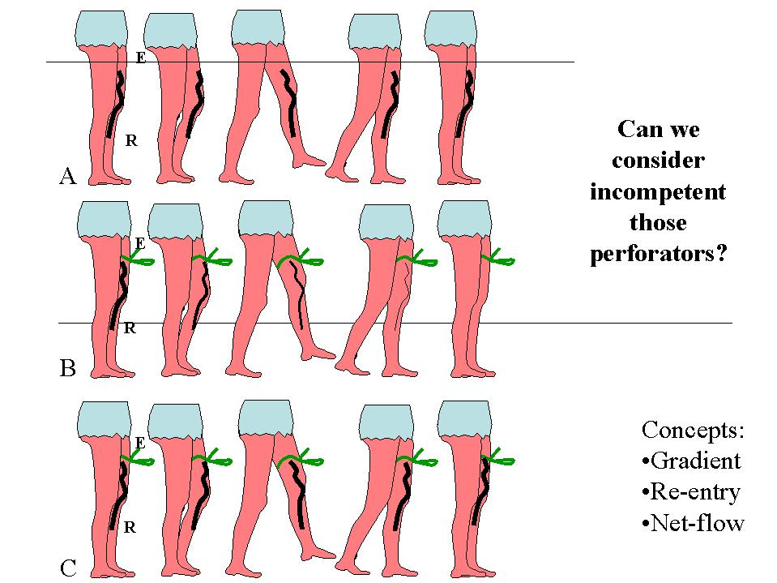
Figure 12.1. Perthes test is a reproducible demonstration of the haemodynamic dependence of distal perforators from superficial reflux. Here is an example of varicose superficial vein related to a closed shunt where E is the refluxing escape point through which the deep blood flows out, then downwards through the superficial incompetent varicose vein, then inward through the re-entry perforator R and then turns back into the deep network. This event occurs only during the valvulo-muscular pump (VMP) diastole because of the valve incompetence (escape point, shunting vein) associated with diastolic reversion of the gradient of pressure. So a flow reversion needs necessarily a valve incompetence AND pressure gradient reversion. When the re-entry perforator is incompetent, retrograde flow can occur only in case of reverse pressure gradient. The Net-flow concept is related to the rate of in-flow and out-flow in bi-directional perforator during stress tests. A: Despite its good condition, the valvulo-muscular pump activated by walk is not powerful enough to narrow the dilate vein of the refluxes the deep blood reclosed shunt. The cause is not into the deep veins through the re-entry perforator R because it is overloaded by thigher pressure to the lower (diastolic reflux fed by the deep veins through the escape point E. B: When the tourniquet presses at the escape point , the diastolic reflux is eliminated and so, the valvulo-muscullar pump power can empty the varicose vein anymore in closed shunt . C: When VMP is impaired and so unable to reverse enough the diastolic pressure gradient (deep venous incompetence or obstacle or muscular inefficiency) the varicose vein doesn’t narrow because the net-flow is unfavourable.
During the eighties, Kevin Burnand reported poor results of perforating vein ablation in post thrombotic limbs with ulceration, but the majority of surgeons still continued think them as an enemy. The recent development of SEPS technological and minimal invasive surgery increased perforating ablation throughout the world [115,138,235].
It has been demonstrated by Elfstrom [89] that ablative surgery of the perforating veins significantly reduces the venous drainage of the leg. Illig, unintentionally, demonstrated the same by the means of PPG after SEPS procedures (Figure 12.3) [138,256].
However, despite his poor clinical and PPG results, he stated that PPG is not the best way of assessing SEPS haemodynamic results. The fact that he fails to discuss the poor results of the SEPS procedure and criticizes instead the methodology for assessing the operation indicates the great and unshakable faith of most surgeons in perforating ablation.

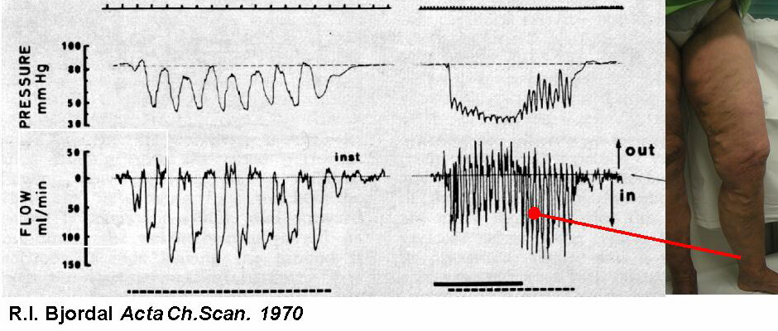
Figure 12.2. Objective measurement of positive NET FLOW in distal perforators by the means of electromagnetic flow-metry [282]. The prevalence of in-ward flow during muscular diastole determines the fall of ambulatory venous pressure (modified from Bjordal).

Figure 12.3. Haemodynamic results of indiscriminate avulsion of terminal perforators demonstrate worsening of venous drainage: In the top panel, by the unchanged expelled volume (EV) after the operation (mod. From Elfstrom), and in the bottom panel by the flat curve of PPG (mod. from Illig).
And yet, every day in our vascular lab, Duplex scanning in primary cases demonstrates a bi-directional flow in the Cockett veins with a permanent in-ward flow during muscular diastole! (Figure 12.4).

Figure 12.4. The great misunderstanding is the equivalence of perforating veins exhibiting a bi-directional flow with insufficient perforating veins. In primary cases, bi-directional distal perforators show an in-ward flow in muscular diastole with a positive net-flow. A) Duplex trace of a Cockett perforator with the in ward direction at muscular relaxation; B) Blue colour of re-entry at muscular relaxation in a bi-trunk Shermann perforator with the opening on the saphenous vein.
Surprisingly, this finding is considered pathological by many investigators, despite the “net profit” proven both by the Perthes test and electromagnetic flow-metry. In my opinion, it is incorrect to consider insufficient those perforator veins that exhibit bi-directional flow without a critical evaluation of their haemodynamic significance in the context of an insufficient saphenous system. No distinction is made between perforating veins with regards to the flow direction during calf muscular contraction or relaxation [70].
Coleridge Smith has reported that bi-directional flow is commonly found in the distal perforators of normal subjects and therefore cannot be considered diagnostic of insufficiency [212].
Such criteria create many limitations, doubts and probably errors both in investigating and in operating.
Furthermore, the standards adopted for duplex assessment of perforator reflux does not permit the identification of re-entry perforators and/or perforators with prevalent in-ward flow, even if bi-directional. These vessels in certain limbs are useful for drainage and cannot be more considered pathological perforating veins. This is the reason of the reduction of venous drainage after perforating veins surgery (Figure 12.4). Careful assessment by colour Doppler of in ward flow during muscular diastole could identify useful pathways for the venous drainage from the lower extremities.
In my opinion, the third element of misconception of the role of perforating veins are studies showing that incompetent perforating veins are associated with recurrent varicose veins.
Such a finding is certainly not surprising. Ablative surgery causes removal of the natural basin of superficial blood collection (saphenous vein) and of its drainage pathways. Residual veins need to drain blood and a gradient guides the flow inward through perforating veins. Thus, the increased number of perforating veins are not a cause but instead a consequence of the new hemodynamic and pathophysiologic scene. This occurs some years after a stripping procedure, even when it is technically correct (see long term results after stripping chapter 11).
Finally, an important element of the perforating veins misconception in primary cases can be brought back to the use of phlebography in clinical practice, of course widely utilized in the pre-ultrasounds medical era. Unfortunately, phlebography doesn’t provide any information about blood flow direction in the perforating veins during muscular contraction/relaxation, but just static, sometimes impressive, images of the vein system. In static conditions the valves are open and the blood distribution in the veins regularly occurs by reason of the principle of communicating vessels.

1. Incompetent Perforators:

Terminal, Non-Terminal and Terminalized

Within the field of ‘private circulations’, or venous shunt in primary cases, by the means of duplex we can detect perforators exhibiting a bi-directional flow, usually considered insufficient.

Figure 12.5. Proximal perforators are more likely to show out-ward flow in muscular diastole, and are usually defined non-terminal perforators (panel A, top trace). In contrast, in primary cases, distal or terminal perforators demonstrate out- ward flow in systole and in-ward flow in diastole (panel A, bottom trace), or just in-ward flow (panel B).
Further analysis of flow direction in muscular systole and diastole, allows distinction in two categories [49]:
- “Terminal” incompetent perforators or those in the “terminal zone,” that is, located in the most distal part of the ‘private circulation’ and representing natural re-entry points (Figure 12.5);
- “Non-terminal” incompetent perforators or those located along the pathway of the ‘private circulation’ (Figure 12.5);
During muscle contraction the majority of the incompetent perforators aspirates blood from the superficial circulation to the deep circulation (Figure 12.6), while a minority produces systolic reflux; this however can be observed mainly in the terminal zone, due to sudden acceleration applied distally to the deep veins by the calf contraction (Figure 12.5 panel A, bottom). During muscle relaxation the incompetent perforators in the terminal zone aspirate blood from the superficial circulation to the deep circulation. It is important to note, however, that perforators producing a systolic reflux (those in the terminal zone) are “compensating for” primary varices since the bias between rates of systolic reflux and diastolic re-entry is weighted in favour of the re-entry rate, as Bjordal has shown. Such perforators therefore are incompetent but “sufficient,” i.e., functionally compensatory.

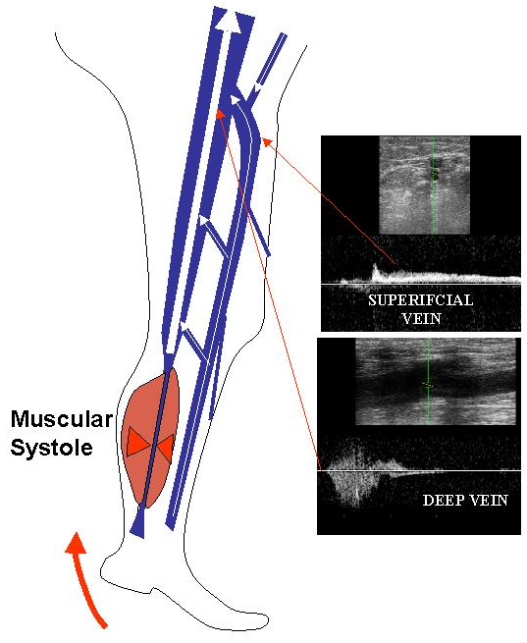
Figure 12.6. Muscular contraction applies more energy to deep veins as compared to superficial one resulting in increased Doppler flow velocity. According to Bernoulli law and Venturi effect (see Pitot’s tubes) this contributes to the aspiration of blood from the superficial to-ward the deep veins in proximal perforators and/or junction level during muscular contraction. The consequent drop in lateral pressure in the deep veins determines an in-ward flow at muscular contraction (Bernoulli Law).
We found this pattern in the vast majority of perforating veins investigated by duplex. In primary cases, exactly 2200/2337 (94,1%) perforators demonstrated an in-ward flow in muscular diastole, and were prevalently located in the Cockett and paratibial groups.
Non-terminal incompetent perforators, on the other hand, may demonstrate diastolic reflux from the deep circulation to the superficial circulation as one progresses from the terminal zone; this is promoted by a pressure gradient from deep level to surface level. This gradient is evidently related to the increased diastolic velocity of the superficial reflux and the consequent drop in lateral pressure on the superficial side by reason of the Bernouilli principle and Venturi effect. The diastolic reflux from the non-terminal perforator supplies the secondary reflux from the incompetent perforator. In our survey we found this pattern in 137/2337 (5.9%) perforators with an out-ward flow in muscular diastole, prevalently located in at the thigh.
Compression below the non-terminal perforator interrupts the secondary ‘private circulation’ and causes the diastolic reflux to disappear. This procedure also helps to demonstrate the flow inversion in diastole from surface level to deep level, just as with the terminal perforators.
This phenomenon has been called “terminalization” of the perforating veins. From a physics perspective, it is the result of reduced diastolic velocity of the primary reflux and of decreased compliance, which in turn is due to the reduced rate of output from the system. The result of both of these events is an increase in superficial lateral pressure, which inverts the gradient that favors aspiration of blood toward the deep circulation (see chapter 1).
Since the perforator terminalization phenomenon reduces the height of the hydrostatic column as well as the compliance of the system, while increases the superficial lateral pressure. Such change of haemodynamic forces automatically limits the degree of systolic reflux and restores balance to the flow of blood between the two systems (Figure 12.7).

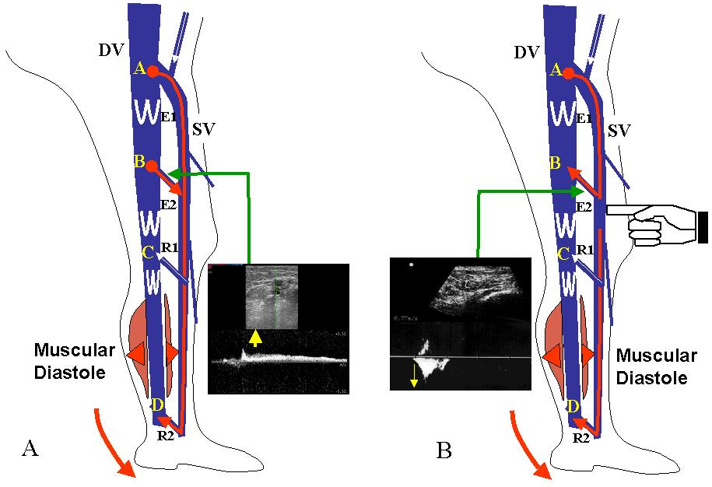
Figure 12.7. Terminalization Phenomenon of an incompetent Hunter perforator, with evident reflux in E2. In b, finger compression below the superficial outlet, by modifying the haemodynamic forces, determines in-ward flow in diastole.
It is important to note that some non-terminal perforators stop refluxing in diastole (at least at a velocity that is detectable on Doppler) simply by reduction of the velocity of the retrograde flow on the surface; this happens when a primary reflux point (for example at the sapheno-femoral junction) is closed and the system is transformed from a refluxing system to an outflow system. Evidence of this may be found by observing the hemodynamics of a perforator after application of manual pressure to the primary reflux point (generally assumed to be the saphenofemoral junction) or by compressing a refluxing saphenous trunk.
A terminal or terminalized perforator should be considered as a hemodynamically valid re-entry whenever drainage of the system through the perforator is detected during the relaxation stage.
From the diagnostic perspective, emptying may be obtained either by a compression-release procedure or by a sway test with the patient standing. Achievement of drainage can be verified either directly by placing the pulsed Doppler sample volume within the perforator or indirectly by detecting a retrograde flow in the vessel longitudinally connected directly or indirectly to the perforator. In this latter case, of course, incompetent tributaries located above the targeted perforator should be excluded by finger compression in order to avoid the effects of other re-entry’s upon the retrograde flow in the vessel in question.

References

- Abbott W.M., Megerman J., Hasson J.E., L'Italien G.J., Warnock D.F. “Effect of compliance mismatch on vascular graft patency” J. Vasc. Surg. 1987;5:376-82
- Agus GB, Mancini S, Magi G; IEWG. The first 1000 cases of Italian Endovenous-laser Working Group (IEWG).Rationale, and long-term outcomes for the 1999-2003 period. Int Angiol. 2006 Jun;25(2):209-15.
- Allegra C, Antignani PL, Bergan JJ, Carpentier PH, Coleridge-Smith P,Cornu-Thenard A, Eklof B, Partsch H, Rabe E, Uhl JF, Widmer MT; “International Union of Phlebology Working Group. The "C" of CEAP: suggested definitions and refinements: an International Union of Phlebology conference of experts.” J Vasc Surg. 2003 Jan;37(1):129-31. No abstract available.
- Allegra C, Bergan J.”Update on fundamental causes and management of chronic venous insufficiency. Executive summary” Angiology. 2003 Jul-Aug;54 Suppl 1:S1-
- Arbeille P, Kerbeci P, Greaves D, Schneider S, Hargens A, Hughson R. Arterial and venous response to Tilt with LBNP test after a 60 day HDT bedrest(WISE study). J Gravit Physiol. 2007 Jul;14(1):P47-8
- Bahnini A, Bailly M, Chiche L, Franceschi C. [Ambulatory conservative hemodynamic correction of venous insufficiency. Technique, results] Ann Chir. 1997;51(7):749-60.
- Bailly M. [Ambulatory and hemodynamic treatment of venous insufficiency (CHIVA cure).Report of an atypical case] J Mal Vasc. 1992;17(3):241-9.
- Bailly M. “Cartographie CHIVA. In: Encyclopédie Médico-Chirurgicale” Paris, 43-161-B, p. 1-4
- Bailly M. “Résultats de la Cure C.H.I.V.A. In: Techniques et stratégie en Chirurgie Vasculaire” Jubilé de J.M. Cormier. Edition A.E.R.C.V., Paris,1992: 255-71
- Baird R.N., Abbott W.M. “Elasticity and compliance of canine femoral and jugular vein segments” Am. J. Physiol.1977;233(1):H15-21
- Baird R.N., Abbott W.M. “Pulsatile blood flow in arterial graft” Lancet 1976;1976:948-50
- Baird R.N., Kidson I.G., L'Italien G.J., Abbott W.M. “Dynamic compliance of arterial graft” Am. J. Physiol. 1977;233(5):H568-72
- Bartolo M, Nicosia PM, Antignani PL, Raffi S, Ricci S, Marchetti M, Pittorino L. Noninvasive venous pressure measurements in different venous diseases. A new case collection. Angiology. 1983 Nov;34(11):717-23.
- Bassi G. “La fisiopatologia delle varici safeniche essenziali. In "Compendio di terapia flebologica” Ed. Minerva Medica, pp 23-30
- Bassi G. “Les mecanismes et les effects des recidives apres traitments actifs de veines perforantes insuffisantes” Phlebologie 1987; 40:743-752
- Bassi G. “Zur chirurgischen Behandlung der insuffizienten Perforanten des Beines” Vasa 1975; 5:252
- Bassi G.l. “Le varici degli arti inferiori” Minerva Medica, 1962
- Bastide. G, Lefebvre D. The "rete venosum plantare" (the plantar venous network or Lejars' venous sole of the foot. Phlebologie. 1993 Apr-Jun;46(2):169-71.
- Belcaro G., Christopoulos D., Nicolaides A.N. “Basic data related to normal and abnormal lower extremity hemodynamics” Ann Vasc Surg 1991; 5:306
- Bergan J, Pascarella L, Mekenas L.”Venous disorders: treatment with sclerosant foam” J Cardiovasc Surg (Torino). 2006 Feb;47(1):9-18.
- Bergan JJ, Pascarella L. “Severe chronic venous insufficiency: primary treatment with sclerofoam” Semin Vasc Surg. 2005 Mar;18(1):49-56.
- Bergan JJ, Rattner Z.”Endovenous therapy”—2005 Acta Chir Belg. 2005 Feb;105(1):12-5.
- Bergan JJ, Schmid-Schonbein GW, Smith PD, Nicolaides AN, Boisseau MR, Eklof B. Chronic venous disease. N Engl J Med. 2006 Aug 3;355(5):488-98.
- Bicknell C, Cheshire NJ. The role of superficial venous operations for leg ulceration. Br J Hosp Med (Lond). 2006 Jun;67(6):305-8.
- Bishop C.C.R., Jarrett P.E.M. “Outpatient varicose vein surgery under local anesthesia” Br J Surg 1986; 73:821-822
- Bjordal R. “Simultaneous pressure and flow recordings in varicose veins of the lower extremity” Acta Chir Scand 1970; 136:309-317
- Bjordal R.I. “Circulation patterns in incompetent perforating veins in the calf and in the saphenous system in primary varicose veins” Acta Chir. Scand. 1972; 138:251
- Bjordal R.I. “Pressure patterns in the saphenous system in patients with venous leg ulcers” Acta Chir Scand 1971; 137:495-501
- Bjordal R.I. “The clinical implications and therapeutical consequences of the observed hemodynamic patterns” In: Perforating veins. Urban & Schwarzenberg, Munchen, 1981
- Bjordal R.J. “Blood Circulation in varicose veins of the lower extremities” Universitetsforlaget. Oslo 1972
- Blanchmaison P., Griton P., Hugentobler J.P., et al “Les valvules ostiales du sujet variqueux. Examen endoscopique” Phlebologie 44:615-622, 1991
- Boersma W. “Quelques remarques sur l’origine périphérique des veins communicantes de la jambe” Phlébologie, 20: 437-443, 1967
- Browse NL, Burnand KG.. The cause of venous ulceration. Lancet. 1982 Jul 31;2(8292):243-5.
- Burton A. “Fisiologia e Biofisica della circolazione” Il Pensiero Scientifico Editore, Roma, 1969
- Caggiati A, Bergan JJ, Gloviczki P, Eklof B, Allegra C, Partsch H;”International Interdisciplinary Consensus Committee on Venous Anatomical Terminology. Nomenclature of the veins of the lower limb: extensions, refinements, and
- Caggiati A, Bergan JJ. The saphenous vein: derivation of its name and its relevant anatomy. J Vasc Surg 2002 Jan;35(1):172-5
- Caggiati A, Ricci S. The caliber of the human long saphenous vein and its congenital variations. Ann Anat. 2000 Mar;182(2):195-201.
- Caggiati A, Ricci S. The long saphenous vein compartment. Phlebology. 1997;12:107–111.
- Caggiati A. Fascial relations and structure of the tributaries of the saphenous veins. Surg Radiol Anat 2000;22(3-4):191-6
- Caggiati A. Fascial relationships of the short saphenous vein. J Vasc Surg 2001 Aug;34(2):241-6
- Caggiati A. The saphenous venous compartments. Surg Radiol Anat 1999;21(1):29-34
- Camilli S., Guarnera G. “L' insufficienza venosa primaria e le possibilità della chirurgia ricostruttiva” Padova: Piccin, 1993
- Campanello M., Hammarsten J., Forsberg C., Bernland P., Henrikson O., Jensen J. Standard Stripping Versus Long Saphenous Vein-Saving surgery for primary varicose veins: a prospective, randomised study with the patients as their own controls. Phlebology 1996; 11:45-9.
- Campbell W.A. “Sapheno-femoral reconnection in recurrent varicose veins” J. Derm. Surg. Onc. 1994;20:67-68
- Cappelli M, Lova RM, Ermini S, Turchi A, Bono G, Bahnini A, Franceschi C. Ambulatory conservative hemodynamic management of varicose veins: critical analysis of results at 3 years. Ann Vasc Surg. 2000 Jul;14(4):376-84.
- Cappelli M, Molino Lova R, Ermini S, Giangrandi I, Giannelli F, Zamboni P. Haemodynamics of the sapheno-femoral complex: an operational diagnosis of proximal femoral valve function. Int Angiol. 2006 Dec;25(4):356-60.
- Cappelli M, Molino Lova R, Ermini S, Turchi A, Bono G, Franceschi C. Comparison between the CHIVA cure and stripping in the treatment of varicose veins of the legs: follow-up of 3 years. J Mal Vasc. 1996;21(1):40-6.
- Cappelli M, Molino Lova R, Ermini S, Zamboni P.”Hemodynamics of the sapheno-femoral junction. Patterns of reflux and their clinical implications.” Int Angiol. 2004 Mar;23(1):25-8.
- Cappelli M., Ermini S., Turchi A., Bono G. “Considérations hémodynamiques sur les perforantes” Phlébologie 1994, 47, 4: 389-393.
- Cappelli M., Ermini S., Turchi A., Bono G. “La sclerose échoguidée” Abstracts XI° Congrès mondial de l’Union internationale de phlébologie Montreal 1992
- Cappelli M., Ermini S., Turchi A., Bono G. “Les reflux d’origine pelvienne” Abstracts XI° Congrès mondial de l’Union internationale de phlébologie Montreal 1992
- Cappelli M., Ermini S., Turchi A., Bono G. “Perchè conservare le safene” Atti XI° congresso nazionale della Società Italiana di Flebologia Clinica e Sperimentale. Torino 1994
- Cappelli M., Ermini S., Turchi A., Bono G., Molino Lova R. “Considérations hémodynamiques sur la vidange saphénienne” Phlébologie 1995, 48, 4: 491-498
- Cappelli M., Ermini S., Turchi A., Bono G., Molino Lova R. “Réflexions sur quelques aspects généraux d’hydrodynamique et d’hydrostatique” Phlébologie 1995, 48, 3: 367-370
- Cappelli M., Molino Lova R., Ermini S., Turchi A., Bono G., Bahanini A., Franceschi C.I. “La Cure C.H.I.V.A. dans le traitement de la Maladie Variqueuse : analyse critique des résultats après trois ans” Ann. Chir. Vasc. 2000; 14 : 376-84.
- Carandina S, Mari C, De Palma M, Marcellino MG, Cisno C, Legnaro A, Liboni A,Zamboni P. Varicose vein stripping vs haemodynamic correction (CHIVA): a long term randomised trial. Eur J Vasc Endovasc Surg. 2008 Feb;35(2):230-7. Epub 2007 Oct 26.
- Cavezzi A, Labropoulos N, Partsch H, Ricci S, Caggiati A, Myers K, Nicolaides A, Smith PC. Duplex ultrasound investigation of the veins in chronic venous disease of the lower limbs--UIP consensus document. Part II. Anatomy. Eur J Vasc Endovasc Surg. 2006 Mar;31(3):288-99.
- Christopoulos D., et al. “Venous reflux: quantification and correlation with the clinical severity of chronic venous disease” Br. J. Surg. 1988; 75:352
- Christopoulos D., Nicolaides A.N., Szendro G., Irvine A.T., Bull M.T., Eastcott H.G. “Air-plethysmography and the effect of elastic compression on venous hemodynamics of the leg” J Vasc Surg 1987; 5:148
- Cockett FB, Jones DE The ankle blow-out syndrome. Lancet 1; 17, 1953
- Coleridge-Smith P, Labropoulos N, Partsch H, Myers K, Nicolaides A, Cavezzi A. Duplex ultrasound investigation of the veins in chronic venous disease of the lower limbs--UIP consensus document. Part I. Basic principles. Eur J Vasc Endovasc Surg. 2006 Jan;31(1):83-92
- Consiglio L., Giorgi G “ Terapia di exeresi o conservativa?” Minerva Ang. 1991;16, sup.1: 442-3.
- Corcos L, Dini S, De Anna D, Marangoni O, Ferlaino E, Procacci T, Spina T,Dini M. The immediate effects of endovenous diode 808-nm laser in the greater saphenous vein: morphologic study and clinical implications. J Vasc Surg. 2005 Jun;41(6):1018-24; discussion 1025.
- Cox S.J., Wellwood J.M., Martin A. “Saphenous nerve injury caused by stripping the long saphenous vein” Br. Med. Journal 1974; 286:415-7 8
- Creton D. 125 reinterventions for recurrent popliteal varicose veins after excision of the short saphenous vein. Anatomical and physiological hypoteses of the mechanism of recurrence. J Mal Vasc 1999 Feb; 24(1):30-6
- Creton D. A nondraining saphenous system is a factor of poor prognosis for long-term results in surgery of Great Saphenous vein recurrences. Dermatol. Surg. 2004; 30:5:May.
- Creton D.: Recidive variquese poplitée après chirurgie du reflux saphène externe 56 rèinterventions poplitées, Phlebologie, 1996, 49: 205-212
- Cromer A.H. “Physics for the Life Sciences” New York, Mc Graw Hill, 1977, pp136-45
- Crotty T.P. “An investigation of radial reflux in an isolated peripheral canine vein segment” Phlebology 10: 115-121, 1995
- Danielsson G, Eklof B, Kistner RL. Association of venous volume and diameter of incompetent perforator veins in the lower limb--implications for perforator vein surgery. Eur J Vasc Endovasc Surg. 2005 Dec;30(6):670-3.
- Darke S.G.: “The morphology of recurrent varicose veins” Eur. J. Vasc. Surg. 1992;512-7. 8
- Dauzat M. “Ultrasonographie vasculaire diagnostique” Vigot, Paris, 1991
- Davies A.H., Magee T.R., Baird R.N., Sheffield E., Horrocks M. “Pre-bypass morphological changes in vein grafts” Eur J Vasc Surg 1993; 7:642-647
- Davies A.H., Magee T.R., Baird R.N., Sheffield E., Horrocks M. “Vein compliance: a preoperative indicator of vein morphology and of veins at risk of vascular graft stenosis” Br. J. Surg. 1992;79:1019-21
- Davies A.H., Magee T.R., Hayward J., Harris R., Baird R.N., Horrocks M. “Non-invasive methods of measuring venous compliance” Phlebology 1992;7:78-81
- De Palma M, S.Carandina, P.Mazza, P. Fortini, A. Legnaro, A. Palazzo, A. Liboni, P. Zamboni. Perforator of the popliteal fossa and short saphenous vein insufficiency. Phlebology, 2005,20:170-174
- De Simone J.G. “Etude de la valvule ostiale de la crosse de la saphene interne et de la parietale de la veine femorale” Phlebologie 44:427-459, 1991
- DeCamp P.T., Ward J.A., Ochsner A. “Ambulatory venous pressure studies in postphlebitic and other disease states” Surgery 1951; 29:365-380
- Delis KT, Husmann M, Kalodiki E, Wolfe JH, Nicolaides AN. In situ hemodynamics of perforating veins in chronic venous insufficiency. J Vasc Surg. 2001 Apr;33(4):773-82.
- Delis KT, Knaggs AL, Khodabakhsh P. Prevalence, anatomic patterns, valvular competence, and clinical significance of the Giacomini vein. J Vasc Surg. 2004 Dec;40(6):1174-83.
- Della Corte M. “Manuale di fisica medica” Società Editrice Universo 1988
- Disselhoff BC, der Kinderen DJ, Moll FL. Is there recanalization of the great saphenous vein 2 years after endovenous laser treatment? J Endovasc Ther. 2005 Dec;12(6):731-8.
- Dodd H.: the varicose tributaries of the popliteal vein, Brit. J. Surg, 1965, vol 52, n° 5 May 350-354
- Dunn CW, Kabnick LS, Merchant RF, Owens R, Weiss RA. Endovascular Radiofrequency Obliteration Using 90 degrees C for Treatment of Great Saphenous Vein. Ann Vasc Surg. 2006 Jul 25;
- Edwards J.E., Edwards E.A. “The saphenous valves in varicose veins” Am. Heart J. 19:338-351, 1940
- Einarsson E., Eklof B., Neglén P. “Sclerotherapy or Surgery as Treatment for Varicose Veins: a Prospective Randomized Study” Phlebology 1993; 8: 22-26
- Eklof B, Rutherford RB, Bergan JJ, Carpentier PH, Gloviczki P, Kistner RL,Meissner MH, Moneta GL, Myers K, Padberg FT, Perrin M, Ruckley CV, Smith PC,Wakefield TW; “American Venous Forum International Ad Hoc Committee for Revisionof the CEAP Classification. Revision of the CEAP classification for chronic venous disorders: consensus Statement” J Vasc Surg. 2004 Dec;40(6):1248-52.
- Eklof B. “Modern Treatment of Varicose Veins” Br. J. Surg. 1988; 75: 297-98
- Elfstrom J, In: Tesi M, Dormandy JA (eds): Superficial and deep venous disease of the lower limbs. Edizioni Minerva Medica, Torino 1984 pp 258-60.
- Escribano JM, Juan J, Bofill R, Maeso J, Rodriguez-Mori A, Matas M. Durability of reflux-elimination by a minimal invasive CHIVA procedure on patients with varicose veins. A 3-year prospective case study. Eur J Vasc Endovasc Surg. 2003 Feb;25(2):159-63.
- Escribano JM, Juan J, Bofill R, Rodriguez-Mori A, Maeso J, Fuentes JM, Matas M. Haemodynamic strategy for treatment of diastolic anterograde giacomini varicose veins. Eur J Vasc Endovasc Surg. 2005 Jul;30(1):96-101.
- Escribano JM.”Regarding "Optimal therapy for advanced chronic venous insufficiency" J Vasc Surg. 2003 Aug;38(2):411; author reply 411
- Evans R.L., Pelley J.W., Quenemoen L. “Some simple geometric and mechanical characteristics of mammalian blood vessels” Am. J. Physiol. 1960;199:1150-6
- Fegan W.G. “Varicose veins: the “Bob-sleigh” theory” Phlebology 8: 142-144, 1993
- Fegan W.G., Kline L. “The cause of varicosity in superficial veins of the lower limb” Br. J. Surg. 59: 798-801, 1972
- Fichelle JM, Carbone P, Franceschi C. [Results of ambulatory and hemodynamic treatment of venous insufficiency (CHIVA cure)]J Mal Vasc. 1992;17(3):224-8.
- Fischer R., Linde N., Duff C., Jeanneret C., Chandler JG., Seeber P. Late recurrent saphenofemoral junction reflux after ligation and stripping of a greater saphenous vein. J. Vasc. Surg. 2001; 34:236-40.
- Fligelstone L. , Salaman R., Oshodi T., Wright I., Pugh N., Shandall A., Lane I. Flush saphenofemoral ligation and multiple stab phlebectomy preserve a useful greater saphenous vein four years after surgery. J. Vascular Surg. 1995 ;22 :588-92.
- Fligelstone L., Carolan G., Pugh N., Shandall A., Lane I. “An assessment of the long saphenous vein for potential use as a vascular conduit after varicose vein surgery” J. Vasc. Surg. 1993; 18:836-40 8
- Franceschi C. [Ambulatory and hemodynamic treatment of venous insufficiency (CHIVA cure)] J Mal Vasc. 1992;17(4):291-300.
- Franceschi C. [Conservative hemodynamic ambulatory treatment of venous insufficiency]Soins Chir. 1992 Mar;(133):29-31.
- Franceschi C. [Measures and interpretation of venous flow in stress tests. Manual compression and Parana manoeuver. Dynamic reflux index and Pstakis index] J Mal Vasc. 1997 May;22(2):91-5.
- Franceschi C. [The conservative and hemodynamic treatment of ambulatory venous insufficiency] Phlebologie. 1989 Nov-Dec;42(4):567-8.
- Franceschi C. “La cure CHIVA et la critique: 14 responses et 1 conclusion” STV 1993; 5:491-497
- Franceschi C.l. “Théorie et Pratique de la Cure Conservatrice et Hémodynamique de l' Insuffisance Veineuse en Ambulatiore” Précy-sous-Thil: Editions de l' Armançon, 1988
- Francheschi C, Bahnini A. Treatment of lower extremity venous insufficiency due to pelvic leak points in women. Ann Vasc Surg. 2005 Mar;19(2):284-8
- Franco G. “Exploration ècho-Doppler des veines perforantes des membres inférieurs” Actualités Vasculaires Internationales, nov. 1992 n° 6
- Franco G. “La Cure Hémodynamique de l' Insuffisance Veineuse en Ambulatiore (CHIVA). Révolution ou régression” J. Mal. Vasc. 1992; 17; 301-307
- Franco G. Ultrasonographic exploration for recurrent varicose veins in the popliteal fossa after surgery. J Mal Vasc. 1997 Dec ; 22(5) : 336-42
- Frings N, Nelle A, Tran P, Fischer R, Krug W. Reduction of neoreflux after correctly performed ligation of the saphenofemoral junction. A randomized trial. Eur J Vasc Endovasc Surg. 2004 Sep;28(3):246-52.
- Georgiev M, Myers KA, Belcaro G. The thigh extension of the lesser saphenous vein: from Giacomini's observations to ultrasound scan imaging. J Vasc Surg. 2003 Mar;37(3):558-63.
- Georgiev M. “The femoro-popliteal vein: Ultrasound anatomy, diagnosis and office surgery” Dermatol Surg. 1996 22: 57-62
- Gillot C.l. “Les veines perforantes internes de la jambe, de la cheville et du pied” Phlébologie 1994 47, n°1, 76-104
- Glass G.M. “Neovascularisation in recurrence of the varicose great saphenous vein following transection” Phlebology 1987; 2:81-92
- Gloviczki P, Bergen JJ, Rhodes JM, Canton LG, Harmsen S, Ilstrup D. Mid-term results of endoscopic perforator vein interruption for chronic venous insufficiency: lessons learned from the North American Subfascial Endoscopic Perforator Surgery registry. J Vasc Surg 1999;29:489-502.
- Goren G., Tellin A.E. “Ambulatory stab evulsion phlebectomy for truncal varicose veins” Am. J. Surg. 1991; 162:166-74
- Gorny P. “Les excés de la “Philosophie” conservatrice dans la chirurgie des varices” Phlébologie 1995, 48, 3: 303-305
- Gorny Ph., Blanchemaison Ph., Chahine D., Hutinel B., Chanvallon C., Payen B., Reinharez D. “Chirurgie Conservatrice et Ambulatiore: étude comparative entre CHIVA et Crossectomie chez 321 patients opérés de la saphène interne. Discussion” Phlébologie 1995, 48, 2: 255-259
- Gorny Ph., Chahine D., Payen B., Hutinel B., Blanchemaison Ph., Renaudin J.M., Tran-Duy S. “Crossectomie, éveinage court ou long? Une étude comparative chez 703 patients opérés de la veine saphène interne. Analyse des résultas” Phlébologie 1995, 48, 4: 487-490
- Gorny Ph., Reinharez D., Hutinel B., Radier P., Blanchemaison Ph., Payen B., Tran-Duy S. “Chirurgie post-stripping en ambulatoire” Phlébologie 1994, 47, 3: 265-273
- Goulbourne I.A., Ruckley C.V. “Operations for hernia and varicose vein in a day-bed unit” Br. Med. J. 1979; 2:712-714
- Green G.E., Hutchinson J.E., Mc Cord C. “Choice of saphenous vein segments for aortocoronary grafts” Surgery 1971; 69:924-7
- Guarnera G., Furgiuele S., Di Paola F.M., Camilli S. “Recurrent varicose veins and primary deep venous insufficiency: relationship and therapeutic implications” Phlebology 1995; 10:98-102
- Guex J.J., Hiltbrand B., Bayron J.M., Henri F., Allaert F.A., Perrin M. “Anatomical patterns in varicose vein disease: a duplex scanning study” Phlebology 1995; 10:94-97
- Haeger K. “Five year results of Radical Surgery for Superficial Varices with or without Coexistent Perforator Insufficiency” Acta Chir. Scand. 1966; 131: 38-49
- Hammarsten J., Bernland P., Campanello M., Falkenberg M., Henrikson O., Jensen J. A study of the mechanisms by which haemodynamic function improves following Long Saphenous vein-saving surgery. . Phlebology 1996; 11: 102-5.
- Hammarsten J., Campanello M., Pederson P. “Long saphenous vein sparing surgery for varicose veins. Correspondence” Eur. J. Vasc. Surg. 1993;7:763-4. 8
- Hammarsten J., Pedersen P., Cederlund C.G., Campanello M. “Long saphenous vein sparing surgery for varicose veins. A long term follow-up” Eur. J. Vasc. Surg. 1990; 4:361-4. 8
- Harada RN, Katz ML, Comerota A: A non invasive screening test to detect critical deep venous reflux" J Vasc Surg 1995, 22: 532-37
- Hartmann K, Klode J, Pfister R, Toussaint M, Weingart I, Waldermann F,Hartmann M. Recurrent varicose veins: sonography-based re-examination of 210 patients 14 years after ligation and saphenous vein stripping. Vasa. 2006 Feb;35(1):21-6.
- Hobbs J.T . Surgery or slerotherapy for varicose veins: 10year results of a random trial. Lancet 1978; 27;1(8074):1149.
- Hobbs J.T. “Surgery and Sclerotherapy in the treatment of Varicose Veins” Arch. Surg. 1974; 109: 793-96
- Hobbs JT The enigma of the gastrocnemius vein Phlebology 1988;3:8-12
- Hobbs JT. Varicose veins arising from the pelvis due to ovarian vein incompetence. Int J Clin Pract. 2005 Oct;59(10):1195-203.
- Hojensgard I.C., Sturup H. “Venous pressure in primary and postthrombotic varicose veins. A study of the statics and dynamics of the venous system of the lower extremity under pathological conditions” I. Acta Chir. Scand. 1949; 99:133-153
- Hugentobler J.P., Blanchmaison P. “CHIVA cure. Etude de 96 patients opres de juin 1988 a juin 1990” J. Mal. Vasc. 1992;17:218-23
- Ibegbuna V, Delis KT, Nicolaides AN. Haemodynamic and clinical impact of superficial, deep and perforator vein incompetence. Eur J Vasc Endovasc Surg. 2006 May;31(5):535-41.
- Illig GK “Photoplethysmography and calf muscle pump function after subfascial endoscopic perforator ligation” J Vasc Surg 1999; 30: 1067-76
- International Consensus Committee. “Classification and grading of chronic venous disease in the lower limbs: A Consensus Statement” Phlebology 1995;10:42-5
- Jakobsen B.H. “The value of different forms of treatment for varicose veins” Br. J. Surg. 1979;66:182-84
- Kakkos SK, Bountouroglou DG, Azzam M, Kalodiki E, Daskalopoulos M, Geroulakos G. Effectiveness and safety of ultrasound-guided foam sclerotherapy for recurrent varicose veins: immediate results. J Endovasc Ther. 2006 Jun;13(3):357-64.
- Kistner RL, Eklof B, Masuda EM. Deep venous valve reconstruction. Cardiovasc Surg. 1995 Apr;3(2):129-40.
- Kistner R.L., Ferris E.B., Randhaw G., Kamida C. “A method of performing descending venography” J. Vasc. Surg. 1986; 4:464-468
- Koyano K, Sakaguchi S. Selective stripping operation based on Doppler ultrasonic findings for primary varicose veins of the lower extremities. Surgery 1988; 103:615-9
- Kupinsky A.M., Evans S.M., Khan, Zorn T.J. “Ultrasonic characterization of the saphenous vein” Cardiovasc. Surg. 1993 1:513-7
- Labropoulos N, Leon L, Engelhorn CA, Amaral SI, Rodriguez H, Kang SS, Mansour AM, Littooy FN. Sapheno-femoral junction reflux in patients with a normal saphenous trunk. Eur J Vasc Endovasc Surg. 2004 Dec;28(6):595-9.
- Labropoulos N, Leon L, Kwon S, Tassiopoulos A, Gonzalez-Fajardo JA, Kang SS, Mansour MA, Littooy FN. Study of the venous reflux progression. J Vasc Surg. 2005 Feb;41(2):291-5.
- Labropoulos N, Leon LR Jr. Duplex evaluation of venous insufficiency. Semin Vasc Surg. 2005 Mar;18(1):5-9.
- Labropoulos N, Manalo D, Patel NP, Tiongson J, Pryor L, Giannoukas AD.”Uncommon leg ulcers in the lower extremity” J Vasc Surg. 2007 Mar;45(3):568-573. Epub 2007 Jan 25.
- Labropoulos N, Tassiopoulos AK, Bhatti AF, Leon L. Development of reflux in the perforator veins in limbs with primary venous disease. J Vasc Surg. 2006 Mar;43(3):558-62.
- Labropoulos N, Tiongson J, Pryor L, Tassiopoulos AK, Kang SS, AshrafMansour M, Baker WH. Definition of venous reflux in lower-extremity veins. J Vasc Surg. 2003 Oct;38(4):793-8.
- Labropoulos N, Tiongson J, Pryor L, Tassiopoulos AK, Kang SS, Mansour MA,Baker WH. Nonsaphenous superficial vein reflux. J Vasc Surg. 2001 Nov;34(5):872-7.
- Large J. “A conflict in vascular surgery” Aust. N. Z. J. Surg. 1985; 55:373-6
- Large J. “Surgical treatment of saphenous varices with preservation of the main great saphenous trunk” J. Vasc. Surg. 1985; 2:886-91 8
- Larson R.H., Lofgren E.P., Myers T.T., Lofgren K.A. “Long-term Results After Vein Surgery” Mayo Clin. Proc. 1974; 49: 114-17
- Laurikka J., Sisto T., Salenius J.P., Tarkka M., Auvinen O. “Long Saphenous Vein Stripping in the Treatment of Varicose Veins: Self- and Surgeon-Assessed Results After 10 Years” Phebology 1994; 9: 13-16
- Lemaire R. “Les structures motrices responsables de l’écoulement veineux” Journal des maladies vasculaires Tome 14 n° 2 1989 95-99
- Lemasle Ph, Uhl Jf, Lefebvre-Vilarderbo M, Baud JM. Proposition d’une definition echographique de la grande saphene et des saphenes accessories a l’etage crural. Phlébologie 1996; 49:279-86.
- Lewis J.D., Parsons D.C.S., Needham T.N., Douglas J.N., Hobbs J.T., Nicolaides A.N. “The use of venous pressure measurements and directional Doppler recording in distinguishing between superficial and deep valvular incompetence in patients with venous insufficiency” Br. J. Surg. 1973;60:312-8
- Li AKC “A technique for re-exploration of the s-f junction” Br.J. Surg 1975 62; 745-46
- Liddle AD, Davies AH. Pelvic congestion syndrome: chronic pelvic pain caused by ovarian and internal iliac varices. Phlebology. 2007;22(3):100-4.
- Lin JC, Iafrati MD, O'Donnell TF Jr, Estes JM, Mackey WC. Correlation of duplex ultrasound scanning-derived valve closure time and clinical classification in patients with small saphenous vein reflux: Is lesser saphenous vein truly lesser? J Vasc Surg. 2004 May;39(5):1053-8.
- Lofgren E.P. and Lofgren K.A. “Recurrence of Varicose Veins After the Stripping Operation” Arch. Surg. 1971; 102: 111-14
- Lofgren K.A., Ribisi A.P., Myers T.T.”An evaluation of stripping versus ligation for varicose veins” Arch. Surg. 1958; 76:310-316 8
- Lurie F, Creton D, Eklof B, Kabnick LS, Kistner RL, Pichot O, Sessa C, Schuller-Petrovic S. Prospective randomised study of endovenous radiofrequency obliteration(closure) versus ligation and vein stripping (EVOLVeS): two-year follow-up. Eur J Vasc Endovasc Surg. 2005 Jan;29(1):67-73.
- Lye C.R., Sumner D.S., Strandness D.E. “The transcutaneous measurement of the elastic properties of the human saphenous vein femoro-popliteal bypass graft” Surg. Gynaecol. Obst. 1975;141:891-5
- Maeso J, Juan J, Escribano J, Allegue NM, Di Matteo A, Gonzalez E, Matas M. Comparison of clinical outcome of stripping and CHIVA for treatment of varicose veins in the lower extremities. Ann Vasc Surg. 2001 Nov;15(6):661-5.
- Maleti O, Lugli M. Neovalve construction in postthrombotic syndrome. J Vasc Surg. 2006 Apr;43(4):794-9.
- Mandolesi S. e Coll. “Etude orthodynamique par Doppler cw du réseau veineux superficiel dans les syndromes par obstacle de décharge des membres inférieures” XI° Congres Mondial de l’Union Internationale de Phlébologie Montreal 1992
- Marongiu G.M. “In quali casi e' indicata la crossectomia isolata nel trattamento della malattia varicosa essenziale? E infine se ne puo' intravedere una indicazione a scopo profilattico?” Atti Giornate Flebologiche Algheresi, pag. 43-46, 1989
- Mashiah A., Rose S.S., Hod I. “The scanning electronic microscope in the pathology of varicose veins” Israel J. Med. Sci. 27:202-206, 1991
- Masuda E.M., Kistner R.L., Eklof B. “Prospective study of duplex scanning for venous reflux: comparison of Valsalva and pneumatic cuff techniques in the reverse Trendelemburg and standing positions” J.Vasc. Surg. 1994; 20: 711-20
- May R. “Nomenclature of the surgically most important connecting veins. In: Perforating veins” Urban & Schwarzenberg, Munchen, 1981
- Mc Farlane R., Godwin R.J., Barabas A.P. “Are varicose veins and coronary bypass surgery incompatible?” Lancet 1985; ii:859
- McMullin G.M., Coleridge-Smith P.D., Scurr J.H. “Objective assesment of high ligation without stripping the long saphenous vein” Br. J. Surg. 1991; 78:1139-42 8
- Meissner MH, Gloviczki P, Bergan J, Kistner RL, Morrison N, Pannier F, Pappas PJ, Rabe E, Raju S, Villavicencio JL. Primary chronic venous disorders. J Vasc Surg. 2007;46:54-67.
- Mellman J. Wupperman Th. “Morphometric properties of incompetent perforaiting veins in the phlebogram” In May R. Perforating Veins. Urban unt Schwarzenberg. Munchen, Wien Baltimore, 1981
- Mendes RR, Marston WA, Farber MA, Keagy BA. Treatment of superficial and perforator venous incompetence without deep venous insufficiency: is routine perforator ligation necessary? J Vasc Surg. 2003;38:891-5.
- Mendoza E. Duplexsonographie der oberflachlichen beinvenen. Steinkopff-Verlag, Darmstadt 2007.
- Munn S.R., Morton J.B., Mac Berth W.A.A.G., Mac Leish A.R. “To strip or not to strip the long saphenous vein? A varicose veins trial” Br. J. Surg. 1981; 68: 426-8
- Navarro TP, Delis KT, Ribeiro AP. Clinical and hemodynamic significance of the greater saphenous vein diameter in chronic venous insufficiency. Arch Surg 2002; 137:1233-1237;
- Negus D. “Should the incompetent saphenous vein be stripped to the ankle?” Phlebology 1986;1:33-6. 8
- Nicolaides A.N., Zukowski A.J. “The value of dynamic venous pressure measurements” World J. Surg. 1986; 10:919-924
- Nicolaides AN, The International Consensus Group“ The investigation of chronic venous insufficiency. A Consensus Statement”. Circulation 2000, 102 (20):e126
- Nicolaides AN; Cardiovascular Disease Educational and Research Trust; European Society of Vascular Surgery; The International Angiology Scientific Activity Congress Organization; International Union of Angiology; Union Internationale de Phlebologie at the Abbaye des Vaux de Cernay. Investigation of chronic venous insufficiency: A consensus statement (France,March 5-9, 1997).Circulation. 2000 Nov 14;102(20):E126-63.
- Norgren L, Thulesius O, Gjöres JE, Söderlundh S. Foot-volumetry and simultaneous venous pressure measurements for evaluation of venous insufficiency. Vasa. 1974;3(2):140-7.
- Patel D.J., Greenfield J.C. Jr., Fry D.L. “In vivo pressure-length-radius relationship of certain blood vessel in man and dog” In: Ahinger EO ed. Pulsatile blood flow. New York: Mc Graw Hill, 1964:293-305
- Payne S.P.K., London N.J.M., Jagger C., et al. “Clinical significance of venous reflux detected by duplex scanning” Br. J. Surg. 1994; 81:39-41
- Perrin M, Allaert FA. Intra- and Inter-observer Reproducibility of the Recurrent Varicose Veins after Surgery (REVAS) Classification. Eur J Vasc Endovasc Surg. 2006 Sep;32(3):326-32.
- Perrin M, Guidicelli H, Rastel D. Surgical techniques used for the treatment of varicose veins: survey of practice in France J Mal Vasc. 2003;28;277-86
- Perrin MR.,Labropoulos N., Leon LR. Jr. Presentation of the patient with recurrent varices after surgery (REVAS). J. Vasc. Surg. 2006; 43:327-34.
- Phifer TJ, Gerlock AJ Jr, Rich NM, McDonald JC. Long-term patency of venous repairs demonstrated by venography. J Trauma. 1985 Apr;25(4):342-6.
- Pollack A.A., Wood E.H. “Venous pressure in the saphenous vein at the ankle in man during exercise and changes in posture” J. Appl. Phys. 1949; 1:649-662
- Pozzi L. “Elementi di emodinamica”La Medicina Internazionale, 1972 n° 15
- Rabe E. “The classification of insufficient perforating veins by color duplex sonography” Phlebology 1994; 23:146-148
- Raju S., Fredericks R. “Valve reconstruction procedures for nonobstructive venous insufficiency: rationale, techniques and results in 107 procedures with two-to eight-year follow-up” J. Vasc. Surg. 1988; 7:301-310
- Raju S, Neglen P. High prevalence of nonthrombotic iliac vein lesions in chronic venous disease: a permissive role in pathogenicity. J Vasc Surg. 2006 Jul;44(1):136-43; discussion 144.
- Rettori R. Postoperative recurrence of varicosities at the level of the popliteal fossa. Anatomic data guiding the ultrasonographic exploration and surgical sequelae. J Mal Vasc. 1998 Feb ; 23 (1) : 54-60
- Ricci S, Georgiev M, Jawien A, Zamboni P. Sciatic nerve varices. Eur J Vasc Endovasc Surg. 2005 Jan;29(1):83-7.
- Ricci S., Caggiati A., Echoanatomical Patterns of the Long Saphenous Vein in Patients with Primary Varices and in Healty Subjects. Phlebology Volume 14, Issue 2, pp 54-58.
- Ricci S., Georgiev M., Goldman M. “Ambulatory Phlebectomy" Mosby Y. B., New York 1995
- Rich NM. Complications of vascular injury management. Surg Clin North Am. 2002 Feb;82(1):143-74.
- Rich NM. Management of venous trauma. Surg Clin North Am. 1988 Aug;68(4):809-21.
- Rivlin S. “The surgical cure of primary varicose veins” Br. J. Surg. 1975; 62: 913-17
- Rizzi A, Quaglio D, Vasquez G, Mascoli F, Amadesi S, Calo G, Regoli D, ZamboniP. Effects of vasoactive agents in healthy and diseased human saphenous veins. J Vasc Surg. 1998 Nov;28(5):855-61.
- Rose S.S., Ahmed A “Some thoughts on the etiology of varicose veins” J. Cardiovasc. Surg. 27:534-543, 1986
- Ruckley CV, Evans CJ, Allan PL, Lee AJ, Fowkes FG. Chronic venous insufficiency: clinical and duplex correlations. The Edinburgh Vein Study of venous disorders in the general population. J Vasc Surg. 2002 Sep;36(3):520-5.
- Rutheford R.B., Sawyer J.D., Jones D.N. “The fate of residual saphenous vein after partial removal or ligation” J. Vasc. Surg. 1990;12:422-26
- Rutherford EE, Kianifard B, Cook SJ, Holdstock JM, Whiteley MS Incompetent perforating veins are associated with recurrent varicose veins Eur J Vasc Endovasc Surg 2001;75:458.
- Sales CM, Bilof ML, Petrillo KA, Luka NL. Correction of lower extremity deep venous incompetence by ablation of superficial venous reflux. Ann Vasc Surg 1996; 10: 186–189.
- Sarin S., Scurr J.H., Coleridge Smith P.D. “Saphenofemoral junction recurrence after surgical ligation” J. Derm. Surg. Onc. 1994;20:70
- Sarin S., Scurr J.H., Smith Coleridge P.D., Medial calf perforators in venous disease: the significance of outward flow, J Vasc Surg 1992;16:40-6.
- Sarin S., Shields D.A., Farrah J., Scurr J.H., Coleridge-Smith P.D. “Does venous function deteriorate in patients waiting for varicose surgery?” J. R. Soc. Med. 1993; 86:21-23
- Sarin S., Shields D.A., Scurr J.H., et al “Photopletismography: A valuable non invasive tool in the assessment of venous dysfunction” J. Vasc. Surg. 16:154-162, 1992
- Sarin S., Sommerville K., Farah J., Scurr J.H., Coleridge Smith P.D. “Duplex ultrasonography for assessment of venous valvular function of the lower limb” Br. J. Surg. 1994; 81:1591-5 8
- Shah D.M, Chang BB, Leopold PW, Corson JD, Leather RP, Karmody AM. The anatomy of the greater saphenous venous system” J. Vasc. Surg. 1987; 6:107-13 12
- Sharif MA, Soong CV, Lau LL, Corvan R, Lee B, Hannon RJ. Endovenous laser treatment for long saphenous vein incompetence. Br J Surg. 2006 Jul;93(7):831-5.
- Stacey MC, Burnand KG, Layer GT, Pattison M. Calf pump function in patients with healed venous ulcers is not improved by surgery to the communicating veins or by elastic stockings. Br J Surg 1988; 75:436-9.
- Stegall F.H. “Muscle Pumping in the Dependente Leg” Circulation Reserch. July 1966 Vol. XIX
- Stiegler H., Rotter G., Standl R., et al. “The value of color-coded duplex sonography in the diagnosis of perforating vein insufficiency: a prospective study in 94 patients” VASA 1994; 23:109-113
- Stolic “Terminology, division and systematic anatomy of communicating veins” In: Perforating Veins, May R. et al., Urban Schwarzenberg, Munchen Wien Baltimore, 1981
- Sturup H., Hojensgard I.C. “Venous pressure in varicose veins in patients with incompetent communicating veins. A study of the statics and dynamics of the venous system of the lower extremity under pathological conditions” Acta Chir. Scand. 1949; 99:518-525
- Sullivan E.D., Peter D.J., Cranley J.J. “Realtime B-mode venous ultrasound” J. Vasc. Surg. 1984;1:465-71
- Szendro G., Nicolaides A.N., Zukowski A. et al “Duplex scanning in the assessment of deep venous incompetence” J. Vasc. Surg. 1986; 4:237
- Talbot S.R. “B-mode evaluation of peripheral veins” Semin. Ultrasound CT MR 1988;9:295-319
- Taulaniemi E. “On the treatm0ent of varices”Acta Chir. Scand. 1963, 125: 429-432
- Tessari L. "Messa a punto sul metodo emodinamico della malattia varicosa"Atti Giornate Flebologiche Algheresi, pag. 521-24 1989
- Thiery L.: Anatomie chirurgicale de la fosse poplitée, Phlebologie, 1986, 39 (1), 57-66
- Thiery L.: Le problème des perforantes, Phlebologie, 1988, 41 (1), 215-228
- Thomson H. The surgical anatomy of the superficial and perforating veins of the lower limb. Ann R Coll Surg Engl. 1979;61:198–205.
- Thulesius O. “Vein wall characteristics and valvular function in chronic venous insufficiency” Phlebology 1993; 8:94-98
- Thulesius O, Norgren L, Gjöres JE. Foot-volumetry, a new method for objective assessment of edema and venous function. Vasa. 1973;2(4):325-9.
- Thulesius O., Ugaily-Thulesius L., Neglen P., Shuhaiber H. “The role of the endoteluim in the control of venous tone: studies on isolate,d human veins” Clin Physiol 1988; 8:359-366
- Tibbs J. D. Fletcher E. W. L. “Direction of flow in superficial veins as a guide to venous disorders in lower limbs” Surgery, 1983; 93; 6; pp. 758-767
- Ting AC, Cheng SW, Ho P, Poon JT, Wu LL, Cheung GC. Reduction in deep vein reflux after concomitant subfascial endoscopic perforating vein surgery and superficial vein ablation in advanced primary chronic venous insufficiency. J Vasc Surg. 2006 Mar;43(3):546-50.
- Ting AC, Cheng SW, Wu LL, Cheung GC. Changes in venous hemodynamics after superficial vein surgery for mixed superficial and deep venous insufficiency. World J Surg. 2001 Feb;25(2):122-5.
- Traissac B, Sagardoy G. [Role of elastic containment with calibrated biflex bandages in the treatment of venous insufficiency in athletes and in vascular rehabilitation] Phlebologie. 1986 Jan-Mar;39(1):173-82.
- Trendelenburg F. “Ueber die Unterbindung der Saphena magna bei Unterschenkelvaricen” Beitr Klin. Chir. 1981; 7:195
- Tretbar L.L. “Ambulatory venous blood flow in the long saphenous vein before and after clipping the sapheno-femoral junction” J. Surg. Derm. Onc. 1994;20: 69-70
- Umeh H.N., Faber R.G., Reece-Smith H., Galland R.B. “Impact of a waiting list initiative on a general surgical waiting list” Ann. R. Coll. Surg. Engl. (Suppl) 1994; 39:103-105
- Van Bemmelen PS, Beach K, Bedford G, Strandness DE Jr. The mechanism of venous valve closure. Its relationship to the velocity of reverse flow. Arch Surg. 1990 May;125(5):617-9.
- Van Cleef J.F. “Modèl dynamique de la pompe musculaire du mollet dans l’insuffisance veineus Profonde” Phlébologie, 1992, 45, n° 3, pp. 259-263
- Van Cleef J.F., Hugentobler J.P., Desnaux P., et al “Quelques aspects endoscopiques de valvules chez la variqueux” Phlebologie 44:623-627, 1991
- Varty K., Jones L., Porter E., Bell P.R.F., London N.J.M.L. “A quantitative study of long saphenous vein morphology in patients undergoing arterial surgery” Phlebology 1995; 10:90-93
- Villaviciencio L. “The anatomic basis for the unreliability of the Doppler examination under Valsalva manouver” Phlebologie-Phlebology 92, vol. 2, ed. by Martimbeau P.R., Prescott R., Zummo M. Paris: Libbey, 1992, 2:9
- Vin F, Chleir F, Ultrasonography of postoperatively recurrent varicose vein in the area of the short saphenous vein. Ann chir 2001 May; 126(4):320-4
- Walsh JC, Bergan JJ, Beeman S, Comer T: Femoral venous reflux abolished by greater saphenous vein stripping; Ann.Vasc Surg 1994, 8, 566-70
- Winterborn RJ, Foy C, Earnshaw JJ. Causes of varicose vein recurrence: late results of a randomized controlled trial of stripping the long saphenous vein. J Vasc Surg. 2004 Oct;40(4):634-9.
- Winterborn RJ, Jones L, Earnshaw JJ. Response to: The lateral accessory saphenous vein--a common cause of recurrent varicose veins. Ann R Coll Surg Engl. 2004 Nov;86(6):490.
- Woodyer A.B., Dormandy J.A. “Is it necessary to strip the long saphenous vein?” Phlebology 1986;1:221-4. 8
- Zamboni P, Cisno C, Marchetti F, Mazza P, Fogato L, Carandina S, De Palma M, Liboni A. Minimally invasive surgical management of primary venous ulcers vs. compression treatment: a randomized clinical trial. Eur J Vasc Endovasc Surg. 2003 Apr;25(4):313-8.
- Zamboni P, Cisno C, Marchetti F, Quaglio D, Mazza P, Liboni A. Reflux elimination without any ablation or disconnection of the saphenous vein. A haemodynamic model for venous surgery. Eur J Vasc Endovasc Surg. 2001 Apr;21(4):361-9.
- Zamboni P, De Palma M, Carandina S, Fogato L, Fortini P, Legnaro A, Mazza P, Ricci S. The "T" vein of the leg. Dermatol Surg. 2004 May;30(5):750-2
- Zamboni P, Escribano JM. Regarding 'Reflux Elimination Without any Ablation or Disconnection of the Saphenous Vein. A Haemodynamic Model for Venous Surgery' and 'Durability of Reflux-elimination by a Minimal Invasive CHIVA Procedure on Patients with Varicose Veins. A 3-year Prospective Case Study'. Eur J Vasc Endovasc Surg. 2004 Nov;28(5):567.
- Zamboni P, Marcellino MG, Cappelli M, Feo CV, Bresadola V, Vasquez G, Liboni A. Saphenous vein sparing surgery: principles, techniques and results. J Cardiovasc Surg (Torino). 1998 Apr;39(2):151-62.
- Zamboni P. Regarding Photoplethysmography and calf muscle pump function after subfascial endoscopic perforator ligation J Vasc Surg 2000; 32: 1039-40
- Zamboni P. La chirurgia conservativa del sistema venoso superficiale. Faenza: Gruppo Editoriale Faenza Editrice, 1996:3-9.
- Zamboni P., D. Quaglio, C. Cisno, F. Marchetti, M. Giacometti, M.G. Marcellino: “Evaluation ultrasonique de la pression veineuse ambulatoire dans l’insuffisance veineuse primaire”. Phlebologie 1999;52; 2.
- Zamboni P., D. Quaglio, C. Cisno, F. Marchetti, S. Lanzara, P. Mazza The relationship between diameter and pressure in the insufficient saphenous vein Journal of Phlebology, 2002;vol 2, num1, 19-23.
- Zamboni P., D.Quaglio, F.Marchetti, C.Cisno, P.Mazza, L.Fogato.The value of the ultrasonic perthes test in predicting the outcome of saphenous vein sparing surgery . Int. Angiology 2001 vol. 20, June, Suppl. 1 to issue n° 2, 142
- Zamboni P., F. Portaluppi, M.G Marcellino, D.Quaglio, R.Manfredini, A. Liboni , RJ Stoney: “In vitro > in vivo assessment of vein wall properties”. Ann Vasc Surg 1998;12:324-329.
- Zamboni P., F. Portaluppi, M.G. Marcellino, L.Pisano, R. Manfredini, A.Liboni: “Ultrasonographic assessment of ambulatory venous pressure in superficial venous incompetence”. J. Vasc. Surg. 1997,26: 796-803.
- Zamboni P., Feo C., Marcellino M.G., Manfredini R., Vettorello G.F., De Anna D. “Angiovideoassisted hemodynamic correction of varicose vein” Int. Angiology 1995; 14:202-208
- Zamboni P, Gemmati D. Clinical implications of gene polymorphisms in venous leg ulcer: a model in tissue injury and reparative process. Thromb Haemost. 2007 Jul;98(1):131-7.
- Zamboni P., Gasbarro V., Marcellino M.G. “Exetrnal valvuloplasty of the sapheno-femoral junction” Vasc.Surg. 28: 327-36, 1994
- Zamboni P., Gasbarro V., Pozza E., De Anna D., Murgia A.P., Donini A., et al. “External valvuloplasty of the sapheno-femoral junction and tributaries preservation” In: Phlebologie 92, Paris: John Libbey Eurotext, 1992:1252:1254
- Zamboni P., Liboni A. “External valvuloplasty of the sapheno-femoral junction using perforated prosthesis” Phlebology 1991, 6:141-147
- Zamboni P., M. Cappelli, MG Marcellino, AP Murgia, L.Pisano, P.Fabi: “Does a saphenous varicose vein exist?” Phlebology 1997;12: 74-77.
- Zamboni P., M.G. Marcellino, L. Pisano, D. Quaglio, V.Gasbarro, D.De Anna, A. Liboni: A new hook-dissector for ambulatory phlebectomy. Abstract Annual Congress North American Society
- Zamboni P., M.G. Marcellino, L.Pisano, M. Cappelli, V. Bresadola, G. Vasquez, A. Liboni: Saphenous vein sparing surgery: indications, techniques and results. J Cardiovasc Surg 1998;39: 151-162.
- Zamboni P., Marcellino M.G., Feo C., Berta R., Vasquez G., Pansini G.C. “When CHIVA treatment could be video guided” Dermatol. Surg. 1995; 21:621-625
- Zamboni, Serena Lanzara, Francesco Mascoli, Alberto Caggiati*, Alberto Liboni Inflammation in venous disease. Review. Int. Ang. 2008, in press
- Zamboni P., Marcellino M.G., Feo C., Pisano L., Vasquez G., Bertasi M., Liboni A. “Alternative saphenous vein sparing surgery for future grafting” Pan. Min. Med 37: 190-97, 1996.
- Zamboni P., Marcellino M.G., Gasbarro V., Viaggi R., R. Manfredini, Liboni A., Donini I. “Primary varices hemodynamic correction with intraoperative angioscopy” J. Dermatol. Surg. Oncol. 1994, 20:69
- Zamboni P., Marcellino M.G., Portaluppi F., Manfredini R., Quaglio D., Liboni A. “The probability of lower saphenous vein compliance in advanced varicose vein disease” World Congress of Phlebology 1995, Abstract book.
- Zamboni P., Marcellino M.G., Portaluppi F., Manfredini R., Quaglio D., Liboni A. “The relationship between in vitro and in vivo venous compliance measurement” Int. Angiology 2: 17-18;1996.
- Zamboni P., Marcellino M.G., Quaglio D., Vasquez G., Murgia A.P., Pisano L., Feo C. “A reliable non invasive methods for venous compliance measurements” Phlebology 1995;10 suppl.1:277-9
- Zamboni P.. Pathophysiology of Perforators in Primary Chronic Venous Insufficiency World Journal of Surgery, 2005;29;1:115-8
- Zamboni P, Izzo M, Tognazzo S, Carandina S, De Palma M, Catozzi L, Caggiati A, Scapoli G, Gemmati D. The overlapping of local iron overload and HFE mutation in venous leg ulcer pathogenesis. Free Radic Biol Med. 2006 May 15;40(10):1869-73. Epub 2006 Feb 14.Comment in: Free Radic Biol Med. 2006 May 15;40(10):1700-1.
- Zamboni P.MD, Caterina Cisno MD, Federica Marchetti MD, Paolo Mazza MD, Luisella Fogato MD, Sergio Carandina MD, Massimiliano De Palma MD, and Alberto Liboni MD Haemodynamic CHIVA correction surgery vs compression for primary venous ulcers: first year results *Phlebology, 2004,19(1): 28-34.
- Zamboni P.MD, Marcello Izzo MD, Fogato Luisella MD, Carandina Sergio MD, and Vincenzo Lanzara PhD Urine haemosiderin: a novel marker to assess the severity of chronic venous disease. J. Vasc. Surg., 2003;37:132-6
- Zamboni P.Regarding: Treatment of superficial and perforator venous incompetence without deep venous insufficiency: is routine perforator ligation necessary? J. Vasc. Surg., 2004; 39(5):1144-1145
- Zamboni P, Gianesini S. Response to Letter to Editor re: Varicose Vein Stripping vs Haemodynamic Correction (CHIVA): a Long Term Randomised Trial, by S. Carandina, C. Mari, M. De Palma, M.G. Marcellino, C. Cisno, A. Legnaro, A. Liboni, P. Zamboni, in Eur J Vasc Endovasc Surg 2008;35(2):230-237. Eur J Vasc Endovasc Surg. 2008 Apr 5 [Epub ahead of print]
- Zamboni P, D Quaglio, C Cisno, F Marchetti, L Cisno, MG Marcellino, The relationship between ultrasonic ambulatory venous pressure and residual volume fraction. Phlebology 1999. 14:146-150.

