CHIVA: Fluid mechanics, Venous hemodynamics and EBM.

CHIVA is an hemodynamic treatment strategy of venous disease based on a hemodynamic patho-physilogical pattern.
On the one hand, CHIVA as a treatment is evaluated according to EBM. The criteria were clinical and instrumental. 3 RCT CHIVA vs stripping give homogeneous results and show better long term outcomes (5,10 years) in terms of varicose recurrence. A fourth RCT vs compression, has demonstrated better CHIVA results in terms of venous ulcer recurrence.
On the other hand, these EBM results give worth to the hemodynamic pattern that led the strategy. The latter was elaborated from clinical and instrumental data in order to gather them in a coherent system.
Chronic venous insufficiency due to valve incompetence
A/ Fluid Mechanics and Venous Hemodynamics CHIVA Patterns
1- Gravitational hydrostatic Pressure (GHP) Fractioning impairment
Is concept of Gravitational hydrostatic Pressure (GHP) Fractioning impairment scientifically consistent in venous disease affected by valve incompetence ?
a-Clinical data:
-Varicose veins caliber:
- maximum in upright position , varicose caliber collapses in proportion to the foot elevation above the heart.
- Trendelenburg maneuver ( 1991): compression of the varicose GSV with a finger in lying position when collapsed by this position, then asking the patient to stand up while keeping the compression, shows a delayed swelling compared to the same action without compression.
Trendelenburg operation: Substituting the finger compression by a GSV ligation led to underlying GSV collapse and ulcer healing.
CHIVA: varicose veins collapse after proximal varicose veins disconnection RCT.
- Skin drainage impairment: Edema, skin disorders and ulcers reduce/heal with prolonged lying stance and increases in upright position. Most cured by Trendelenburg’s operation and CHIVA. Ref RCT Zamboni CHIVA vs Compression in venous ulcer
b-Instrumental data :
Invasive pressure measurement. Since 1945, Invasive pressure measurements show pressure at the ankle around 20 mmHg in lying position and 90 mmHg in upright still stance in accordance with the GHP column height variation. “Surprisingly” the pressure at the ankle drops down to 30 mmhg when walking, whereas the upright stance. What happened ?. Necessarily a GHP column fractionation. On the other hand, this fractionation is impaired in proportion to the venous valves incompetence…..and is restored by valve incompetence repair. Thus, valves play a fractionating role only during walking, i.e when the muscles squeeze the veins and acts as a pump. This is the evidence of a Dynamic GHP column fractioning by the valvo-muscular pump.
Noninvasive data: Duplex US: GSV caliber reduction (thus pressure) after refluxing SFJ disconnection . ref
Conclusion: The low Ankle venous pressure in incumbent position increases in standing still normal individuals proportionally to the height of the venous blood column. It decreases dramatically when walking. To do that, a column fractioning is mandatory. As the ankle pressure variation is similar in both normal and valve incompetence except when walking where the latter doesn’t show a substantial decrease, the competent valves are necessary for fractioning. Besides, the valve competence doesn’t fractionate the column at rest but only when walking, i.e actioning the leg muscles. So, muscular action and competent valves are the necessary conditions for a correct fractioning. Therefore muscle + valves work (like an alternate pump valvo-muscular pump (VMP)) that fraction dynamically the column, resulting in Dynamic Fractioning of the Gravitational Hydrostatic Pressure (DFHP). So, restoring DFHP in venous incompetence needs a valve repair/graft/prosthetic valve) or venous staggered stops (CHIVA). QED. QED quod erat demonstrandum Quod erat demonstrandum (Latin ''what had to be proved'' or ''what was to be demonstrated

2- TMP and Residual pressure RP
Is trans-mural pressure the final parameter for tissue drainage and veins caliber?
21- Residual pressure RP
RP is a classical academic parameter of the venous system. It is the part of the venous pressure provided by the artery though the microcirculation. Its value is much lower than the arterial ( around 20 mmHg) due to the charge loss in the microcirculation resistance. So it varies with the microcirculation resistance regulation/vasoregulation
22- Trans-mural pressure TMP is the Pressure gradient across the venous and capillary wall, i.e the difference between intravenous pressure ( GHP,RP and VMP pressure) and extra-venous pressure (tissues, atmospheric pressure) .
Besides the Starling law regarding the micro-circulation that states TMP as central in the drainage function of the venous end of the capillaries, clinical and instrumental data demonstrate its central relevance in venous disease.
Clinical data:
Edema, skin disorders and ulcer are relieved/cured by compression i.e increasing the extravenous pressure or endo-venous pressure reduction ( recumbent , DFHP restore)

,
3- Venous Shunts
Venous shunts are defined as veins through which blood is diverted from its normal path. (Shunt: Dictionary definition. Verb: to shove or turn (someone or something) aside or out of the way. Noun: channel through which blood or other bodily fluids diverted from its normal path. http://dictionary.reference.com/browse/shunt?s=ts)
Different venous shunt patterns can be described according to their topography, the origin and destination of their abnormal flow added to their normal outflow (physiological draining flow).
Do Closed shunts (CS) , Open deviated shunts (ODS) and Open Vicarious shunts (OVS) match the fluid mechanics patterns and clinical/instrumental venous assessment ?
Deviate Dictionary :: turn aside; be at variance with; cause to turn away from a previous or expected course; markedly different from an accepted norm; a person whose behavior deviates from what is acceptable especially in sexual behavior
http://www.kgbanswers.com/whats-the-definition-o
Vicarious: Experienced or gained by the loss or to the consequence of another, such as through watching or reading. Done on behalf of others
31-Closed shunts CS: Physical conditions and behavior vs venous CS:
311-Material Condition
3111- Material system Physical Condition a conduit (a) connects to the input (e) through the connection ( b) and the output (f) through the connection (c) of an alternate pump (d) ( like heart: active variation of volume of a container placed between at least 2 valves (e and f) insuring a one way flow direction).2 additional valves located in (c) and (b) , (c) downstream to d and (b) upstream. In addition, the conduits are collapsible, flexible and compliant.
3112-Material Venous condition: Let’s take the GSV example. Anatomy shows a compliant venous conduit , connecting to the deep venous veins on each side ( e and f) of the calf valvo-muscular pump (d) , downstream above the knee through the sapheno-femoral junction SFJ (c) and upstream below the knee through one or more perforators (b). Therefore, anatomy fulfills the corresponding physical conditions. QED.
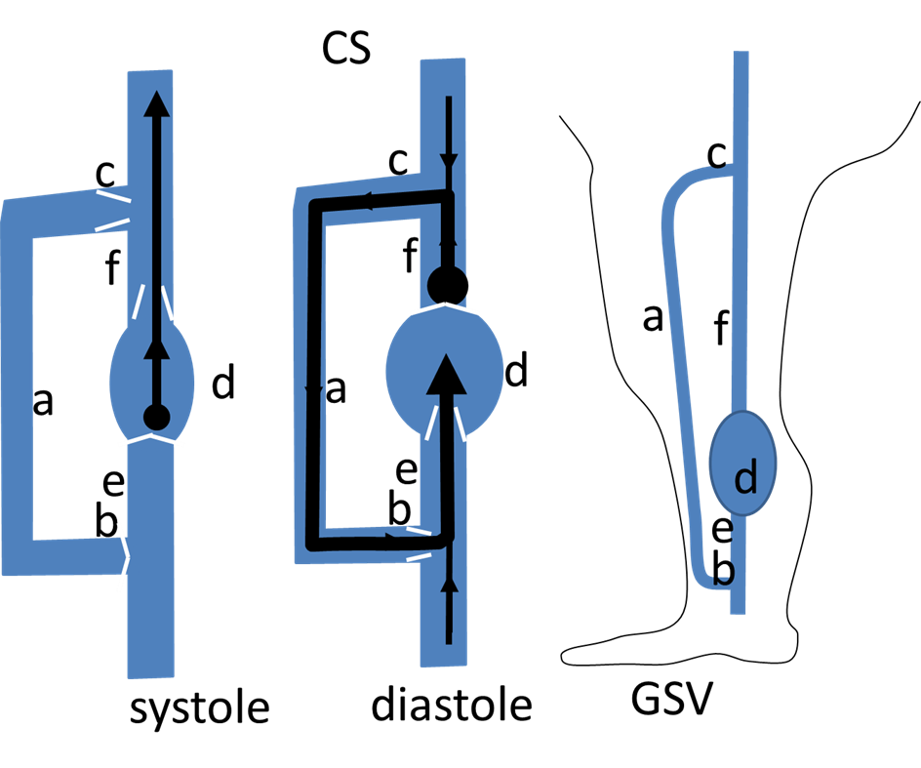
312- Physical system Behavior:
The conduits are vertical. So, the Gravitational Hydrostatic pressure GHP ( high liquid column) has to be added to the pump pressure.
As the conduits are compliant, they will change caliber according the trans-mural pressure and their Hook’s module.
3121- Pump contraction ( systole) produces a bidirectional Pressure Gradient (PG) d>e and d>f. If all the valves (c,f,e,b) are competent, contraction propels the flow in an antegrade unique direction d>f because d>e closes the input valve (e ) and contemporarily opens the output valve (f). This contraction produces a negligible effect on (a) flow. The (c) valve suppression doesn’t change significantly this behavior.
3122- Pump dilation (diastole) reverses GP, e>d and f>d. If all the valves (c,f,e,b) are competent, f>d closes at the same time the output valve (f) and the (c) valve while e>d opens the input valve (e ) opens aspirating (e ) .At the same time , (c ) and (f) valves closure fractionate the GHP column. If the (c ) valve is absent or incompetent , e>d aspires back to (d) the (f) flow ( reflux) into (d) through (c ), (a) then (b).This produces a “closed circuit) where the roe of a “closed shunt” (CS) triggered by the (d) diastole. This CS loads with flow/pressure/energy provided by the (d) and (e ) diastolic pressure decreases less than before. This phenomenon is amplified in these vertical conduits, because of the GHP column is no more fractionated by the (c ) valve closure during the diastole. (c) valve restore or disconnection, restores the normal pressures. If (d) functioning is impaired by (e) and (f) valves absence/incompetence, diastole doesn’t any more reduce (e ) and (d) pressure and hampers the (b) inflow such as reducing/ablating the (f) and (a ) reflux (f,d,e competitive reflux).
313- Venous system behavior:
Let’s keep the GSV example.
3131- Pressure changes. If all the valves (c,b,e,f) are competent, invasive pressure measurement show that, during the Valvo-muscular action of the calf (walking) , the PG is high in normal patients (50>30 mmHg) thanks to the pressure decrease below the knee (ankle). On the contrary, when a closed shunt is formed, i.e SFJ valve (c ) and its trunk (a ) are incompetent, the ankle pressure decrease is impaired. ( >30 mmHg up to 90 at the ankle according to the incompetence grade) despite the deep proper valves of the pump are competent. (ref). (c ) disconnection fractionating the GHP column and disconnecting the CS leads to a GSV caliber decrease (ref Erika). So this effect is in accordance with the CS physical experiment regarding the pressure changes. Clinical data as Perthes test show that a tourniquet blocking at the proximal incompetent GSV (a) make the caliber collapse ( pressure drop) of the veins below the tourniquet when walking if the calf pump functioning is correct. This collapse is impaired proportionally to the pump efficacy ( e.g pump proper valves incompetence) because of the PG reduction (labeled “competitive deep reflux”) QED.
3132- Flow changes.
When the SFJ (c) called escape point and GSV trunk ( a) valves are incompetent, a diastolic reflux ( calf squeezing and Paranà relaxation phase) fed by the common femoral vein (f) is recorded down to a one or more below knee perforators (b) where it re-enters in the deep veins (e ). These perforators are labeled “re-entries”. This flow assessed by daily Duplex US exanimations and recorded by all the sonographers (ref consensus). This flow behavior is in accordance with the CS physical model. CS can be formed by any escape point, shunting vein and re-entry. QED.
32- Open Deviated Shunts ODS: Physical conditions and behavior vs venous ODS:
Deviate Dictionary: turn aside; be at variance with; cause to turn away from a previous or expected course
321-Material Condition
3211- Material system Physical Condition: a conduit (a) connects to the input (e) through the connection ( b) and the output (f) through the connection (c) of an alternate pump (d) ( like heart: active variation of volume of a container placed between at least 2 valves (e and f) insuring a one way flow direction).2 additional valves located in (c) and (b) , (c) downstream to d and (b) upstream (Fig 1A). Two more conduits (g) and (h) are connected. (g) to (a) and (h) to (a) and (e ) through a connection (i). (a), (b), (g) and (h) receive a law flow/pressure from an additional pump (j) through a variable resistance(r ). . In addition, the conduits are collapsible, flexible and compliant.
3212-Material Venous condition: Let’s take the GSV example. Anatomy shows a venous conduit ( GSV trunk (a ) , connecting to the deep venous veins on each side ( e and f) of the calf valvo-muscular pump (d) , downstream above the knee through the sapheno-femoral junction SFJ (c) and upstream below the knee through one or more perforators (b). In addition, many tributaries connect to (a) and among them, a tributary (g) and an other that connects also to (e ) through (i). All veins are connected to the arterial system that feed them ( flow/pressure) trough micro-circulation resistances (r). Therefore, anatomy fulfills the corresponding physical conditions. QED.
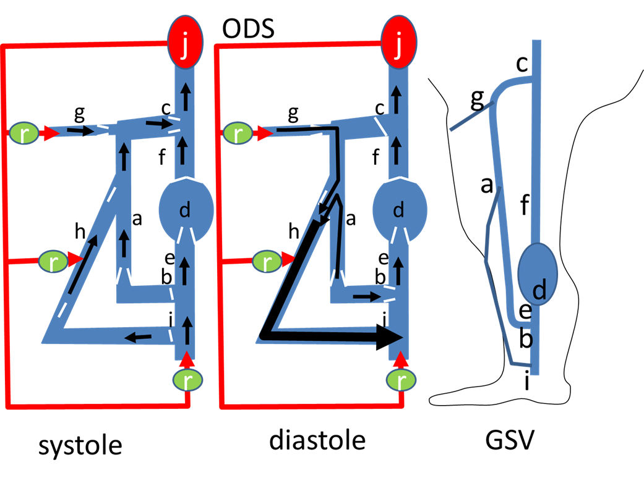
322- Physical system Behavior:
Being collapsible, flexible and compliant, the pressure variation will change the caliber inproportion to t the pressure and the Hook’s module of the conduit material. The conduits are vertical. So, the Gravitational Hydrostatic pressure GHP ( high liquid column) has to be added to the pumps ( d and J) pressure.
3221- The conduits are vertical. Pump contraction ( systole) produces a bidirectional Pressure Gradient (PG) d>e and d>f. If all the valves (c,f,e,b,h,g,i)) are competent, contraction propels the flow in an antegrade unique direction d>f because d>e closes the input valve (e ) and contemporarily opens the output valve (f). This contraction produces a negligible effect on (a) flow. The (c) valve suppression doesn’t change significantly this behavior.
3222- Pump dilation (diastole) reverses GP, e>d and f>d. If all the valves (c,f,e,b,h) are competent, f>e PG closes at the same time the output valve (f, c,a,h,c) valve while the input valve (e ) opens aspirating (e ) .At the same time , (f,c,h,a,) valves closure fractionate the GHP column.
If the (h) valves are absent or incompetent , e>d aspires back to (g, upper (a) and (h) flow ( reflux) into (d) through ( upper a ) and (h).This produces an Open deviate Shunt ODS , in open circuit ( because no return in closed through (c ) which is competent. In addition to the its small flow fed by (j), it is overloaded by (g) and (a). This deviation is due to a diastolic PG (g>i>e) preferential to g>c>f that can produce a reflux thanks to (h) incompetence and the absence of valve between (g) and the upper (a). This phenomenon is amplified in these vertical conduits, because of the GHP column is no more fractionated between (c, and (i). Upper (h) valve restore or disconnection, disconnects the overloading flow and at the same time fractionates the GHP column despite a diastolic reflux remains, but at lower pressure/volume.
323- Venous system behavior:
Let’s keep the GSV example.
3231- Pressure changes. If all the valves (c,b,e,f) are competent, invasive pressure measurement show that, during the Valvo-muscular action of the calf (walking) , the PG is high in normal patients (50>30 mmHg) thanks to the pressure decrease below the knee (ankle). On the contrary, when a ODS is formed, the(h) tributary dilates because (h) valves being incompetent, the GHP column is no more fractionated between (g,c) and (i) and it is overloaded by (g) and (a ) flow/pressure. (h) disconnection at its junction with (a), relieves the overloading flow/pressure and at the same time fractionates the GHP column. Clinical data as Perthes test show that a tourniquet blocking the upper end of incompetent tributary, makes its caliber collapse ( pressure drop) when walking if the calf pump functioning is correct. So this effect is in accordance with the CS physical experiment regarding the pressure changes. QED.
3232- Flow changes.
When the (h) upper junction to (a ) labeled “escape point” is incompetent, a diastolic reflux ( calf squeezing and Paranà relaxation phase) is recorded in the overlying portion of the GSV trunk ( but not at the competent SFJ) and flows down into the incompetent tributary (h) then into deep veins upstream the calf pump ( e) through the re-entry perforator (i). This flow is assessed by daily Duplex US exanimations and recorded by all the sonographers (ref consensus). It’s behavior is in accordance with the ODS physical model. ODS can be formed by any escape point provided it doesn’t connect to the deep veins, otherwise it would be in closed circuit, thus a CS. (h) disconnection at its junction with (a), shows only a physiologic draining flow despite refluxing. QED.

33- Open Vicarious Shunts OVS: Physical conditions and behavior vs venous ODS:
Dictionary: Vicarious: Experienced or gained by the loss or to the consequence of another

Open Vicarious Shunts (OVS) are veins that by-pass any obstructed vein in order to allow the drainage. Their physical/physiological rational is undisputable and agreed by the medical community. We just remember that a venous obstruction leads to upstream drainage impairment and pressure excess that are relieved by any by-pass, provided the latter is appropriate. CHIVA is conservative, in order not only to preserve potential grafts , but also for physiologic reasons: avoid skin disorders due to drainage impairment and prevent varicose recurrence due to OVS effect .QED.
B/ EBM and CHIVA Outcomes
REF 4 RCT CHIVA + Others
1. Varicose vein surgery: stripping versus the CHIVA method: a randomized controlled trial.
Parés JO, Juan J, Tellez R, Mata A, Moreno C, Quer FX, Suarez D, Codony I, Roca J:
Ann Surg; 2010 Apr;251(4):624-31
Abstract | More from the authors | Email 23017jop@ comb.cat | Citation export
2. Recurrent varicose veins of the lower limbs after surgery. Role of surgical technique (stripping vs. CHIVA) and
surgeon's experience.
Milone M, Salvatore G, Maietta P, Sosa Fernandez LM, Milone F:
G Chir; 2011 Nov-Dec;32(11-12):460-3
Abstract | More from the authors | Citation export

