POPLITEAL-DISTAL BYPASS VERSUS INFRA-POPLITEAL ENDOVASCULAR THERAPY FOR INFRA-POPLITEAL OCCLUSIVE DISEASE
Hassan Chamseddine, MDª ∙ Mouhammad Halabi, MDª ∙ Alexander Shepard, MDª ∙ … ∙ Yasaman Kavousi, MDª ∙ Kevin Onofrey, MDª ∙ Loay Kabbani, MDª lkabban1@hfhs.org … Show
Abstract
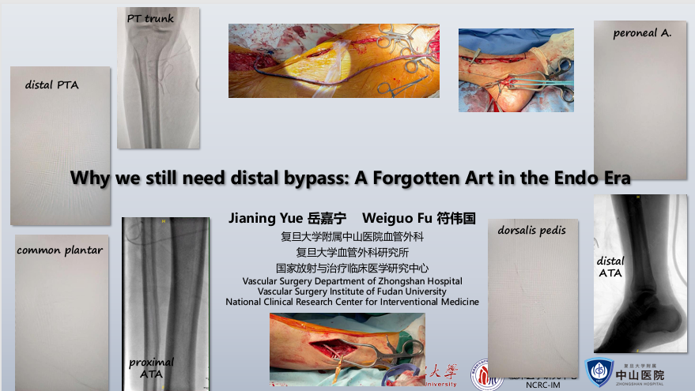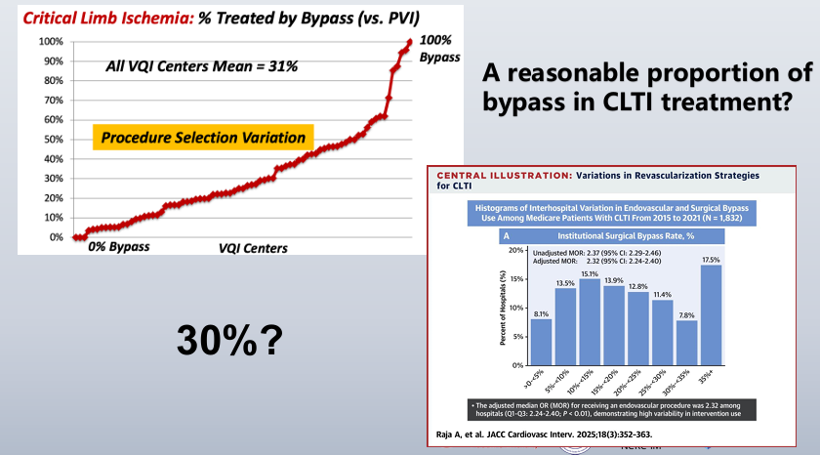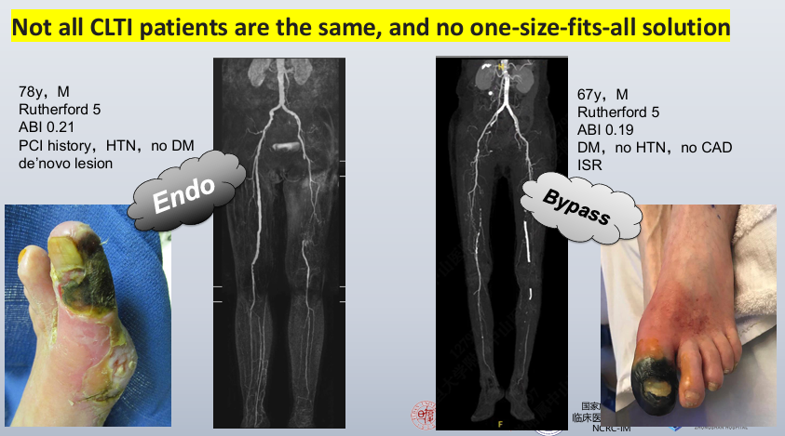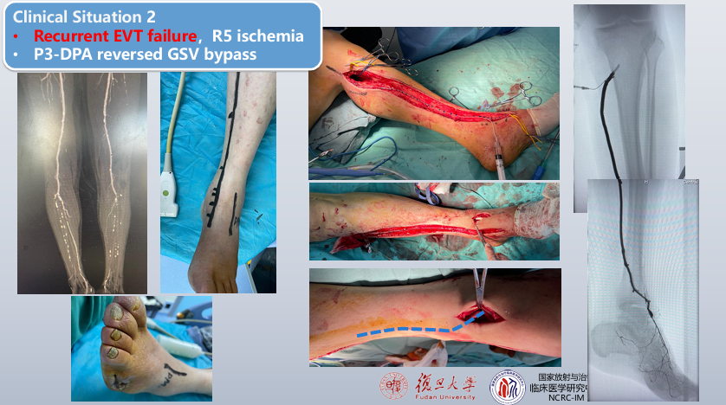Full length articleArticles in PressAugust 04, 2025 JVS
Popliteal-distal bypass versus infra-popliteal endovascular therapy for infra-popliteal occlusive disease
Hassan Chamseddine, MDª ∙ Mouhammad Halabi, MDª ∙ Alexander Shepard, MDª ∙ … ∙ Yasaman Kavousi, MDª ∙ Kevin Onofrey, MDª ∙ Loay Kabbani, MDª lkabban1@hfhs.org … Show
Show Outline
Abstract
Objective
Isolated infrapopliteal occlusive disease poses significant clinical challenges due to limited durable treatment options and poor limb salvage and survival rates. Although endovascular therapy (ET) has gained prominence for its minimally invasive approach, popliteal-distal bypass (PDB) provides an effective open approach that minimizes dissection and length of bypass required. This study aims to compare real-world outcomes of PDB vs infrapopliteal ET for chronic limb-threatening ischemia (CLTI) secondary to isolated infrapopliteal occlusive disease.
Methods
Patients who underwent a PDB or isolated infrapopliteal ET for CLTI between 2010 and 2024 were identified in the Vascular Quality Initiative. PDB was defined as a bypass using single-segment great saphenous vein originating from an above-knee or below-knee popliteal artery inflow; patients with a concomitant more proximal peripheral vascular intervention or bypass were excluded. Infrapopliteal ET was defined as transluminal balloon angioplasty, atherectomy, and/or stenting of a tibial artery; patients with a concomitant bypass or femoropopliteal intervention were excluded. Three-to-one nearest-neighbor propensity score matching without replacement was performed to ensure balance of covariates between the two comparison groups. Kaplan-Meier and Cox regression analysis were used to estimate long-term event rates and evaluate the association of type of intervention with the long-term outcomes of survival, amputation-free survival, primary patency, and major adverse limb events defined as the composite outcome of amputation and/or reintervention.
Results
A total of 3619 patients who underwent PDB were matched to 10,857 patients who underwent isolated infrapopliteal ET. All baseline characteristics and demographics were balanced after propensity score matching. The utilization of PDB for isolated infrapopliteal occlusive disease decreased from 25% to 5% between 2010 and 2023, whereas that of infrapopliteal ET increased from 75% to 95%. PDB was associated with a significantly longer hospital stay (6 days vs 1 day; P < .001) and higher rates of in-hospital mortality (1.4% vs 0.9%; P = .021), myocardial infarction (2.5% vs 0.4%; P < .001), acute kidney injury (7.2% vs 1.4%; P < .001), pneumonia (2.2% vs 0.7%; P < .001), and surgical site infection (2.9% vs 0.0%; P < .001) compared with infrapopliteal ET. At 1-year follow-up, PDB was associated with significantly higher survival (86.7% vs 83.9%; P < .001), amputation-free survival (72.6% vs 65.9%; P < .001), and primary patency (73.6% vs 69.0%; P = .002) and lower major adverse limb events (25.9% vs 30.1%; P = .007) compared with infrapopliteal ET. PDB was associated with significantly higher amputation-free survival compared with infrapopliteal ET for both above-knee PDB (73.6% vs 65.9%; P < .001) and below-knee PDB (71.9% vs 65.9%; P < .001), with no difference observed between above-knee and below-knee PDB (P = .407). Similarly, PDB was associated with significantly higher amputation-free survival compared with infrapopliteal ET for both PDB to a tibial artery (72.3% vs 65.9%; P < .001) and PDB to a pedal artery (72.6% vs 65.9%; P < .001), with no difference observed between PDB to a tibial artery and PDB to a pedal artery (P = .860).
Conclusions
Although its use has declined over the past decade, PDB continues to provide superior long-term outcomes in amputation-free survival, patency, and limb salvage compared with infrapopliteal ET in patients with infrapopliteal occlusive disease, albeit with a higher rate of perioperative mortality and morbidity. Careful preoperative risk assessment and thoughtful patient selection are essential to optimize the outcomes of isolated infrapopliteal interventions, ensuring that immediate procedural risks are appropriately weighed against the potential for improved longer-term outcomes in this patient population.

